Spring 2016 barcode here
Physics 441
Exam 2
Dr. Colton, cell: 801-358-1970

No time limit. Student calculators are allowed. One page of notes allowed (front & back). Books not allowed. FRONT AND BACK INSIDE COVERS OF TEXTBOOK SHOULD BE PROVIDED.

Name ______________________________

Instructions: Please label & circle/box your answers. Show your work, where appropriate! There are 100 total points.

One or more of the following integrals and derivative may or may not be helpful on the exam. If you find yourself needing anything more complicated than this, then you have likely made an error.

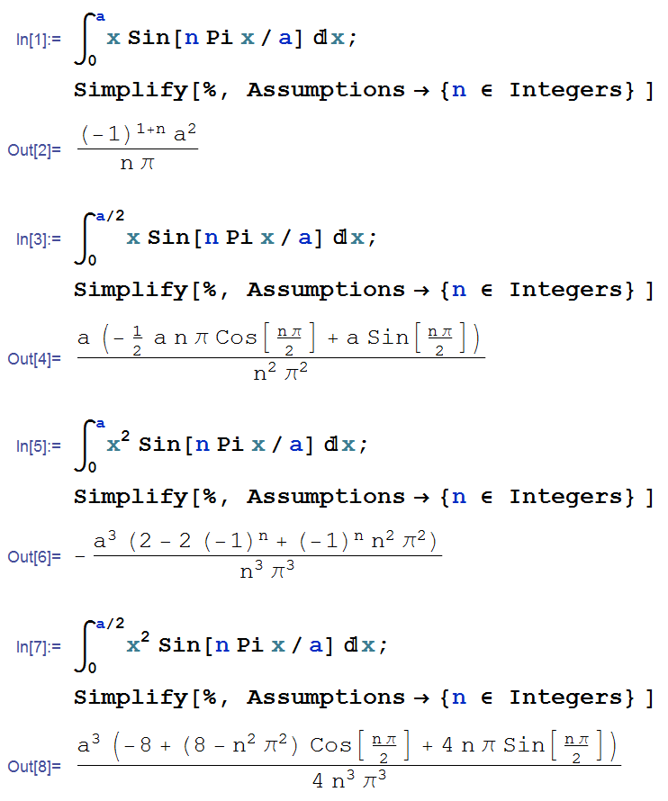
Some Legendre polynomials:
P₀(x) = 1
P₁(x) = x
P₂(x) = 3/2 x² – 1/2
P₃(x) = 5/2 x³ – 3/2 x
(18 pts) Problem 1: Multiple choice, 2 pts each. Circle the correct answer.

  - Poisson’s equation tells us that $∇^{2}V=-\frac{ρ}{ε_{0}}$. If the charge density throughout some volume is zero, what else must be true throughout that volume:
- V = 0
- E = 0
- Both V and E must be zero
- None of the above is necessarily true.

  - A positive charge +q is close to two grounded conducting semi-infinite planes, as shown (the arrows are conductors which extend infinitely into and out of the page, as well as infinitely in the direction of the arrows).
+q

Which of the following image configurations could be used to determine the electric potential near the charge q?

(a) (b) (c) (d) (e)
None of them.
+q
–q
+q
+q
–q
–q
–q
+q
–q
–q
+q
–q
+q
–q

  - Which of the following are true statements about a function which is a solution to Laplace’s equation in three dimensions?

- The function’s value at a given point is the average of the surrounding values of a spherical surface centered at the point.
- Separation of variables always leads to the function involving products of sines and/or cosines, and exponentials.
- There are no local maxima or minima; extrema of the function exist only at the boundaries.

- I only
- I and II only
- I and III only
- II and III only
- I, II, and III

  - True/False: The following integral is zero due to the orthogonality of the Legendre polynomials: $\int_{-1}^{1}{P_{3}\left(x\right) P_{5}\left(x\right)dx}$
- True
- False

  - True/False: The following integral is zero due to the orthogonality of the Legendre polynomials: $\int_{0}^{π}{P_{3}\left(\cos{θ}\right) P_{5}\left(\cos{θ}\right)dθ}$
- True
- False

  - A spherical surface of radius R is somehow maintained at the following potential: $V\left(θ\right)=V_{0}\left(\cos^{4}{θ}+1\right)$. The formula for the potential inside the surface will involve:
- An infinite sum of Legendre polynomials in $\cos{θ}$.
- A finite sum of Legendre polynomials in $\cos{θ}$.

  - A sphere of radius R has a uniform polarization $P=P_{0}\hat{z}$. What is the total dipole moment of the sphere?
P₀
- zero
- P₀
- 4πP₀
- P₀ R³
- 4πP₀ R³/3
- None of the above.

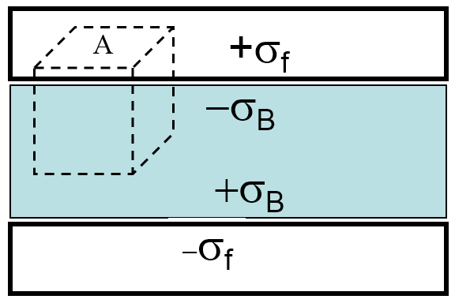
  - A parallel plate capacitor is charged up (charge Q, area A, charge density σ_{f} = Q/A) with a dielectric present between the plates (dielectric constant ε_{r}). The dielectric polarizes, and bound charge densities +σ_{B} and –σ_{B} are produced as shown. What is the magnitude of the D field in the dielectric? (Ignore fringing fields as usual.)
- σ_{B}
- 2σ_{B}
- σ_{B} /2
- σ_{f}
- 2σ_{f}
- σ_{f} /2
- σ_{f} + σ_{B}
- 2(σ_{f} + σ_{B})
- (σ_{f} + σ_{B})/2

  - Assuming that there is no free surface charge on the boundary between the two dielectric media shown, which of the figures represents possible electric field intensity vectors on the two sides of the boundary?
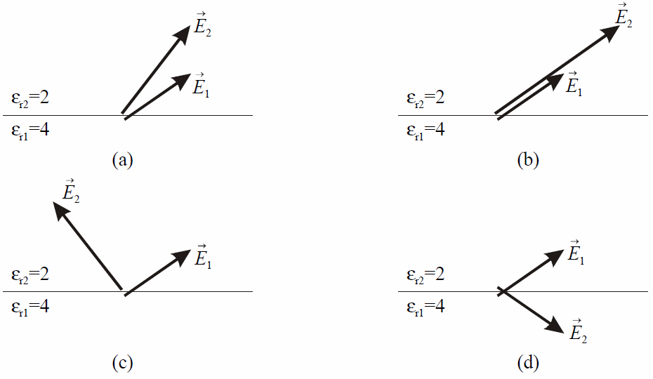
(18 pts) Problem 2. The figure below extends infinitely in the + and – z-directions (not shown), and in the + x-direction. The potential is held fixed along the sides as indicated: the upper and lower sides are held at 0, whereas the left-hand side changes linearly according to V₀ y/a. The goal of the problem is to find V(x,y) inside the boundary.

Boundary conditions
1. V = 0 at y = 0
2. V = 0 at y = a
3. V = 0 at x = ∞
4. V = V₀ y/a at x = 0
y
V=0

V = V₀ y/a
V=0
x
V=0

I’ll get you started solving this problem via separation of variables. First, you would write V(x,y) = X(x) Y(y), and plug V(x,y) into Laplace’s equation. That allows you to separate X and Y and (skipping some work) gives you sines/cosines and exponentials as your solutions to the X and Y equations.

BC 3 means that you must choose exponentials for X, and also that you must throw out the positive exponential as a potential solution. So the solution for X is:

$$X\left(x\right)=A e^{-kx}$$

The choice of exponentials for X means that you must get sines/cosines for Y. BC 1 means that the cosines will not work, so you are left with sines for Y:

$$Y\left(y\right)=B\sin{ky}$$

Now you continue…
(a) What restriction is put on k, and why?

(b) Write down the general form on an infinite series solution for V with unknown coefficients.

(c) Use BC 4 and “Fourier’s Trick” to determine the value of the coefficient of an arbitrary term of the infinite sum.

(18 pts) Problem 3: Four charges exist each a distance a from the origin as shown below. Find the electric field at these two points (not shown), point 1 at (d, 0), and point 2 at (0, d), for d >> a (i.e., very far away from where these charges are). (Just worry about the z = 0 plane.)
+q
+q
–q
–q
y
x

a

(18 pts) Problem 4. A cube is centered at the origin, with the faces in the x, y, and z, axes as shown below. Each side has length of 2a. It has a constant polarization in the z-direction, . (a) Find σ_{B} (for all six surfaces) and ρ_{B}. (b) Use those bound charge densities to set up one or more integrals which could be used to find the potential, V, at some arbitrary point (x, y, z) by direct integration. The integral(s) should be in terms of only P₀, ε₀, a, x, y, z, and the variables of integration.
x
y
z
. (x, y, z)

2a

(16 pts) Problem 5. Two spherical concentric conducting shells have radii a and c, as shown. Inside the conductors are two different dielectrics: from r = a to b, the first one has a dielectric constant of ε_{r1}; from r = b to c, the second one has a dielectric constant of ε_{r2}. Determine the capacitance of this configuration.
conductors
r=c

b
a
ε_{r2}
ε_{r1}

(12 pts) Problem 6. An infinite cylinder of radius R has a built-in polarization: . Use Gauss’s Law for D to obtain the electric field inside the cylinder (s < R). As usual, be sure to explicitly draw your Gaussian surface.

