Physics 441 Final Exam - due Thurs 12/15/16, 5 pm

Rules/Guidance:

- The exam is completely open notes/books. You may use the textbook, other textbooks, your own class notes, websites, etc.
- You may not communicate with other people about the exam (classmates, classmates’ notes, other current or past Physics Department students, relatives, internet forums or chat rooms, Facebook, etc.).
- If the wording of any of the exam problems seems unclear, please talk to me and I will clarify what is meant.
- Feel free to ask me or Spencer any questions about homework, exam, or in-class worked problems. But limit it to actual problems we’ve already done, rather than hypothetical problems that might be similar to the exam problems.
- Please work neatly and start each problem on a new page.
- The exam is out of 140 total points.
- Please turn in this printed out exam along with your work.

Name ____________________________________

Additional Instructions: Please label & circle/box your answers. Show your work, where appropriate! And remember: in any problems involving Gauss’s or Ampere’s Law, you should explicitly show your Gaussian surface/Amperian loop.

(18 pts) Problem 1: Multiple choice, 2 pts each. Circle the correct answer.

  - The figure shows an equilateral triangle ABC. A positive point charge +q is located at each of the three vertices A, B, and C. Each side of the triangle is of length a. A positive point charge Q is placed at the mid-point between B and C.

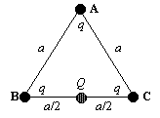

What is the initial direction the point charge Q will move once initially placed?

- B) C)

D) E) F)

  - A conducting sphere of radius a with total charge q is surrounded by a spherical shell of inner radius b and total charge –q. What is the electrostatic potential energy of the system?
a
b
q
-q

- $\frac{1}{4πϵ_{0}}\int_{0}^{∞}{\frac{q}{r^{2}}dr}$
- $\frac{1}{4πϵ_{0}}\int_{a}^{b}{\frac{q}{r^{2}}dr}$
- $\frac{1}{8πϵ_{0}}\int_{a}^{b}{\frac{q^{2}}{r^{2}}dr}$
- $\frac{1}{32π^{2}ϵ_{0}}\int_{0}^{∞}{\frac{q^{2}}{r^{4}}dr}$
- $\frac{1}{32π^{2}ϵ_{0}}\int_{a}^{b}{\frac{q^{2}}{r^{4}}dr}$
- $0$

  - Which of the following is true of Laplace’s equation?
- It can have more than one solution for a given set of boundary conditions.
- The solutions in one dimension must be sines and cosines (or a linear combination).
- It is only valid in regions of space that contain no charges.
- It requires that nowhere within the region of interest can the potential be zero
- More than one of the above.

  - A positive charge Q is located at a distance L above an infinite grounded conducting plane:
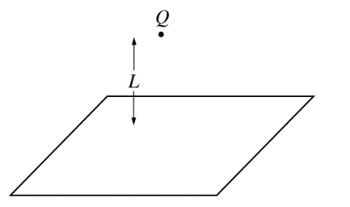

What is the total charge that will be induced on the plane?

- 2Q
- Q
- 0
- –Q
- –2Q

  - A localized charge distribution has no net charge, zero dipole moment, but a nonzero quadrupole moment. At a large distance r from the distribution, the electric potential will fall off like:
- 1/r
- 1/r²
- 1/r³
- 1/r⁴
- 1/r⁸

  - A sheet of current with surface current density $K=K_{0} \hat{x}$ is in the x-y plane. Just above the sheet, i.e., when z = a very small positive number, the magnetic field $B=B_{0}\hat{x}$. K₀ and B₀ are both positive constants. In what direction will B be just below the sheet, i..e., when z = a very small negative number?
- +x
- –x
- +z
- -z
- +y
- –y
- Some other direction
- It cannot be determined from the information given

  - An infinite cylinder has a permanent magnetization M₀ in the z-direction (along the axis of the cylinder). Which of the following are true about the fields inside the cylinder?
- The B field is zero; the H field is non-zero
- The B field is non-zero; the H field is zero
- Both B and H fields are zero
- Both B and H fields are non-zero, and pointing in the same direction
- Both B and H fields are non-zero, but pointing in opposite directions

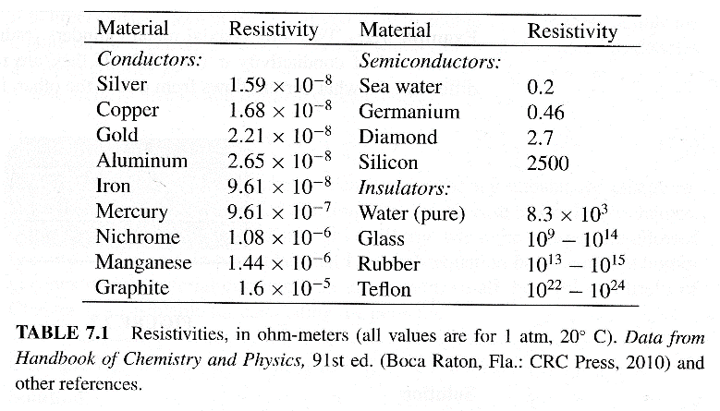
  - A table of resistivities is given. What would be the approximate resistance of a 10 m long section of 32 gauge (0.2 mm diameter) copper wire?
- 0.01 Ω
- 0.05 Ω
- 0.2 Ω
- 1 Ω
- 5 Ω
- 20 Ω

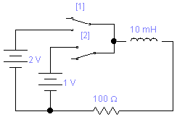

  - Switch 2 is closed and the system comes to equilibrium. Then, switch 2 is opened while switch 1 is closed simultaneously, and the system comes to another equilibrium. What is the final current through the inductor?
- 0.01 A
- 0.02 A
- 0.03 A
- 0.04 A
- 0.05 A
- 0.06 A

Worked problems – please write on your own paper, no more than one problem per page.

(10 pts) Problem 2. Two point charges of equal but opposite charge (i.e. q and –q) are separated by a distance d, the positive charge being on the left and the negative one on the right. Find the electric potential along the line connecting the two charges as a function of distance from the positive charge, x.

(13 pts) Problem 3. A sphere (radius R) has a volume charge density which increases with the distance from the center of the sphere: ρ = k r. (a) What are the units of k? (b) Determine the electric field in terms of k and r for points inside and outside the sphere. (c) Determine the electric potential for points inside the sphere, using the normal convention that V(r = ∞) = 0.

(13 pts) Problem 4. The figure below extends infinitely in the + and – z-directions (not shown), and in the + x-direction. The potential is held fixed along the sides as indicated: the upper and lower sides are held at 0, whereas the left-hand side is help at a potential of $V_{0}sin⁡(\frac{πy}{L})$, where V₀ is a constant and L is the length of the object in the y-direction. Find the potential V(x,y) everywhere inside the boundary. Then use Mathematica or similar program to make a 3D plot of the potential (set V₀ and L equal to 1).

Boundary conditions
1. V = 0 at y = 0
2. V = 0 at y = L
3. V = 0 at x = ∞
4. V = $V_{0}sin⁡(\frac{πy}{L})$
at x = 0
y
V=0

V=V₀ sin(πy/L)
V=0
x
V=0

(15 pts) Problem 5. (a) A molecule with a polarizability α is placed in an electric field and polarizes. If the field has the functional form, $E=5x\hat{x}+2z^{3}\hat{z}$ and the molecule is located at the point (1, 2, 3) (ignore units for this problem) what are the force and torque on it? (b) What charge distribution $ρ\left(x,y,z\right)$ would give rise to such a field?

(15 pts) Problem 6. A current flows clockwise in a square loop of side length 2a that lies flat in the plane of this page. Write down several integral expressions that you could use to find the magnetic field at a point (x, y) that lies in the plane of the loop, where the distances x and y are measured from the center of the square. (You don’t have to actually do the integrals.)

(10 pts) Problem 7. An infinitely long, thick cylindrical shell of inner radius a and outer radius b has a magnetization of $M=\frac{k}{s^{2}} \hat{ϕ}$. Calculate the magnetic field in the region a < s < b as a function of distance from the center of the cylinder.

(12 pts) Problem 8. The current of an infinite solenoid (n turns/length) is increasing linearly according to $I=I_{0}\frac{t}{τ}$, where I₀ and τ are positive constants). Determine the induced electric field, both magnitude and direction.

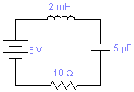
(19 pts) Problem 9. There is no initial current in the displayed RLC circuit, but the capacitor has an initial voltage of 2 V (the side on the top in the diagram has the positive charge). The battery is connected and switched on at t = 0. Find the voltage of the capacitor thereafter as a function of time.

(15 pts) Problem 10. As we talked about many times in class, the quantity $1/\sqrt{ϵ_{0}μ_{0}}$ equals c, the speed of light in a vacuum. We have the tools now to derive that relationship using the Maxwell Equations!

The 1-dimensional “wave equation” is a well known partial differential equation describing waves moving at a velocity v:

It’s called the wave equation because a basic traveling sine wave f = A sin(kx–ωt),* is in fact a solution of the equation as can be seen by taking two spatial derivatives, two time derivatives, and plugging them into the equation:

$$-k^{2}A\sin\left(kx-ωt\right)=\frac{1}{v^{2}}\left(-ω^{2} A\sin\left(kx-ωt\right)\right)$$
$$k^{2}=\frac{1}{v^{2}}\left(ω^{2}\right)$$

So the wave equation is true for that function, as long as the wave speed v = ω/k.

A very similar equation arises directly from the Maxwell equations, which is the point of this problem.

  - Suppose you have electric and magnetic fields in a vacuum (i.e., no charge/current densities). Write down the 4 Maxwell equations for this case.
  - Show that the E field can be decoupled from the B field using Vector Identity 11 from the front cover, giving you a single equation for E. (The same can be done for B.) The equation for E that you end up with should be a three dimensional version of the wave equation (a ∇² instead of a d²/dx²).
  - Show that the wave speed v that you end up is indeed $1/\sqrt{ϵ_{0}μ_{0}}$. This is still amazing to me, and a central part of the “magic” of Maxwell’s equations! Maxwell’s equations were derived/discovered by looking at forces between charges and currents—yet this equation describes a traveling electromagnetic wave moving precisely at the measured speed of light!
  - Now suppose you have a dielectric material (linear, isotropic) which has no free charge nor free current, where μ_{r} = 1, but where ϵ_{r} is not just equal to 1 anymore. Write out the “in matter” Maxwell’s equations for this case. Use Ampere’s Law for H to determine what the curl of B equals, in terms of the E field and other given quantities.
  - Repeat steps (b) and (c) to get the wave equation for E again. What velocity do you obtain in this case? I taught my Phys 123 students that inside materials the speed of light v = c/n, where n is the index of refraction—what does n turn out to be, in terms of the information given in the problem?

(5 pts) Problem 11. Extra credit, no partial credit. In class I mentioned I have a textbook that gives equations in both SI and Gaussian units. Here are a few random SI equations from that book. Do the translation to give their Gaussian equivalents. I suppose if you can use Google to find these equations in Gaussian form, then you can just write down the answers. But that might take quite a while (if even possible), whereas using the conversion tricks I taught in class take only seconds! Note: I didn’t teach you quite everything about this; there are a couple of additional rules for these types of conversions beyond what I mentioned. But all of these particular equations can be done with only the rules I taught.
- $λ_{L}={\left(\frac{ϵ_{0}mc^{2}}{nq^{2}}\right)}^{1/2}$ (penetration depth of a magnetic field into a superconductor)
- $ϵ\left(ω\right)=1-\frac{ne^{2}}{ϵ_{0}mω^{2}}$ (dielectric constant of a plasma, as a function of photon frequency)
- $C_{V}=Nk_{B}{\left(\frac{ℏω}{k_{B}T}\right)}^{2}\frac{e^{\frac{ℏω}{k_{B}T}}}{{\left(e^{\frac{ℏω}{k_{B}T}}-1\right)}^{2}}$ (Einstein model for phonon-related heat capacity of a solid)
- $ω_{c}=\frac{eB}{m^{*}}$ (cyclotron resonance frequency in a semiconductor)
- $a_{d}=\frac{4πϵ_{r}ϵ_{0}ℏ^{2}}{m_{e}e^{2}}$ (the Bohr radius of an electron at a donor atom)

* In case it’s not obvious, this is a “traveling sine wave” because if you look at it at successive times, the peaks of the sine wave move to the right at a certain speed. Actually, sinusoidal waves are not the only solutions to the wave equation—traveling waves of any shape will solve the equation. But that’s beyond what I care about here.

