Rainbow Colors

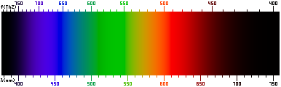
Wikipedia “Visible Spectrum”

ROYGBIV

Is “all the colors of the rainbow” a valid expression?

(What about brown??)
Human Perception of Color

Three types of cone cells: S, M, L
sensitive to “short λ” “medium λ” “long λ”
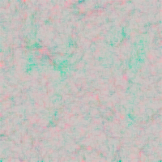
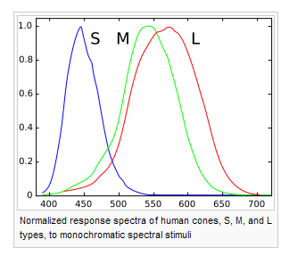
Wikipedia “Color Blindness”
Wikipedia “Color Vision”

Color blindness:
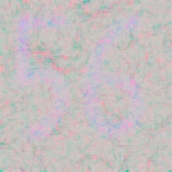
protanomaly – L cones mutated (1% of males)
deuteranomaly – M cones mutated (6% of males; 0.4% of females)
tritanomaly – S cones mutated (rare)
protanopia – lacks L cones (don’t know %)
deuteranopia – lacks M cones (1% of males)
tritanopia – lacks S cones (<1% of males)
Primary Colors

How the song should go: “The primary [additive] colors are 1-2-3: red, green and blue”
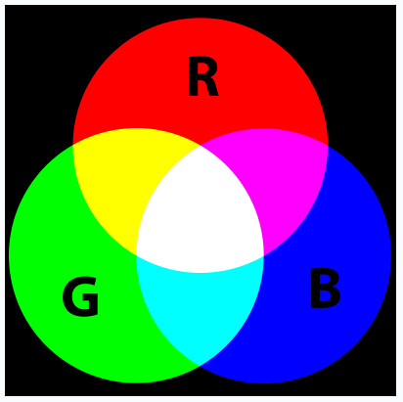
Wikipedia “RGB Color Model”

Additive color mixing
Red + Green = Yellow
Red + Blue = Magenta
Blue + Green = Cyan
Red + Green + Blue = White

Subtractive colors?
Components of Red, Green, and Blue
3-component vector—plot in 3-space

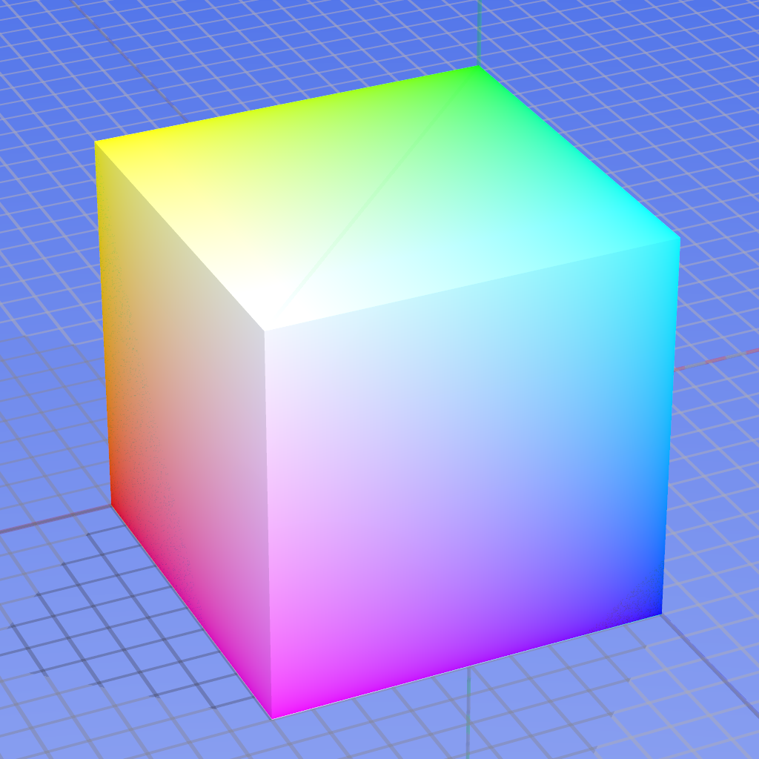
Wikipedia “RGB Color Model”

Various amounts of R, G, and B

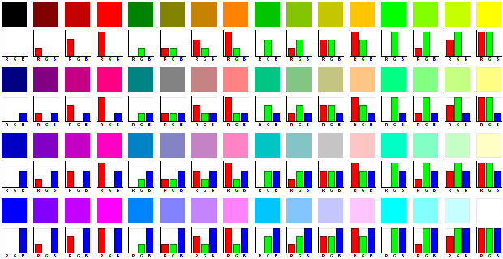
Wikipedia “RGB Color Model”
What is “R”, “G”, and “B” anyway?

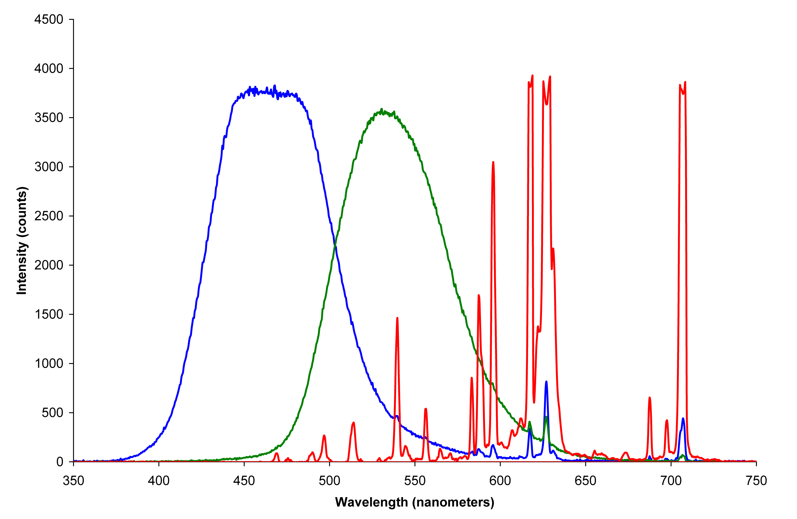
Wikipedia “Primary Color”

The emission spectra of red, green, and blue phosphors that define
the additive primary colors of a CRT color video display

1931: “Color matching functions”
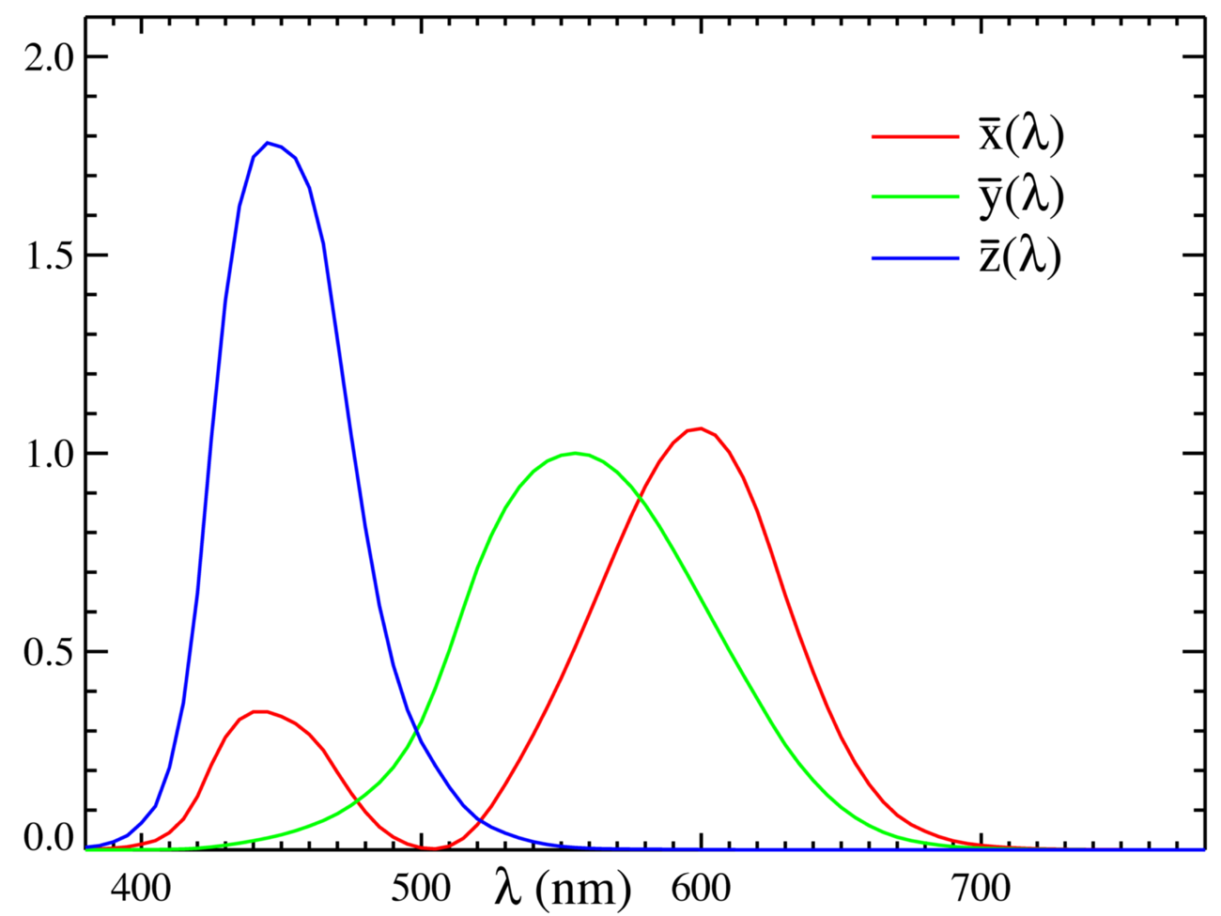
y-bar = special
(and changed slightly in 2005)
Wikipedia “CIE 1931 Color Space”

Compare to human eye response:

Overlap Integrals: Example

X =
Y =
Z =

Normalize:
x =
y =
z =

→ Note that x, y, and z are not independent
→ x and y completely specify color
→ Y specifies overall intensity (brightness)
What is (x, y) for a pure wavelength?

Example: delta function at 560 nm

My estimates:
X = 0.59
Y = 0.98
Z = 0

x = .38
y = .62

→ Do that for every single wavelength: the “locus” curve
Chromaticity Diagram
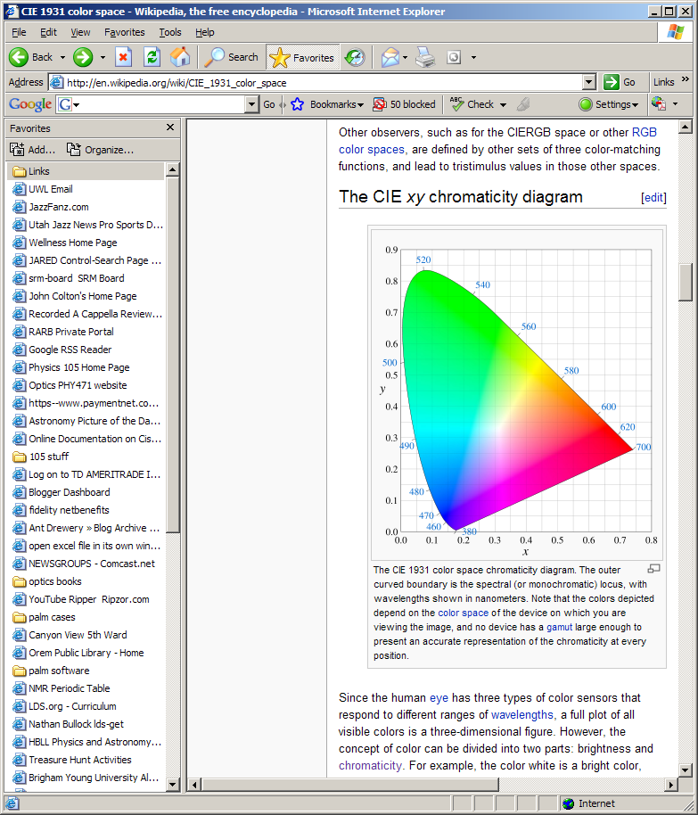
The three white lines are artifacts (not real)
Wikipedia “CIE 1931 Color Space”

→ Lines, triangles, and “gamut”
→ “White point”
sRGB (most monitors & HDTV)
“red” = (0.65, 0.33) “blue” = (0.15, 0.06)
“green” = (0.30, 0.60)

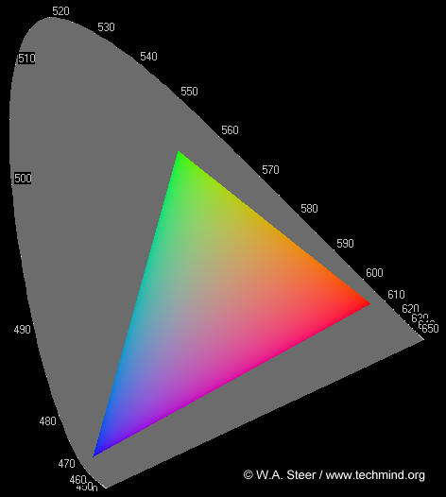
“Introduction to Color Science”
http://www.techmind.org/colour/
http://www.techmind.org/colour/rogues.html
What’s the color of Blackbody Radiation?
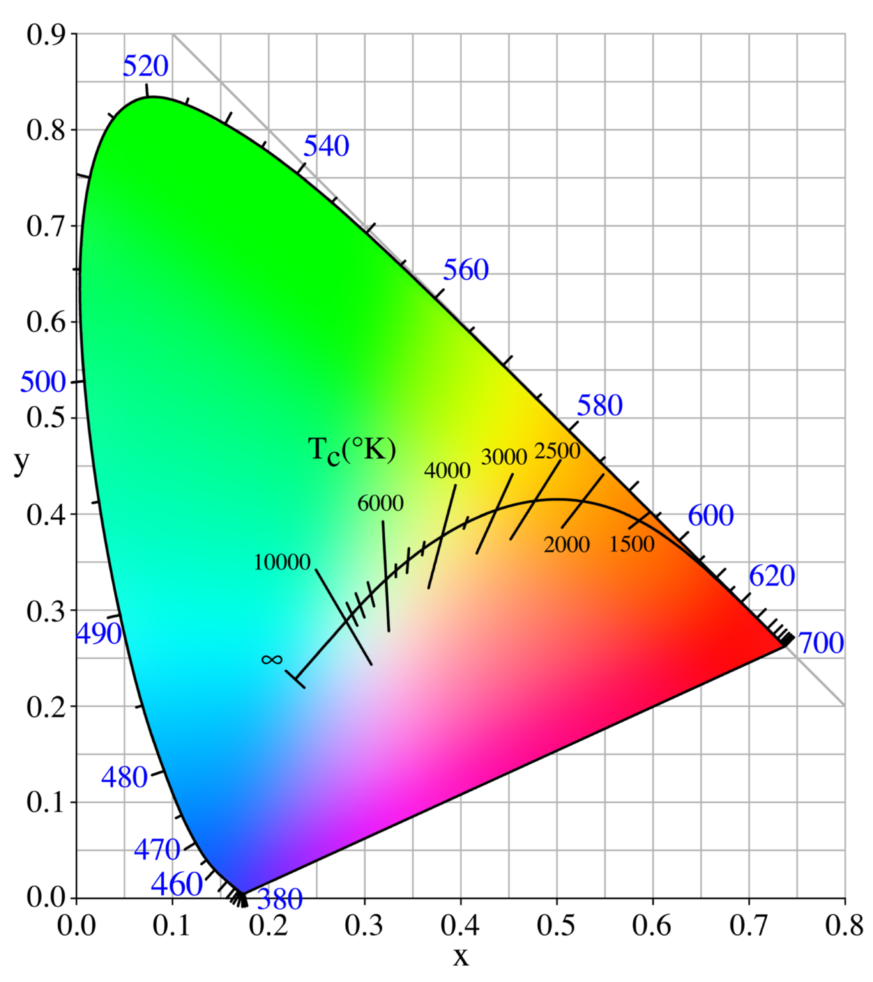
Wikipedia “Color Temperature”
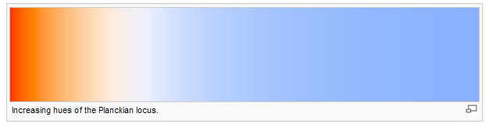
- Dominant color (aka “hue”), λ_{D}
- Saturation (aka “purity”), P
- Complement
- Line of purples
- Surfaces
- Non-white illumination

Summary: Ways to specify a color
http://www.techmind.org/colour - Any red, orangey or yellow coloured lightsource or reflective surface which has essentially no energy at wavelengths shorter than around 550nm will have a visual colour lying right on the edge of the chromaticity diagram locus, and thus outside the sRGB gamut. Yellow and orange flowers such as daffodils and pansies are examples. Furthermore, the deep red petals of flowers such as a rose or camellia often lie outside (below and to the right) of the red-corner of the sRGB gamut. This is one reason why in photographs you may find it difficult to obtain satisfactory-looking colours of some types of flowers.
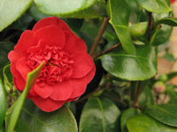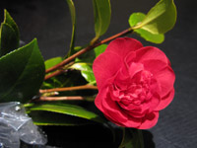
In the photo on the left my camera has rendered the camellia brighter and more orangey than in real life, while in the different lighting on the right it has come out too pink (desaturated). When I illuminated this flower using a quartz-halogen spotlight and measured colours from it using a precision spectrophotometer I obtained a spread of colour-coordinates with several readings extending down to CIE x=0.68, y=0.30 .


