Solid State Physics Homework 2: Assigned Wed, Jan 19; Due Wed, Jan 26
Dr. Colton, Winter 2011

- Kittel 2.2. Hexagonal space lattice.

- Kittel 2.4. Width of diffraction maximum.

- Kittel 2.5. Structure factor of diamond.

- Forbidden (222) reflection. According to the results of the last problem, the structure factor for the (222) reflection in the diamond structure should be zero. However, the following experimental data shows that the intensity of the “forbidden” (222) diffraction spot is not zero!

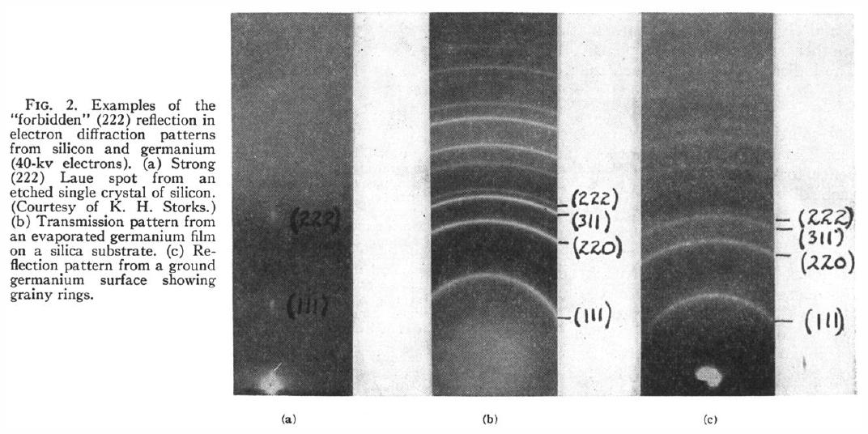
From R.D. Heidenreich, Phys Rev 77, 271 (1950).

Show that the (222) diffraction spot will have non-zero intensity if there is an accumulation of electron density in the mid-point between two nearest neighbor atoms. This pile-up of charge between two atoms forming a covalent bond is known as the bond charge. Thus the x-ray diffraction pattern provides a very direct evidence of this covalent bond in diamond. Hint: Consider what will be the total structure factor for (222) when you include all the bond charges in the conventional unit cell in addition to the atoms. You can assume that each bond charge has a form factor of f_{bond}.

- Kittel 2.6. Form factor of atomic hydrogen.

- Diffraction lines of copper. Suppose you use x-rays with λ = 1.542 Å to measure x-ray diffraction from copper. What are all of the possible Bragg angles where diffraction will occur? For each angle, identify the relevant crystal planes and the reciprocal lattice vector G. Hint: Look up the crystal structure and lattice parameter in the textbook. It’s one of the cubic structures, so you can use the simple formula I gave in class (from Kittel problem 2.1c) to determine the spacing between planes. You can use the notation where e.g. (200) is used to represent the second order diffraction from the (100) planes. Don’t forget to employ the selection rules given by the structure factor to eliminate planes from consideration. When you get to high enough (hkl) numbers, the planes are close enough that Bragg’s law doesn’t yield a solution for θ. Also notice that e.g. (100) and (010) lead to the same angle, so you only need to consider (hkl) triplets with h ≥ k ≥ l. I used a spreadsheet to do the calculations; I found 22 such (hkl) triplets that were allowed by Bragg’s law; all but eight of them were forbidden by the structure factor.

- Bragg Diffraction Lab. In the Physics Department “walk in lab” area, room S415 ESC, this contraption is set up:

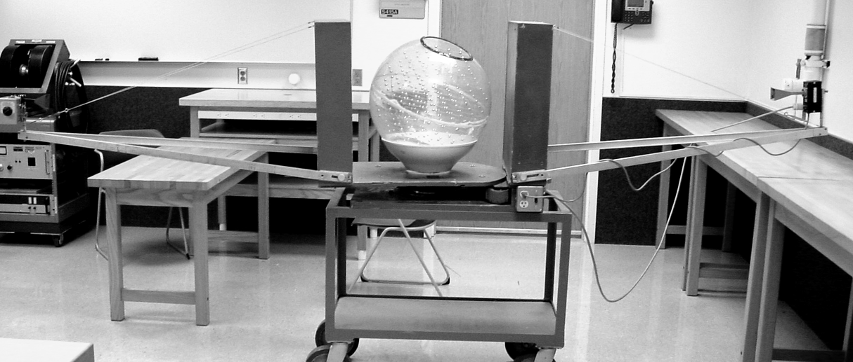

It is a scaled-up version of x-ray diffraction from crystals. All distances in the experiment are increased by about 100 million times: the “x-rays” are actually microwaves with a wavelength of 3 cm; the “atoms” are actually metal balls separated by a few cm. A microwave source is on one end of the contraption; a microwave detector is on the other end. In the middle is a plastic ball with metal atoms arranged in a simple cubic structure.

The detector end is free to rotate. As the detector rotates, the plastic ball automatically rotates as well, but with half the angle. This preserves the overall requirement that the reflection must be specular (incident angle = reflected angle). In the middle section there is an angular measurement; be careful, this gives the angle between source and detector, so the Bragg angle (the angle relative to the crystal planes) is actually half that. I repeat: divide your angles by two before using them in the Bragg equation!

Make sure the apparatus is plugged into the wall, and that the source and detector are both turned on. Be sure to turn them back off when you are done.

(a) With the angle at 0° (i.e., the detector, ball, and source all in line with each other), orient the ball such that the (100) planes are perpendicular to the microwaves. Rotate the detector around until you can measure the +1, –1, +2, and –2 diffraction peaks. Use those four bits of information to deduce a “best value” for the spacing between planes. This is the lattice constant, a.

(b) With the angle at 0°, orient the ball such that the (110) planes are perpendicular to the microwaves. Predict where the +1 and –1 diffraction angles should be, and test out your prediction. Remember that the spacing between planes will be smaller than a.

(c) With the angle at 0°, orient the ball such that the (111) planes are perpendicular to the microwaves. Predict where the +1 and –1 diffraction angles should be, and test out your prediction. Note: Remember that when you look down the [111] direction, you should see hexagonal symmetry. I found this a little trickier to align than the (110) direction, but after realigning things a couple of times, I managed to see the +1 and –1 diffracted beams each within a degree of where I expected them.

