Solid State Physics Homework 4: Assigned Wed, Feb 9; Due Wed, Feb 16
Dr. Colton, Winter 2011

- Kittel 4.3. Basis of two unlike atoms. Note the problem is misleading when it says to “find the amplitude ratios”… as you should find, u and v become decoupled, so they don’t relate to each other and there is no ratio.

- Diatomic Lattice Lab. In the Physics Department “walk in lab” area, room S415 ESC, this contraption is set up:

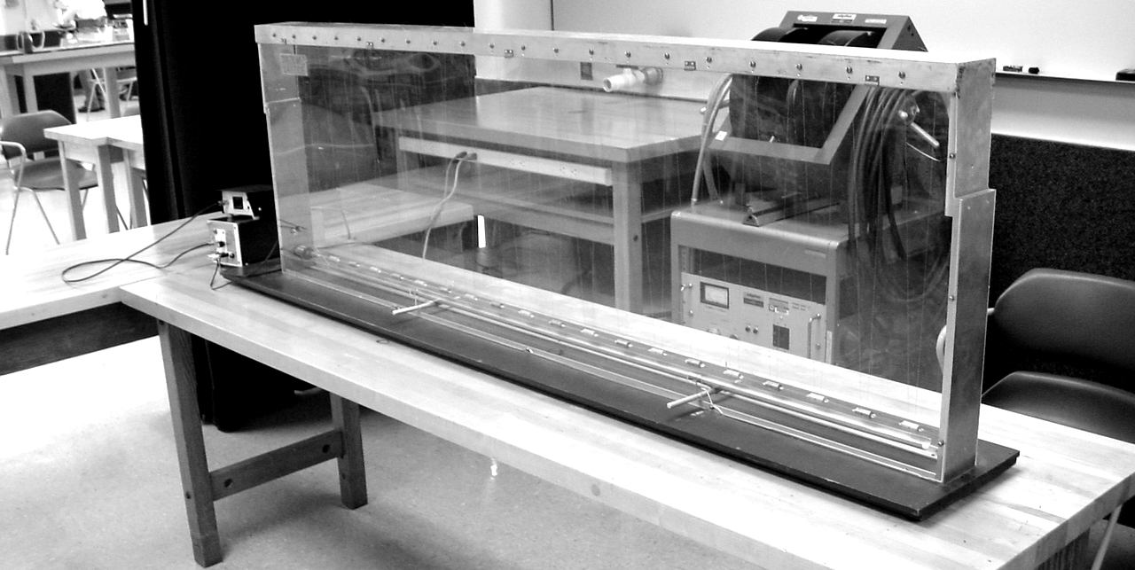

It is a scaled-up version of a linear diatomic lattice: the atoms are suspended metal cylinders of alternating masses, and there are spring forces between the atoms. There are two different types of atoms, but all atoms are separated by the same distance. In other words, this is the same situation you just analyzed in Problem 1. An oscillation source is located on one end of the contraption which can send waves through the atoms at different frequencies.

The frequency of oscillation is actually set via the period in milliseconds. Ignore the final digit (I couldn’t tell if it controls tenths of milliseconds, or if it is not even hooked up). That is, to set a period of 123 ms, set the digits to “1230”.

Note: the metal half-tube below the atoms can be used for damping out the waves when necessary.

(a) Zone-edge behavior – As learned for Problem 1 above, at the zone edge the two sub-lattices decouple: the acoustic branch becomes a standing wave where only the heavy atoms move, and the optical branch becomes a standing wave where only the light atoms move. After much trial and error, it looks to me like the zone-edge acoustic branch frequency corresponds to about 178 ms. Test it out: see if at this frequency you get a situation where only the heavy atoms move. If it doesn’t seem to work, try shifting the frequency up or down in increments of 1 ms. While the precise frequency didn’t seem to be 100% reproducible to me, I would be very surprised if the frequency you want isn’t in the 173-183 ms range.* You may need to wait for a minute after each time you shift the frequency, to allow the old frequency to damp out and the new frequency to take control. Look closely, because the heavy atoms don’t move too much.

(b) The atoms are made of stainless steel and aluminum. All of these atoms have the same volumes, so the mass of each atom is just proportional to the density. Use the densities given in the table in chapter 1 (the density of stainless steel is very close to the density of iron), the frequency given in part (a), and the zone-edge results for a two-atom lattice derived in class, to figure out the frequency of the optical branch at the zone edge. Test it out. If that exact frequency doesn’t work, try lowering the period by a few ms. (I got the best results with a period 5 ms below my prediction.) It should be very obvious when you have the right frequency—now the light atoms move while the heavy atoms remain stationary. And the light atoms will move a lot more than the heavy atoms did in part (a).

(c) Disallowed frequencies 1 – At high enough frequencies, you should enter a region where the dispersion relationship says no waves can propagate. In theory this should be for all frequencies above the zone center value for the optical branch. So, double the frequency from part (b) (i.e., half the period) and see if this is the case. Does that frequency propagate in the lattice?

(d) Disallowed frequencies 2 – The dispersion equation derived in class predicts that there should be a “band gap” in between the acoustic and optical branches (see the plot that I handed out). Thus, frequencies between the ones used for part (a) and part (b) should also be disallowed. Test it out with a frequency roughly half-way between part (a) and part (b). Does that frequency propagate? (Unfortunately, my results for this part weren’t as good as my results for part (c). That is, I did in fact see some wave propagation in this band gap region, where I saw practically none in part (c).)

- Kittel 4.5. Diatomic chain. Instead of just “sketching the equations by eye”, do a real plot with a program like Mathematica. Use c = m = a = 1 for your plot, but use your equations to figure out the general values of the two curves at k = 0 and k = π/a.

- Kittel 4.6. Atomic vibrations in a metal. Some hints/instructions:

(a) Find the restoring force by using F = q E and finding the electric field via Gauss’s law. Your restoring force should be in the form of F = (stuff) × displacement from equilibrium, just like Hooke’s law. Then, by analogy to oscillation of a mass on a spring, the frequency ω = sqrt(stuff/m).

(b) Use a periodic table to calculate the mass of a sodium atom. Use the table on page 21 to find the number density, and hence R.

(c) The “common sense” Kittel refers to, is this: the acoustic sound velocity is dω/dk, which will be not too far from ω_{max}/k_{max}. The maximum allowed frequency, ω_{max}, will be approximately equal to your answer in part (b), and as you should know, k_{max} is just π/a. (You’ll have to look up the lattice constant a.)
Please add part (d): compare your answer to part (c) with a brief chapter 3-type calculation of the [100] sound velocity for sodium, sqrt(C₁₁/ρ).

- Two-dimensional square lattice.

• • • • • • • • • •

• • • • • • • • • •

• • • • • • • • • •

• • • • • • • • • •

The dots represent atoms in a 2D square lattice (lattice constant a in both directions). Each atom has the same mass m. When the atoms are displaced from their equilibrium positions in the direction perpendicular to the plane of the crystal (such as in a transverse wave), the restoring force for small displacements is simply proportional to the difference between the displacement of neighboring atoms. The constant of proportionality will be denoted by C. For example, if we label the displacement of atom (l, m) from its equilibrium position as u_{lm}, the restoring force on that atom is given by:

(a) Calculate the dispersion relation (ω as a function of k) of the vibrational waves (phonons) in this crystal for a wave with a wave vector k = (k_{x}, k_{y}).

(b) Calculate the acoustic sound velocity of this crystal by calculating dω/dk in the limit that k goes to zero.

(c) What does the Brillouin Zone look like for this crystal?

(d) Use your ω(k_{x}, k_{y}) function found in part (a) to derive equations for ω(k) along the [10] and [11] directions. Use a computer program such as Mathematica to create plots of these equations from the center of the BZ to the edge, for C = m = a = 1. Use your equations to figure out the general values of the curves at the BZ edge, which is k = π/a for the [10] case and k = sqrt(2)π/a for the [11] case.

(e) Use something like Mathematica’s Plot3D function to make a three-dimensional plot of ω vs. (k_{x}, k_{y}) over the full Brillouin Zone.

- Inelastic neutron scattering from copper: peak B. Determine ω and k for the phonon absorbed in peak B from the inelastic neutron scattering data of copper handed out in class. Don’t forget to convert the k-vector into its first Brillouin zone value. Your exact answer will depend on what value you read off of the graph, but when I did it I got ω = 2.2e13 rad/s, and k = 1.1Å⁻¹ at an angle of 30° away from the x-axis.

* After I wrote that sentence, I had the TA try the lab. He got a frequency corresponding to 170 ms for this part.

