Solid State Physics Homework 4: Assigned Fri, 3 Feb 2012; Due Mon, 13 Feb 2012
Dr. Colton, Winter 2011

- Kittel 4.3. Basis of two unlike atoms. Note: the problem is misleading when it says to “find the amplitude ratios”. As you should find, u and v become decoupled, so they don’t relate to each other and there is no ratio.

- Diatomic Lattice Lab. In the Physics Department “walk in lab” area, room S415 ESC, this contraption is set up:

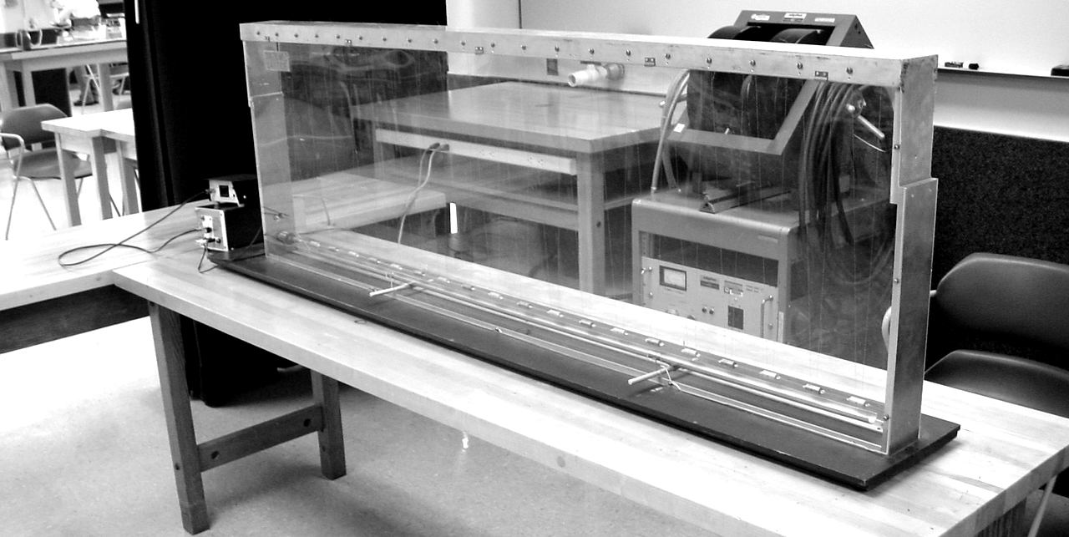

It is a scaled-up version of a linear diatomic lattice: the atoms are suspended metal cylinders of alternating masses, and there are spring forces between the atoms. There are two different types of atoms, but all atoms are separated by the same distance. In other words, this is the same situation you just analyzed in Problem 1. An oscillation source is located on one end of the contraption which can send waves through the atoms at different frequencies.

The frequency of oscillation is actually set via the period in milliseconds. Ignore the final digit (I couldn’t tell if that digit controls tenths of milliseconds, or if it is not even hooked up). That is, to set a period of 123 ms, set the digits to “1230”.

Note: the metal half-tube below the atoms can be used for damping out the waves when necessary.

(a) Zone-edge behavior – As learned for Problem 1 above, at the zone edge the two sub-lattices decouple: the acoustic branch becomes a standing wave where only the heavy atoms move, and the optical branch becomes a standing wave where only the light atoms move. After much trial and error, it looked to me like the zone-edge acoustic branch frequency corresponds to about 178 ms. Test it out: see if at this frequency you get a situation where only the heavy atoms move. If it doesn’t seem to work, try shifting the frequency up or down in increments of 1 ms. While the precise frequency didn’t seem to be 100% reproducible to me when I repeated the experiment, I would be surprised if your frequency isn’t within 10 ms or closer of my frequency. You may need to wait for a bit after each time you shift the frequency, to allow the old frequency to damp out and the new frequency to take control. Look closely, because the heavy atoms don’t move too much.

(b) The atoms are made of stainless steel and aluminum. All of these atoms have the same volumes, so the mass of each atom is just proportional to the density. Use the densities given in the table in chapter 1 (the density of stainless steel is very close to the density of iron), the frequency given in part (a), and the zone-edge results for a two-atom lattice derived in class, to figure out the frequency of the optical branch at the zone edge. Test it out. If that exact frequency doesn’t work, try varying the period by a few ms. (I got the best results with a period 5 ms below my prediction.) It should be very obvious when you have the right frequency—now the light atoms move while the heavy atoms remain stationary. And the light atoms will move a lot more than the heavy atoms did in part (a).

(c) Disallowed frequencies 1 – At high enough frequencies, you should enter a region where the dispersion relationship says no waves can propagate. In theory this should be for all frequencies above the zone center value for the optical branch. So, double the frequency from part (b) (i.e., half the period) and see if this is the case. Does that frequency propagate in the lattice?

(d) Disallowed frequencies 2 – The dispersion equation derived in class predicts that there should be a “band gap” in between the acoustic and optical branches (see the plot that I handed out). Thus, frequencies between the ones used for part (a) and part (b) should also be disallowed. Test it out with a frequency roughly half-way between part (a) and part (b). Does that frequency propagate? (Unfortunately, my results for this part weren’t as good as my results for part (c). That is, I did in fact see some wave propagation in this band gap region, where I saw practically none in part (c).)

- Kittel 4.5. Diatomic chain. Instead of just “sketching the equations by eye”, do a real plot with a program like Mathematica. Use c = m = a = 1 for your plot, but use your equations to figure out the general values of the two curves at k = 0 and k = π/a.

To plot two functions at the same time in Mathematica, group the functions with braces. For example, this will plot y = x² and y = sqrt(x) at the same time (from x= 0 to x = 1):
Plot[{x^2,Sqrt[x]},{x,0,1}]

- Kittel 4.6. Atomic vibrations in a metal. Some hints/instructions:

(a) Find the restoring force by using F = q E and finding the electric field via Gauss’s law. Your restoring force should be in the form of F = (stuff) × displacement from equilibrium, just like Hooke’s law. Then, by analogy to oscillation of a mass on a spring, the frequency ω = sqrt(stuff/m).

(b) Use a periodic table to calculate the mass of a sodium atom. Use the table on page 21 to find the number density, and hence R.

(c) The “common sense” Kittel refers to, is this: the acoustic sound velocity is dω/dk, which will be not too far from ω_{max}/k_{max}. The maximum allowed frequency, ω_{max}, will be approximately equal to your answer in part (b), and as you should know, k_{max} is just π/a. (You’ll have to look up the lattice constant a.)

Please add part (d): compare your answer to part (c) with a brief chapter 3-type calculation of the [100] sound velocity for sodium, sqrt(C₁₁/ρ).
- Two-dimensional square lattice.

• • • • • • • • • •

• • • • • • • • • •

• • • • • • • • • •

• • • • • • • • • •

The dots represent atoms in a 2D square lattice (lattice constant a in both directions). Each atom has the same mass m. When the atoms are displaced from their equilibrium positions in the direction perpendicular to the plane of the crystal (such as in a transverse wave), the restoring force for small displacements is simply proportional to the difference between the displacement of neighboring atoms. The constant of proportionality will be denoted by C. For example, if we label the displacement of atom (l, m) from its equilibrium position as u_{lm}, the restoring force on that atom is given by:

(a) Calculate the dispersion relation (ω as a function of k) of the vibrational waves (phonons) in this crystal for a wave with a wave vector k = (k_{x}, k_{y}).

(b) Calculate the acoustic sound velocity of this crystal by calculating dω/dk in the limit that k goes to zero.

(c) What does the Brillouin Zone look like for this crystal?

(d) Use your ω(k_{x}, k_{y}) function found in part (a) to derive equations for ω(k) along the [10] and [11] directions. Use a computer program such as Mathematica to create plots of these equations from the center of the BZ to the edge, for C = m = a = 1. Use your equations to figure out the general values of the curves at the BZ edge, which is k = π/a for the [10] case and k = sqrt(2)π/a for the [11] case.

(e) Use something like Mathematica’s Plot3D function to make a three-dimensional plot of ω vs. (k_{x}, k_{y}) over the full Brillouin Zone.

- Finite 1D chain of atoms & springs. As discussed in class, in our ball & spring models of atoms, the finite length of the system of balls causes the allowed frequencies to be discrete rather than continuous as one would expect from the dispersion curves that we have been drawing. However, for macroscopic numbers of atoms, the spacing between frequencies (and allowed k-values) is so small that the points basically blur together and my claim is that they become the same continuous solutions that we obtain for the infinite case. So, let’s test it out.

(a) Numerically solve the problem of a finite length chain of 100 identical atoms. Assume all masses and spring constants are equal to 1. They are described by displacements u₁, u₂, …, u_{s-1}, u_{s}, u_{s+1}, … u₉₉, u₁₀₀. As discussed in class, you should use Newton’s Second Law on each one to get 100 coupled equations which you have to solve with a matrix equation. That gets you 100 allowed frequencies that are closely related to the eigenvalues of the matrix. Each frequency corresponds to a particular relationship between the u_{s}’s, that is to say, a particular wavelength (or k-value). (To find the correspondence, we would have to work out the eigenvectors, but that’s too complicated for this problem.) When solving this problem, you have to make some assumption about the boundary conditions to get the first and last rows of your matrix, such as “wrap around” or “u = 0”, etc. Since those are just two rows out of 100, it turns out to not matter very much what assumption you pick. Try at least two different sets of boundary conditions. See the paragraph below for help with how to set up the matrix in Mathematica.

(b) In class we solved this same problem for an infinite chain, and found a particular dispersion relation:

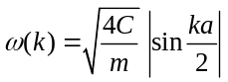

Assuming that there are 100 equally-spaced k values across the Brillouin zone that actually work, use that equation to generate a list of ω values that correspond to those k values. Compare that list to the list from part (a). See below for a suggestion on how to generate this list, and how to compare the two lists.

When you turn in your problem, please don’t include long printouts of huge matrices. Instead, just summarize the matrices you used… but do give the lists of allowed ω values from both parts (a printout of that part of your Mathematica code is fine), along with an explanation/evidence of how you compared them.

Help with Mathematica: This took me some trial and error, and there may well be an easier way to do things, but this sequence of six Mathematica commands will produce a 100 × 100 matrix called “M”, with values “a”, “b”, and “c”, along the diagonals of the 98 interior rows.

lowerdiags = Table[a,{i,1,98}]
diags = Table[b,{i,1,99}]
diags[[1]] = 0
upperdiags = Table[c,{i,1,99}]
upperdiags[[1]] = 0
M = DiagonalMatrix[lowerdiags,-1,100] +
DiagonalMatrix[diags,0,100]+DiagonalMatrix[upperdiags,1,100];

You can manually set values of elements in the first and last rows to nonzero numbers by using commands like this:
M[[1]][[1]] = 1.75

or this:
M[[100]][[99]] = -3.1

You can view the matrix with this command:
MatrixForm[M]

The eigenvalues of a numerical matrix can be calculated fairly quickly using this command:
N[Eigenvalues[M]]

(The “N” command is useful here because if you just use the command Eigenvalues[M], it gives you the eigenvalues in an odd non-numerical format.)

I also found these commands to be useful:
The Sqrt[ ] command (to get ω instead of ω²)
The Sort[ ] command (to put the ω values in ascending order)
The Table[f[k], {k, -Pi+Pi/100, Pi - Pi/100, 2 Pi/100}] command (to generate a list of the predicted ω values, with 100 equally separated k-values, where I had previously defined f(k) to be the equation we derived in class)
The ListPlot[ ] command (to graphically display the allowed ω values, as a way of comparing part (a) of this problem with part (b))

