Spring 2016 barcode here
Physics 441
Final Exam
Dr. Colton, cell: 801-358-1970

No time limit. Student calculators are allowed. One page of notes allowed (front & back). Books not allowed. FRONT AND BACK INSIDE COVERS OF TEXTBOOK SHOULD BE PROVIDED.

Name ______________________________

Instructions: Please label & circle/box your answers. Show your work, where appropriate! And remember:
- in any problems involving Gauss’s Law, you should explicitly show your Gaussian surface.
- in any problems involving Ampere’s Law, you should explicitly show your Amperian loop.

There are 140 total points, with an additional 10 extra credit points possible on the last problem.

Legendre orthogonality:
$$\int_{0}^{π}{P_{l}\left(\cos{θ}\right)}P_{m}\left(\cos{θ}\right)\sin{θ}dθ =\left\{\begin{matrix}0 if l≠m \\ \\ \frac{2}{2l+1} if l=m\end{matrix}\right.$$
Some Legendre polynomials:
P₀(x) = 1
P₁(x) = x
P₂(x) = 3/2 x² – 1/2
P₃(x) = 5/2 x³ – 3/2 x

(18 pts) Problem 1: Multiple choice, 2 pts each. Circle the correct answer.

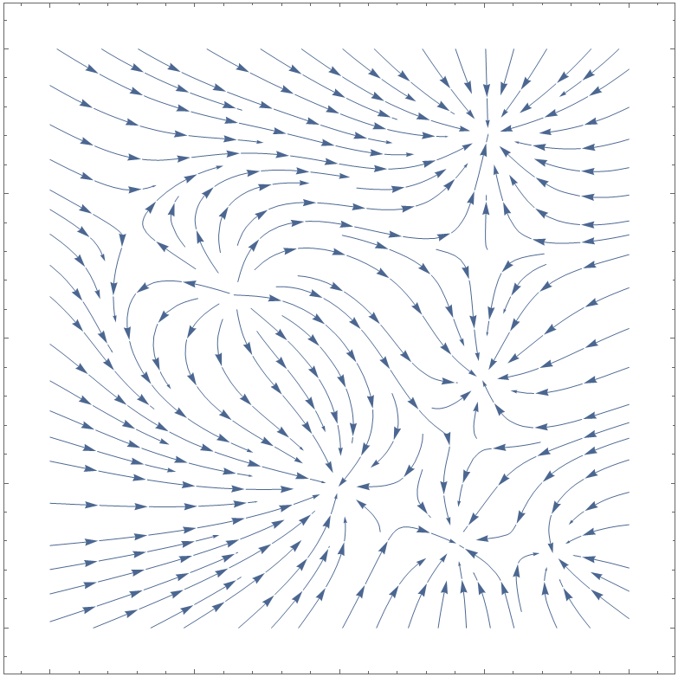
  - Various electric charges of different magnitudes (both positive and negative) are present in the x-y plane in a region of space. The figure shows a plot of the field lines in the region. How many charges are there?
- 3
- 4
- 5
- 6
- 7
- 8

  - A boundary exists between two linear dielectric materials, i.e. ϵ_{r} has two different values above and below the boundary. There are no free charges in the region considered. What must be continuous across the boundary?
i) E// ii) E⊥ iii) D// iv) D⊥

- (i) only
- (ii) only
- (iii) only
- (iv) only
- (i) and (ii)
- (i) and (iii)
- (i) and (iv)
- (ii) and (iii)
- (ii) and (iv)
- (iii) and (iv)

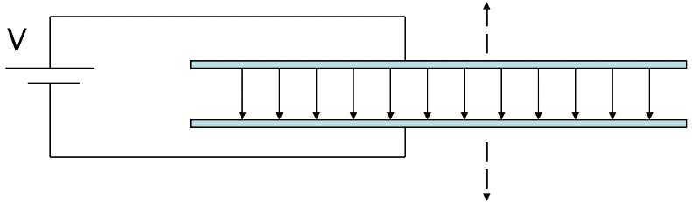
  - A parallel plate capacitor is attached to a battery which maintains a constant potential difference (voltage) between the capacitor plates. While the battery is attached, the plates are pulled straight apart from each other in the direction of the block arrows shown, increasing their separation. The electrostatic energy stored in the capacitor:
- increases
- decreases
- stays constant

  - Which of these charge distributions produce a potential which varies as 1/r² when you get far away?

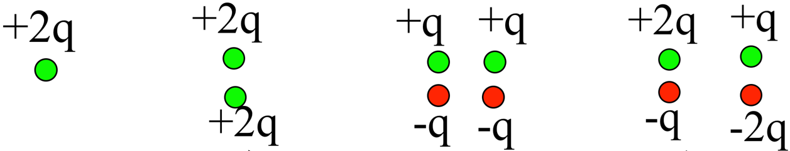
(i) (ii) (iii) (iv)

- (i) only
- (ii) only
- (iii) only
- (iv) only
- (i) and (ii)
- (i) and (iii)
- (i) and (iv)
- (ii) and (iii)
- (ii) and (iv)
- (iii) and (iv)

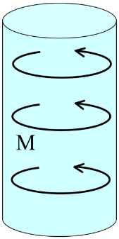
  - A solid cylinder has uniform magnetization M throughout the volume in the φ direction as shown. In which direction does the bound surface current flow on the “wrapper” (curved side)?
- There is no bound surface current on that surface.
- The current flows in the $±\hat{ϕ}$ direction.
- The current flows in the $±\hat{s}$ direction.
- The current flows in the $±\hat{z}$ direction.
- The direction is more complicated than answers (b), (c), or (d).

  - In class I said something like, “The magnetic susceptibility of a ferromagnetic is very large, but it’s somewhat ill-defined.” Why did I say it is ill-defined?
- The ratio of M to H depends on the current field.
- The ratio of M to H depends on the history of what the field has been.
- M and H do not have a linear relationship.

- (i) only
- (ii) only
- (iii) only
- (i) and (ii)
- (i) and (iii)
- (ii) and (iii)
- (i), (ii) and (iii)

  - Which of the following is/are true about mutual inductance between two conducting loops?
- Mutual inductance just depends on the sizes, shapes, orientation, and other geometrical quantities.
- The mutual inductance of conductor 1 acting on conductor 2 is the same as the mutual inductance of 2 acting on 1.
- Mutual inductance is a vector quantity.

- (i) only
- (ii) only
- (iii) only
- (i) and (ii)
- (i) and (iii)
- (ii) and (iii)
- (i), (ii) and (iii)
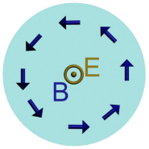
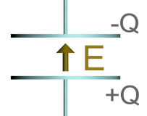
  - The figures show a side and top view of a capacitor with charge Q and electric and magnetic fields E and B at time t. At this time the charge Q is:
- Increasing in time
- Decreasing in time.
- Constant in time.

  - When a slab of dielectric material is placed in an electric field, it polarizes: positive bound charges move slightly in one direction and negative bound charges move slightly in the opposite direction. This movement of charge is a type of current. Where is this current taken into account in Maxwell’s equations?
- In Ampere’s law for B: through the μ₀J term
- In Ampere’s law for B: through the μ₀ϵ₀dE/dt term
- In Ampere’s law for H: through the J_{free} term
- In Ampere’s law for H: through the dD/dt term

- (i) only
- (ii) only
- (iii) only
- (iv) only
- (i) and (iii)
- (i) and (iv)
- (ii) and (iii)
- (ii) and (iv)

Worked problems – please write on your own paper, no more than one problem per page.

(19 pts) Problem 2. Point charges of +q and –q are located at the corners of a square of side a, as shown. (a) Find the electric field at a point “P” located a distance d to the right of the center of the square. (b) Find the electric potential at the same point. (c) How can your answers to (a) and (b) be reconciled with the fact that E = –∇V?
y
–q
–q
+q
+q
a

P = (d,0)
×
x

(19 pts) Problem 3. Suppose you have a capacitor made out of two concentric spheres: a charge +Q exists on the inner conductor (radius a) and a charge of –Q exists on the outer conductor (radius b). In between the two conductors is a dielectric with relative permittivity ϵ_{r}. (a) Find the E and D fields everywhere. (b) Determine the total energy stored in the electric field by integrating $E∙D$ over all space. (c) Compare that with what the standard “energy of capacitor” formula from Phy 220: U = Q²/2C. Explain why the two energies are the same or different. Recall that for this configuration $C=4πϵ_{0}ϵ_{r}{(1/a -1/b)}^{-1}$ as we found in a worked problem done in class.

(17 pts) Problem 4. A cylinder is positioned on the x-axis, as shown. Its length is L and its cross-sectional area is A. The cylinder has a polarization that changes along its length: $P=\left(ax^{2}+b\right)\hat{x}$. Find the bound charge densities (volume and surface), and show explicitly that the total bound charge adds up to zero.
x
y

(20 pts) Problem 5. A current I travels around a square loop (side 2a) in the x-y plane as shown. Using the Biot-Savart Law, set up an integral that you could use to determine the magnetic field at point P on the z-axis. Use symmetry to make the integral as simple as possible.

×
x
y
z
P = (0,0,z)
2a

I

(15 pts) Problem 6. An infinitely long solid cylinder of radius R carries volume and surface current densities as shown, $J=\frac{k_{1}}{s}\hat{z}$ and $K=k_{2}\hat{z}$. Find B everywhere due to these current densities.
J
K

(18 pts) Problem 7. A vector potential A exists, such that (in cylindrical coordinates):
$$A=\left\{\begin{matrix}k_{1}s\hat{ϕ} for s<R \\ k_{2}s^{2}\hat{ϕ} for s>R\end{matrix}\right.$$

(a) What’s the relationship between k₁ and k₂? (b) Find the magnetic field corresponding to this A, for both s < R and s > R. (c) Is this A in the Coulomb gauge? How do you know? (d) Is there a surface current density at s = R? How do you know?
(14 pts) Problem 8. A hydroelectric generator is made by using water force to continuously rotate a loop of wire (radius R) through a magnetic field $B=B_{0}\hat{z}$ produced by permanent magnets, at an angular frequency of ω rad/s. The normal to the surface of the loop changes continuously: $\hat{n}=\hat{z}\cos{ωt}+\hat{x}\sin{ωt}$. (a) Calculate the magnetic flux passing through the loop, as a function of time. (b) Use Faraday’s Law to calculate the AC voltage produced by the generator. (c) At t = 0, is the induced current clockwise or counter-clockwise (viewed from above)?

B

ω

(10 pts) Problem 9, extra credit. No partial credit, so you need to decide if this is worth your time. Two concentric spheres of radii a and b are each held at a constant potential, V_{a} and V_{b} respectively. Determine V(r) in the region between the two spheres, using the technique of separation of variables in spherical coordinates to obtain a solution which matches the boundary conditions. It’s OK if you jump directly to the solutions for Laplaces’s equation in spherical coordinates with no ϕ dependence as done in class, namely $R\left(r\right)=Ar^{l}+\frac{B}{r^{l+1}}$ and $Θ\left(θ\right)=C P_{l}\left(\cos{θ}\right)+D Q_{l}(\cos{θ})$, where $Q_{l}(x)$ are the Legendre functions of the second kind (which are infinite at x = ± 1) and the other symbols should be self-explanatory.

(16 pts) Problem 9. As we talked about several times in class, the quantity $1/\sqrt{ϵ_{0}μ_{0}}$ equals c, the speed of light in a vacuum. We have the tools now to derive that relationship using the Maxwell Equations!

The 1-dimensional “wave equation” is a well known partial differential equation describing waves moving at a velocity v:

It’s called the wave equation because a basic traveling sine wave f = A sin(kx–ωt),* is in fact a solution of the equation as can be seen by taking two spatial derivatives, two time derivatives, and plugging them into the equation:

$$-k^{2}A\sin\left(kx-ωt\right)=\frac{1}{v^{2}}\left(-ω^{2} A\sin\left(kx-ωt\right)\right)$$
$$k^{2}=\frac{1}{v^{2}}\left(ω^{2}\right)$$

So the wave equation is true for that function, as long as the wave speed v = ω/k.

A very similar equation arises directly from the Maxwell equations, which is the point of this problem.

  - Suppose you have electric and magnetic fields in a vacuum (i.e., no charge/current densities). Write down the 4 Maxwell equations for this case.
  - Show that the E field can be decoupled from the B field using Vector Identity 11 from the front cover, giving you a single equation for E. (The same can be done for B.) The equation for E that you end up with should be a three dimensional version of the wave equation (a ∇² instead of a d/dx²).
  - Show that the wave speed v that you end up is indeed $1/\sqrt{ϵ_{0}μ_{0}}$. This is truly amazing to me, and a central part of the “magic” of Maxwell’s equations! In particular, recall that Maxwell’s equations were derived/discovered by looking at forces between charges and currents—yet this equation describes a traveling electromagnetic wave moving precisely at the measured speed of light!
  - Now suppose you have a dielectric material, where the free charge and current densities are zero, where μ_{r} = 1, but where ϵ_{r} is not just equal to 1 any more. Use Ampere’s Law for H to determine what the curl of B equals, in terms of the D field and other given quantities.
  - Repeat steps (b) and (c) to get the wave equation for E again. What velocity do you obtain in this case? I taught my Phys 123 students that inside materials the speed of light v = c/n, where n is the index of refraction—what does n turn out to be, in terms of the information given in the problem?

* In case it’s not obvious, this is a “traveling sine wave” because if you look at it at successive times, the peaks of the sine wave move to the right at a certain speed. Actually, sinusoidal waves are not the only solutions to the wave equation—traveling waves of any shape will solve the equation. But that’s beyond what I care about here.

