Spring 2016 barcode here
Physics 441
Exam 1
Dr. Colton, cell: 801-358-1970

No time limit. Student calculators are allowed. One page of notes allowed (front & back). Books not allowed.

Name ______________________________

Instructions: Please label & circle/box your answers. Show your work, where appropriate! And remember: in any problems involving Gauss’s Law, you should explicitly show your Gaussian surface. There are 100 total points.

One or more of the following integrals and derivative may or may not be helpful on the exam. If you find yourself needing anything more complicated than this, then you have likely made an error.
( = Mathematica for )

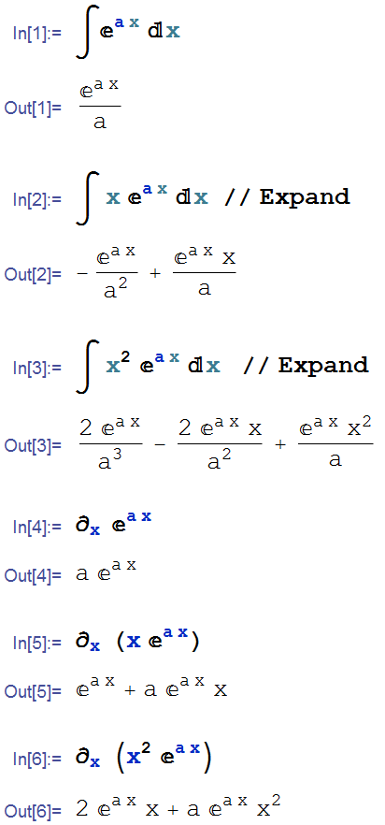

(20 pts) Problem 1: Multiple choice, 2 pts each. Circle the correct answer.

  - Three small charged bodies are placed at the vertices of an equilateral triangle. The electric force F_{e} on the lower right charge is
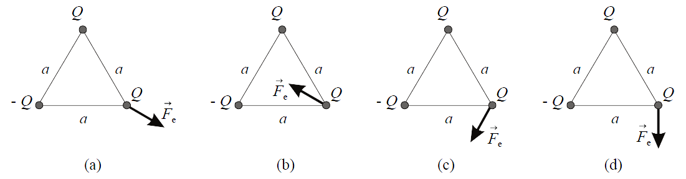
- as in Figure (a).
- as in Figure (b).
- as in Figure (c).
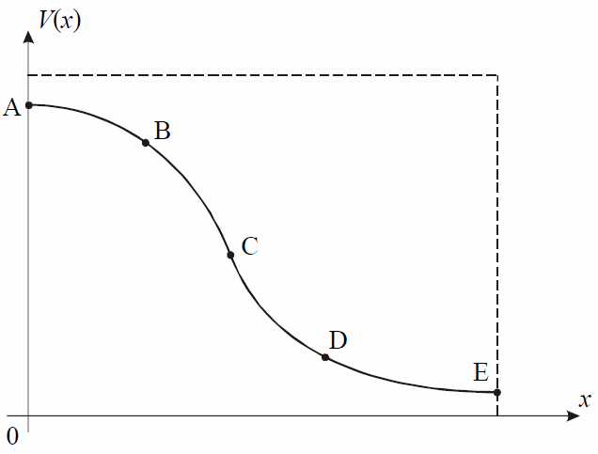
- as in Figure (d).
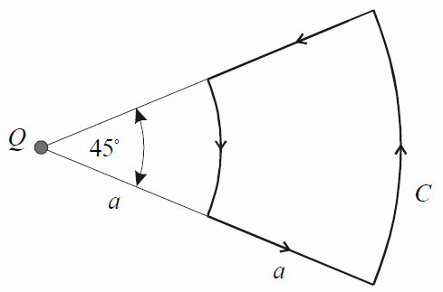
- zero.

  - The electrostatic potential V in a region of space is only a function of x, and V(x) is shown in the figure. Consider the electric field magnitudes at points A, B, C, D, and E. The largest magnitude is at point
- A.
- B.
- C.
- D.
- E.

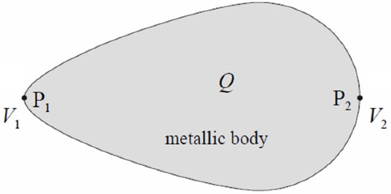
σ₁
σ₂
  - A charged metallic body is situated in free space. The surface charge density and electric potential at a point P₁ of the body are σ₁ and V₁, respectively. At a point P₂, these quantities equal σ₂ and V₂. If the total charge of the body is positive, we have that
- σ₁ = σ₂ and V₁ = V₂.
- σ₁ < σ₂ and V₁ = V₂.
- σ₁ > σ₂ and V₁ = V₂.
- σ₁ < σ₂ and V₁ < V₂.
- σ₁ > σ₂ and V₁ > V₂.

  - If the total charge enclosed inside a Gaussian surface is zero, then E everywhere on the Gaussian surface must be zero.
- True
- False

  - A spherical region (radius R, centered on the origin) has electric field E(r) = 0 throughout. The voltage V(r) must also vanish throughout that region.
- True
- False

  - A spherical region (radius R, centered on the origin) has voltage V(r) = 0 throughout. The electric field E(r) must also vanish throughout that region.
- True
- False

  - If you have a point charge at rest at the point (x₀,y₀,z₀), and no other charges anywhere, then $∇∙E=0$ everywhere in all space.
- True
- False

  - If you have a point charge at rest at the point (x₀,y₀,z₀), and no other charges anywhere, then $∇×E=0$ everywhere in all space.
- True
- False

  - A surface in the x-y plane (i.e. z = 0) has a constant surface charge density σ on it. Just above the surface, the electric field is $+3\hat{z}$ N/C, just below the surface the field is $-3\hat{z}$ N/C. What is the surface charge density σ?
- 3 N/C × ϵ₀
- 3 N/C ÷ ϵ₀
- 6 N/C × ϵ₀
- 6 N/C ÷ ϵ₀
- Zero

  - A negative point charge Q is located in air above a large, flat conducting sheet. The electric field intensity vector in air immediately above the surface of the sheet is

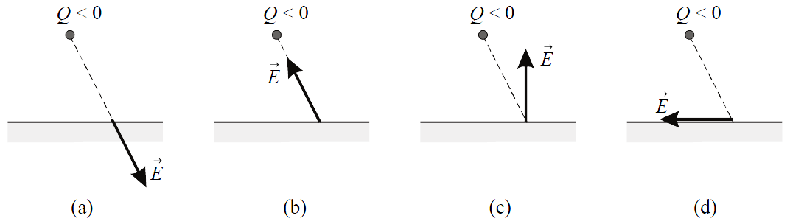

- as in Figure (a).
- as in Figure (b).
- as in Figure (c).
- as in Figure (d).
- zero.

(14 pts) Problem 2: You have a short line of charge on the y-axis from y = 0 to y = L. The linear charge density is λ = k y². Set up the integral that you would need to do in order to directly calculate the electric field E(x,y) for an arbitrary point in the x-y plane. You don’t need to do the integral, just get it into a form that e.g. you could type into Mathematica to get the answer.

· (x, y)
y

L

λ = k y²
x

(16 pts) Problem 3. A sphere of radius R has a spherically-symmetric charge density given by:

$$ρ\left(r\right)=\frac{ρ_{0}e^{-r/R}}{{(r/R)}^{2}}$$

Determine the electric field for the two regions: (i) r < R, (ii) r > R.

(18 pts) Problem 4. Suppose the electric field in the previous problem came out to be:

(Note: those are not the correct answers!)

Find the potential V(r) for the two regions, using the typical convention that V(r = ∞) = 0.

(18 pts) Problem 5. Using the same electric field as the previous problem, namely:

(a) What is the volume charge density ρ which gives rise to this field?
(b) Is there a surface charge density at r = R? Justify your answer.

(14 pts) Problem 6. As mentioned in class, the electromagnetic energy of a point charge diverges (is infinite) due to the r = 0 limit of integration. Because of this result it has been suggested that physical particles (like the electron) are not point particles. One possible model for the electron is that it is a spherical shell of charge with small but nonzero radius, having a constant surface charge density everywhere on the shell. Calculate the radius you get for such an electron by assuming that the total energy stored in the electron’s electric field is equal to Einstein’s equation for the inherent energy of a particle: Energy = mc². (Give a numerical as well as symbolic answer.)

