Spring 2016 barcode here
Physics 441
Exam 3
Dr. Colton, cell: 801-358-1970

No time limit. Student calculators are allowed. One page of notes allowed (front & back). Books not allowed. HANDOUT WITH FRONT AND BACK INSIDE COVERS OF GRIFFITHS TEXTBOOK SHOULD BE PROVIDED.

Name ______________________________

Instructions: Please label & circle/box your answers. Show your work, where appropriate! And remember: in any problems involving Ampere’s Law, you should explicitly show your Amperian loop. There are 100 total points.

You shouldn’t need any special integrals or derivatives.

(20 pts) Problem 1: Multiple choice, 2 pts each. Circle the correct answer.
  - A proton (positive charge) is released from rest in uniform E and B fields. E points up, B points into the page, as shown. Which of the paths will the proton initially follow?
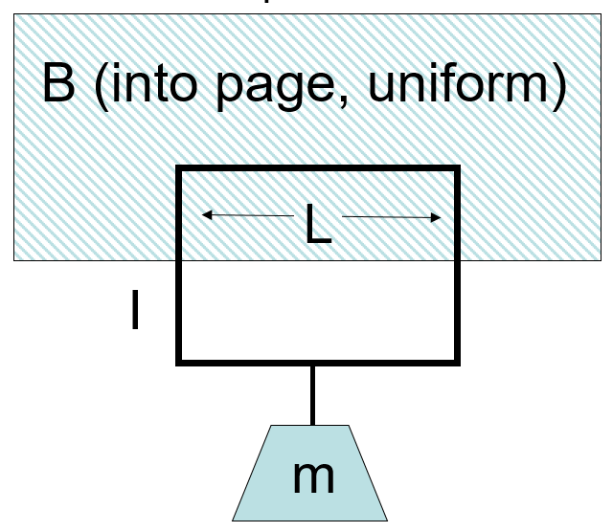
  - A wire loop in a B field has a current I. The magnetic field is localized; it only exists in the hatched region, and is essentially zero everywhere else. Which way must I be flowing to hold the mass in place as shown (gravity points down)?
- Clockwise
- Counter-clockwise
- You cannot “levitate” a mass like this

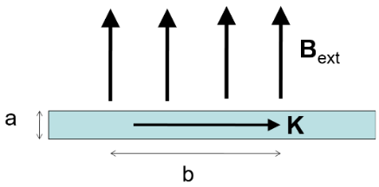
  - A "ribbon" (width a, length b, and infinitely thin in the third dimension) with a uniform surface current density K to the right is in a uniform magnetic field B_{ext}, oriented as shown. What is the magnitude of the force on the ribbon?
- KB_{ext}
- aKB_{ext}
- abKB_{ext}
- bKB_{ext}/a
- KB_{ext}/(ab)
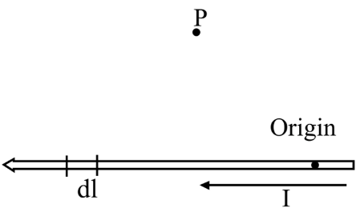

  - To find the magnetic field B at the point P due to a current-carrying wire we use the Biot-Savart law. What is the direction of the infinitesimal contribution dB created by current in the section of wire, dl, that is shown?
- Upwards
- Up and to the left
- Up and to the right
- Downwards
- Down and to the left
- Down and to the right
- Into the page
- Out of the page

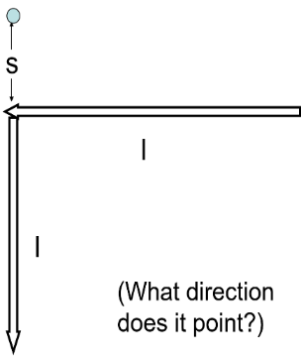
  - A wire makes a 90° bend as shown. The current flows to the left, then downwards. What is the magnitude of the magnetic field created by the wire, at the point shown a distance s above the bend?
- μ₀I/(πs)
- μ₀I/(2πs)
- μ₀I/(4πs)
- μ₀I/(8πs)
- None of the above
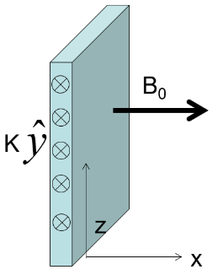
  - A sheet of current with surface current density K in the y-direction as shown serves as a boundary between two regions of space. If $B=B_{0}\hat{x}$ just to the RIGHT of the sheet, in what direction will B be just to the LEFT of the sheet? (The magnetic fields are not solely due to the sheet itself; they are produced in part by additional currents not shown.)
- +x
- –x
- +z
- -z
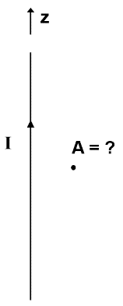
- +y
- –y
- None of the above

  - The vector potential A due to a long straight wire with current I along the z-axis, will be in which direction? (Assume Coulomb gauge, and don’t worry about the sign.)
- $\hat{z}$
- $\hat{ϕ}$
- $\hat{s}$

  - With regards to the vector potential A (in general), which of the following is continuous as you move past a boundary?
- A
- Not all of A, just the perpendicular component
- Not all of A, just the parallel component
- Nothing is guaranteed to be continuous regarding A

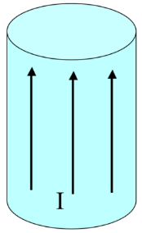
  - A very long aluminum (paramagnetic!) rod carries a uniformly distributed current I along the +z direction. What is the direction of the bound surface current? Hint: the current will set up a B field inside the rod (as well as outside); that B field will induce a magnetization.
- It points parallel to I
- It points antiparallel to I
- It points clockwise (viewed from above)
- It points counter-clockwise (viewed from above)
- It is zero

  - Same situation. What is the direction of the bound volume current?
- It points parallel to I
- It points antiparallel to I
- It points clockwise (viewed from above)
- It points counter-clockwise (viewed from above)
- It is zero
(18 pts) Problem 2. An infinitely long, thick cylindrical shell of inner radius a and outer radius b carries a current given by the combined effects of a volume current density, $J=J_{0}\frac{s^{2}}{b^{2}}\hat{z}$ that exists between a and b, and a surface current density $K=K_{0}\hat{z}$, that exists at s = b. (There is no current inside s = a.) Find B everywhere due to these current densities, in terms of the given quantities.
J
K
a
b
(16 pts) Problem 3. Suppose you have some vector potential, $A=k\hat{ϕ}$, in a region of space.

(a) Find the magnetic field corresponding to that vector potential.

(b) Find the current density corresponding to that vector potential.

(16 pts) Problem 4. A cube of side a is centered on the origin. It is made out of a ferromagnetic material with a permanent magnetization, $M=M_{0}\hat{z}$. (a) What bound currents are implied by this magnetization? Make a sketch and calculate the magnitude(s). (b) Approximately what is the magnetic field produced by this cube at a point, (x, y, z), a large distance away from the cube? You can give your answer in terms of the usual spherical coordinates r, θ, and ϕ.

• (x, y, z)

M

(16 pts) Problem 5. Consider a large compound slab (dimensions w × $l$ × 2b, with w and $l$ both much greater than b) consisting of an inner conductor of thickness 2a carrying a uniform current (current density J = I/2$l$a) in the +y direction, and outer conducting shells located at z = ±b carrying uniform currents (surface current densities K = I/2$l$) in the –y direction. That is, the total current flowing in the +y direction, I, is equal and opposite to the total current flowing in the –y direction. The space between the conductors (a < z < b and –b < z < –a). is filled with a linear paramagnetic material with magnetic susceptibility χ_{m}.

Determine H, B, and M (magnitude and direction) in the region between the inner and upper conductors, i.e. for a < z < b. Since the slab is very very thin, you may use the “infinite slab” assumption.
z
$$K=-I/2l \hat{y}$$
at z = +b

$J=I/2la \hat{y}$
between z = –a and z = +a
$$l$$
w
z = b
z = a
y
x

material with χ_{m}
$K=-I/2l \hat{y}$
at z = –b

(14 pts) Problem 6. A square loop of wire, with sides of length a, lies in the first quadrant of the x-y plane as shown. (The z-direction is out of the page.) In this region there is a non-uniform time-dependent magnetic field $B\left(x,t\right)=kx^{2}t^{3}\hat{z}$ (where k is a positive constant).
x
y

(a) Find the magnitude of the EMF induced in the loop.

(b) In what direction will the induced current flow (CW vs. CCW)? Justify your answer.

