**Fall 2016** barcode here

**Physics 441**

**Exam 1**

**Dr. Colton, cell: 801-358-1970**

**No time limit. Student calculators are allowed. One page of handwritten notes allowed (front & back). Books not allowed. A HANDOUT WITH FRONT AND BACK INSIDE COVERS OF GRIFFITHS TEXTBOOK SHOULD BE PROVIDED. If not, please ask the Testing Center for it and/or have them call me.**

Name ____________________________________

*Instructions:* Please label & circle/box your answers. **Show your work**, where appropriate! And remember: **in any problems involving Gauss’s Law, you should explicitly show your Gaussian surface**. For all problems, unless otherwise specified you may assume that you are dealing with **electrostatics**, i.e. the charges are not moving and the fields have come to equilibrium.

*Integral/derivative table*: One or more of the following integrals and derivatives may or may not be helpful on the exam. If you find yourself needing anything more complicated than this, then you have likely made an error.

( = Mathematica for )

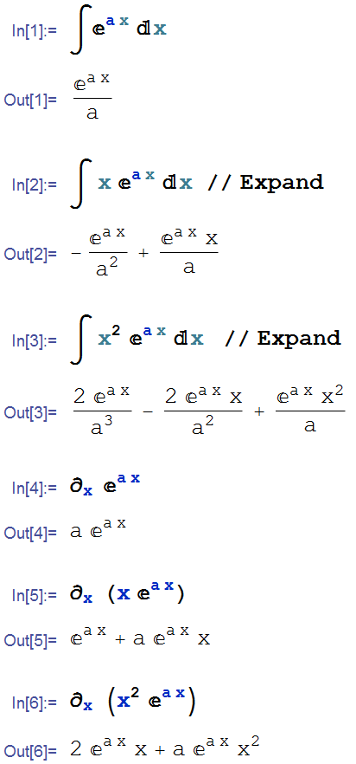

(20 pts) Problem 1: Multiple choice, 2 pts each. Circle the correct answer.

* 1. The electric field lines at a certain location:

1. Never cross
2. Are always parallel to equipotential lines
3. Are always parallel to the electric force on a test charge placed at that location
4. I
5. I and II
6. II and III
7. I and III
8. I, II, and III
   1. A solid, conducting sphere of radius *R* is positively charged. Of the following distances from the center of the sphere, which location will have the greatest electric potential? (Take *V* = 0 at *r* → ∞)
9. 0 (center of the sphere).
10. 1.1 *R*
11. 1.25 *R*
12. 2 *R*
13. None of the above because the potential is constant.
    1. Two charges are assembled as shown below. Which graph correctly depicts values of *Ex* for points along the *x*-axis? (Don’t worry about the numbers, just the shape of the graphs.)

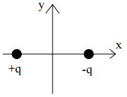

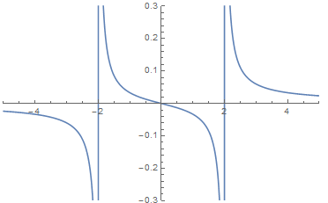

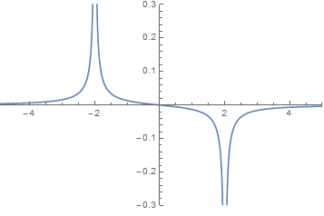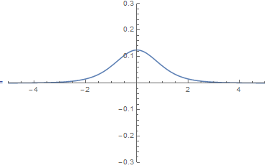(a) (b) (c)

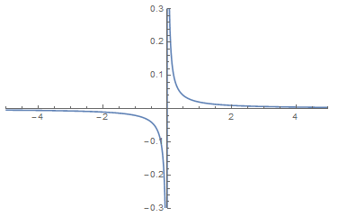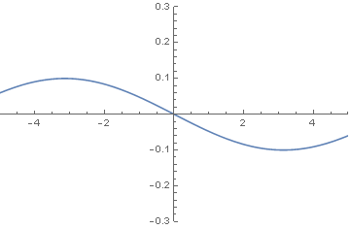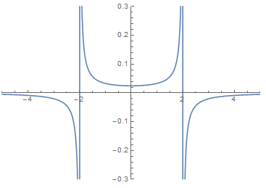

(d) (e) (f)

* 1. Same situation. Which graph correctly depicts values of *Ex* for points along the *y*-axis?





(a) (b) (c)



(d) (e) (f)

* 1. A charge *Q* is placed at the center of the base of a triangular prism (pyramid with five sides as shown). What is the flux in terms of *Q* through the shaded side of the prism?

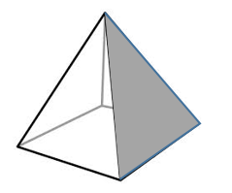

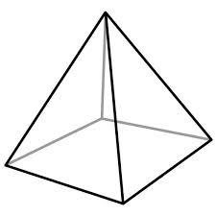

*Q*

* 1. Which of the following does not have symmetry sufficient to use a Gaussian surface to relatively easily find E?
  2. Sphere of constant charge density
  3. Infinite plane of constant charge density
  4. Infinite cylinder of constant charge density
  5. Cube of constant charge density
  6. Infinite line of constant charge density
  7. None of the above (ALL can be solved with a Gaussian surface)
  8. Two opposite charges are placed on a line as show in the figure below.

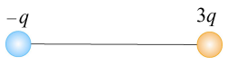

The charge on the right is three times the magnitude of the charge on the left. Besides infinity, where else can the electric field possibly be zero?

1. Between the two charges
2. To the right of the charge on the right
3. To the left of the charge on the left
4. Nowhere else can it be zero
   1. Which of the following conditions allows the electric field to be written as $E=-∇V$, where *V* is the electrostatic potential?
 $∇ ⋅E=0$

 $∇ ⋅E=\frac{ρ}{ε_{0}}$

 $∇ ×E=0$

$F=QE$

${ ϕ}_{E}=\int_{S}{E⋅da}$

2. A conducting shell is placed around the origin. Which of the following is true?
5. Charges inside the shell will not create electric fields outside the shell.
6. Charges outside the shell will not create electric fields inside the shell.
7. I only
8. II only
9. Both I and II
10. Neither I nor II
    1. Rank the work needed to assemble the charge distributions below (i.e. moving the charges in from infinity to be next to each other), from least to greatest. In all cases, the separation between the middle charge and the outer charges are the same.

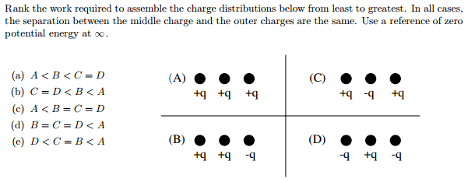

1. A < B < C = D
2. C = D < B < A
3. A < B = C = D
4. B = C = D < A
5. D < C = B < A

(10 pts) **Problem 2**: A volume charge density is given by $ρ\left(x,y,z\right)=c δ\left(x\right)δ(z-2)$.

(a) Sketch the charge distribution and also describe it in a few words.

(b) What are the units of *c*? (Hint: the delta function has units. If you don’t know them offhand, you’ll need to figure them out.)

(12 pts) **Problem 3**: A spherical shell of charge (radius *R*, charge *Q* uniformly distributed on the shell) is at the origin. A point charge (charge *q*) placed outside the sphere is at the coordinates $(x{}_{0}, y_{0}, z_{0})$. What is the electric field **E** at an arbitrary point $(x,y,z)$? Indicate directions via the regular rectangular unit vectors $\hat{x}$, $\hat{y}$, and $\hat{z}$.

(10 pts) Problem 4: A square of charge of side length *L* is centered on the origin as shown. The surface charge density is a function of *x* and *y* as per this equation: *σ* = *kx*2*y*. Set up the integral that you would need to do in order to directly calculate the electric potential for an arbitrary point in the *x-y* plane, *V*(*x*,*y*). You don’t need to do the integral, just get it into a form that e.g. you could type into Mathematica to get the answer.

· (*x*, *y*)

*y*

*x*

** = *kx*2*y*

(14 pts) **Problem 5**. An infinite cylinder of radius *R* has a charge density given by:

$$ρ\left(s\right)=\frac{ρ_{0}e^{-s/R}}{(s/R)}$$

where $ρ_{0}$ has units of charge density (C/m3) and *s* is the usual cylindrical coordinate.

Determine the electric field for the two regions: (i) *s* < *R*, (ii) *s* > *R*.

(7 pts) **Problem 6**. A finite line of charge exists along the x-axis from 0 to *L* as shown. It has a constant linear charge density, *λ*. Without doing any calculations, what should the potential at the point $x_{0}$ be, in the limiting case that $x_{0}≫L$? Don’t just say “it goes to zero”, but rather write down an equation describing *how* it goes to zero in terms of the variables given.

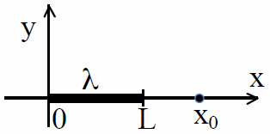

(10 pts) **Problem 7**. A small positive charge (Q = 10-15 C) is located at rest 3 meters above an infinite sheet of negative charge (σ = –102 C/m2). It is released from rest and “falls” towards the sheet. How much kinetic energy will it have when it is 1 meter above the sheet? You may ignore gravity, air resistance, etc.

(17 pts) **Problem 8**. The ionosphere of the Earth is a layer in the atmosphere about 100 km above the surface of the Earth that is made conducting due to the atoms there having been ionized by UV rays from the sun. The ground/ionosphere system for the Earth can be modeled as two concentric conducting spheres at *r*1 = 6400 km (the surface of the Earth) and *r*2 = 6500 km (the ionosphere), that have a potential difference of 300 kV. The Earth’s surface is negatively charged and the ionosphere is positively charged; you may assume that the two charges are equal. Give numerical answers to the following (and be sure to show your work):

* 1. What is the capacitance of the system?
  2. What is the total charge *Q*, and the surface charge density *σ*, of the Earth’s surface?
  3. How much electrical energy is stored in the electric field between the concentric spheres?