**Fall 2017** barcode here

**Physics 441**

**Exam 1**

**Dr. Colton, cell: 801-358-1970**

**No time limit. Student calculators are allowed. One page of handwritten notes allowed (front & back). Books not allowed.**

Name ____________________________________

*Instructions:* Please label & circle/box your answers. **Show your work**, where appropriate! And remember: **in any problems involving Gauss’s Law, you should explicitly show your Gaussian surface**. For all problems, unless otherwise specified you may assume that you are dealing with **electrostatics**, i.e. the charges are not moving and the fields have come to equilibrium.

*Griffiths front and back covers*

|  |  |
| --- | --- |
|  |  |
|  |  |

This “Scriptar” brought to you by Annie. ☺

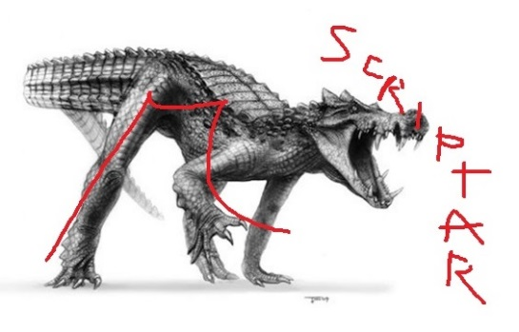

(16 pts) Problem 1: Multiple choice, 2 pts each. Circle the correct answer.

* 1. True/false: A vector field can have non-zero divergence or non-zero curl, but not both.

1. True
2. False
   1. For an infinitesimal dA on the “wrapper” of a cylinder, what would be the appropriate formula to use in cylindrical coordinates?



* 1. This is a plot of a function, $f\left(x\right)$… it’s a “spiky” function centered on 4 that has an area of 1. Indeed, it looks a little like a delta function although it doesn’t spike all the way to infinity. Which of the following is closest to $\int_{0}^{8}{f\left(x\right) e^{-x}dx}$?

1. 0
$\frac{1}{2}e^{-1}$

$e^{-1}$

$\frac{1}{2}e^{-2}$

$e^{-2}$

$\frac{1}{2}e^{-3}$

$e^{-3}$

$\frac{1}{2}e^{-4}$

$e^{-4}$

2. Can’t give an estimate from the information given
   1. Given a surface charge density, $σ\left(s,ϕ\right)=σ_{0}\left(\frac{R}{s}\right)sin⁡(2ϕ)$ that exists as a disk of radius *R* in the *x*-*y* plane, what direction will the electric field be for points on the positive *z*-axis? (Hint: draw a picture.)
$+\hat{x}$

$-\hat{x}$

$+\hat{y}$

$-\hat{y}$

$+\hat{z}$

$-\hat{z}$

3. some other direction
4. zero
   1. Which situation below has the greatest net electric flux through the closed surfaces shown? (All charges are inside the surfaces.)

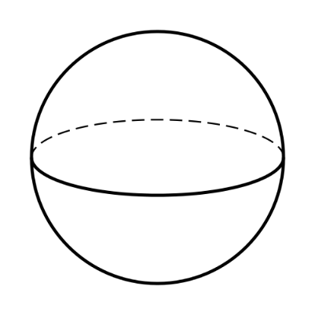

**+q**

R

(1)



**-q**

**+q**

R

**+q**

(3)

(2)

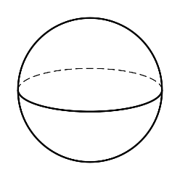

R/2

**+q**

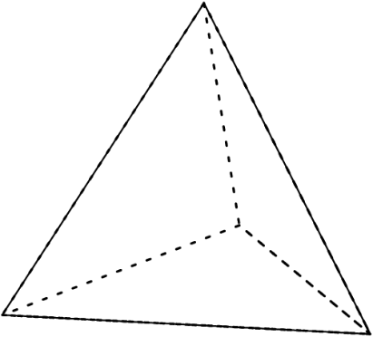

**+q**

R

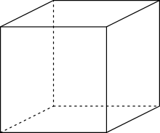

2R

**+q**

(5)

(4)

* + 1. 1
    2. 2
    3. 3
    4. 4
    5. 5
    6. 3 and 4
    7. 1 and 4
    8. 1 and 3
    9. They are all the same

*a*

*R*

*b*

*Q*

* 1. There is a total charge *Q* on the shaded infinitely thin ring (inner diameter *a*, outer diameter *b*) which lies on an otherwise uncharged disc of radius *R* in the *x*-*y* plane. Which of these would be the best method to find the E field in the x-y plane a distance *s* from the origin, for *s* < *R*?
  2. Use Gauss’s law with the Gaussian surface being an infinite cylinder of radius *s*
  3. Use Gauss’s law with the Gaussian surface being a short and squatty “pillbox” of radius *s*
  4. Use direct integration of “d**E**”, with the integral ranging from 0 to *s*
  5. Use direct integration of “d**E**”, with the integral ranging from *a* to *b*

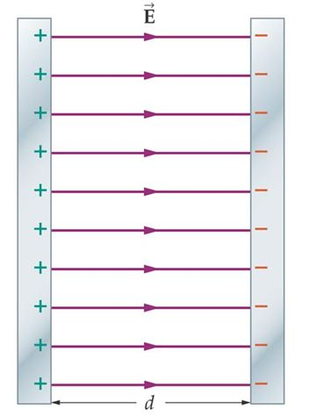

2m



m

(A)

(B)

* 1. A parallel plate capacitor has an electric field E pointing to the right as in the figure. The field is confined to the region between the plates. Suppose two particles with the same charge but with different masses as shown are released from rest at the center of the capacitor and acted upon by the electric field. How would their final kinetic energies compare just before striking the capacitor plates?

1. A > B
2. A < B
3. A = B and nonzero
4. A = B and zero



A

B

V at point A

V at point B

V at points in between A and B is the solid curve

path from A to B is the dashed curve

* 1. A charged particle takes the dashed path from A to B in the *x*-*y* plane, and the potential V that it experiences along that path is plotted as a function of *x* and *y* as the solid curve. What is $\int_{pt A}^{pt B}{∇V∙dl}$ for the particular path shown? (Choose the closest value unless more information is needed in which case choose the last answer. Don’t worry about units, just use the numbers from the plot if you need numbers.)

1. 0
2. 4.5
3. 7.5
4. 10.5
5. 13.5
6. 18.0
7. Can’t tell; it depends on the details of the path

(12 pts) **Problem 2**: For the point shown, (2, 0, 2), what are the following? Put the unit vectors in terms of $\hat{x}$, $\hat{y}$, and $\hat{z}$. You can just write down the answers, no work necessary. Note that $\hat{r}$, $\hat{θ}$, $\hat{ϕ}$, and $\hat{s}$ aren’t always defined when using spherical and cylindrical coordinates. If this is one of those situations for any of those unit vectors, then write that it’s undefined.

*x*

*y*

*z*

* 1. *r* (magnitude)
  2. *θ*
  3. *ϕ*
  4. *s*

$\hat{r}$

$\hat{θ}$

$\hat{ϕ}$

$\hat{s}$

(8 pts) **Problem 3**: What are the SI units of the following? You can just write down the answers, no work necessary.

1. *ρ*
2. *σ*
3. *λ*
4. δ(*x*) (Hint: think of using it in an integral.)
5. δ(3)(**r**)

(10 pts) **Problem 4**: Two point charges of equal but opposite charge are separated by a distance *d*, the +*q* charge being on the left and –*q* on the right. If the negative charge is moved an additional distance *d* to the right, what is the change in potential energy of the system, *U*? Be sure to specify whether the potential energy has increased or decreased.

(12 pts) **Problem 5:** An infinite slab with thickness *d* is centered on the *x*-*y* plane. A cross section is shown. It has charge density $ρ=ρ_{0}{\left(\frac{z}{d}\right)}^{4}$. Determine the electric field *inside* the slab, as a function of *z*, for 0 < z < *d*/2.

*z*

*x-y plane*

$$ρ=ρ_{0}{\left(\frac{z}{d}\right)}^{4}$$

(14 pts) **Problem 6**. In class we talked about a situation with a point charge +*q* surrounded by a spherical conducting shell (inner radius a, outer radius b), and found that induced surface charges would combine with the point charge to produce an electric field like this:

$$r<a: E=\frac{1}{4πϵ_{0}}\frac{q}{r^{2}} \hat{r}$$

$$a<r<b: E=0$$

$$r>b: E=\frac{1}{4πϵ_{0}}\frac{q}{r^{2}} \hat{r}$$

Determine the electric *potential* as a function of *r* for the same three regions, using the usual convention that the potential is zero at infinity.

(14 pts) **Problem 7**. (a) Show that the electromagnetic energy stored in the field of a point charge is infinite, if the particle is truly a point. (b) Because of this result it has been suggested that physical particles (like the electron) are not point particles but instead have some finite extent. One possible model for the electron is that it is a spherical shell of charge, having a small but nonzero radius *R*. Let’s assume it has a constant surface charge density everywhere on the shell, $σ=\frac{e}{4πR^{2}}$. Calculate this radius *R* (sometimes called the “classical radius of the electron”), assuming that the total energy of the electron’s electric field is equal to Einstein’s equation for the inherent rest energy of a particle: $E=mc^{2}$. Give a symbolic answer to this, but if you want to check your answer you can also put it in numerical form—it should be in the femtometer range (10-15 m). *Note*: strictly speaking, the “classical radius of the electron” is actually twice the value you get by this calculation—the usual calculation assumes a solid sphere of uniform charge density rather than a spherical shell as in this problem.

(14 pts) **Problem 8**. Find the capacitance per length of a pair of concentric cylinders, infinite in length, the inner one having radius *a* and the outer one having radius *b*. (Yes, this is exactly like a HW problem.)