**Fall 2018** barcode here

**Physics 441**

**Exam 1**

**Dr. Colton, cell: 801-358-1970**

**No time limit. Student calculators are allowed. One page of handwritten notes allowed (front & back). Books not allowed.**

Name ____________________________________

*Instructions:* Please label & circle/box your answers. **Show your work**, where appropriate! And remember: **in any problems involving Gauss’s Law, you should explicitly show your Gaussian surface**. For all problems, unless otherwise specified you may assume that you are dealing with **electrostatics**, i.e. the charges are not moving and the fields have come to equilibrium.

*Griffiths front and back covers*

(similar things true for 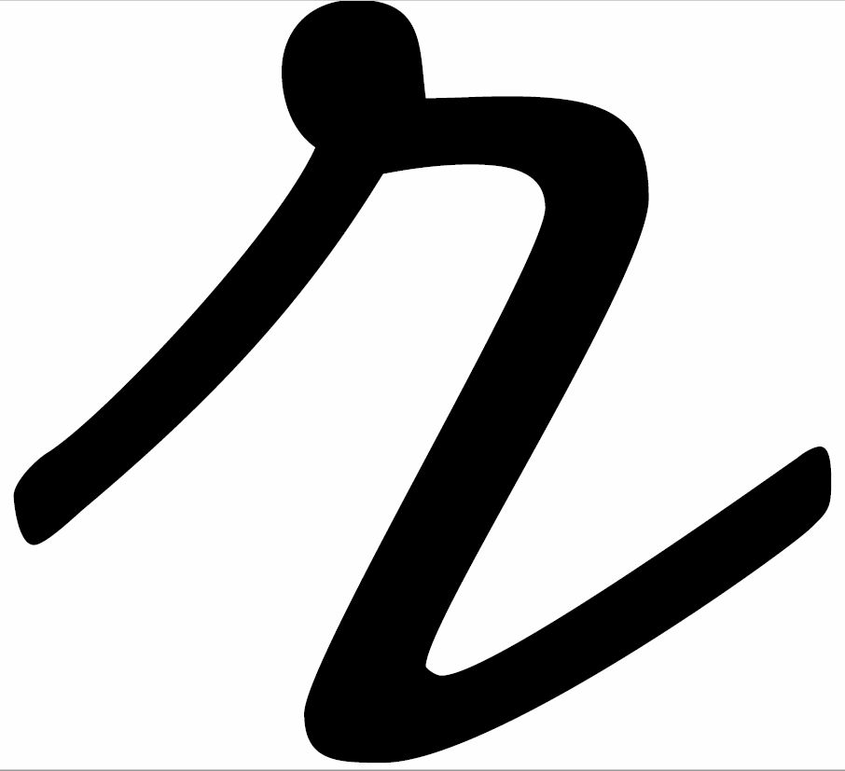)

|  |  |
| --- | --- |
| Special case derivatives: $$∇∙\frac{\hat{r}}{r^{2}}=4πδ(r)$$ $$∇^{2}\frac{1}{r}=-4πδ(r)$$ |  |
|  |  |

Some miscellaneous mathematical stuff:

$\sin^{2}{x}=\frac{1}{2}-\frac{1}{2}\cos{2x}$ $\cos^{2}{x}=\frac{1}{2}+\frac{1}{2}\cos{2x}$

Some indefinite integrals:

$\int{\sin{Cx}}=\frac{-\cos{Cx}}{C}$ $\int{\sin^{2}{Cx}}=\frac{x}{2}-\frac{\sin{2Cx}}{4C}$

$\int{\cos{Cx}}=\frac{\sin{Cx}}{C}$ $\int{\cos^{2}{Cx}}=\frac{x}{2}+\frac{\sin{2Cx}}{4C}$

Some definite integrals:

$\int_{0}^{a}{\sin\left(\frac{nπx}{a}\right)\sin\left(\frac{mπx}{a}\right)dx}=\left\{\begin{matrix}0, if n≠m \\ \frac{\begin{aligned} \\ a\end{aligned}}{2}, if n=m\end{matrix}\right.$

$\int_{0}^{π}{\sin^{2}{x}dx}=\frac{π}{2}$ $\int_{0}^{π}{\cos^{2}{x}dx}=\frac{π}{2}$ $\int_{0}^{2π}{\sin^{2}{x}dx}=π$ $\int_{0}^{2π}{\cos^{2}{x}dx}=π$

$\int_{0}^{π}{\sin^{3}{x}dx}=\frac{4}{3}$ $\int_{0}^{π}{\cos^{3}{x}dx}=0$ $\int_{0}^{2π}{\sin^{3}{x}dx}=0$ $\int_{0}^{2π}{\cos^{3}{x}dx}=0$

$\int_{0}^{π}{\sin^{4}{x}dx}=\frac{3π}{8}$ $\int_{0}^{π}{\cos^{4}{x}dx}=\frac{3π}{8}$ $\int_{0}^{2π}{\sin^{4}{x}dx}=\frac{3π}{4}$ $\int_{0}^{2π}{\cos^{4}{x}dx}=\frac{3π}{4}$

(27 pts) **Problem 1**. Multiple choice, 1.5 pts each. Circle the correct answers for the multiple choice questions.

* 1. For an infinitesimal dA on the “wrapper” of a cylinder, what would be the appropriate formula to use in cylindrical coordinates?
 $s ds dϕ \hat{s}$

 $s ds dϕ \hat{ϕ}$

$s ds dϕ \hat{z}$

$s dϕdz \hat{s}$

$s dϕdz \hat{ϕ}$

$s dϕdz \hat{z}$

2. For an infinitesimal dA on the top of a cylinder, what would be the appropriate formula to use in cylindrical coordinates?
 $s ds dϕ \hat{s}$

 $s ds dϕ \hat{ϕ}$

$s ds dϕ \hat{z}$

$s dϕdz \hat{s}$

$s dϕdz \hat{ϕ}$

$s dϕdz \hat{z}$

3. What are the units of δ(*x*) if *x* is measured in meters?

1. δ is dimensionless (no units)
2. [m]: Unit of length
3. [m2]: Unit of length squared
4. [m-1]: One over unit of length
5. [m-2]: One over unit of length squared
   1. The plot to the side is of the function $f\left(x\right)$… it’s a “spiky” function centered on 4 that has an area of 1. Indeed, it looks a little like a delta function although it doesn’t spike all the way to infinity. Which of the following will be closest to ?
6. 0

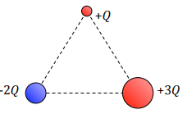

* 1. Three point charges, of charge *+Q*, *-2Q*, and *+3Q*, are placed equidistant as shown. Which vector best describes the net direction of the electric field acting on the *+Q* charge?

1. 
2. 
3. 
4. 
5. 
   1. A point charge is placed at the center of a spherical Gaussian surface. The net electric flux passing through the surface will changed for which of the following situations:
6. The sphere is replaced by a cube of the same volume.
7. The sphere is replaced by a cube of one-tenth the volume.
8. The point charge is moved to a location within the sphere but close to the surface.
9. The point charge is moved to a location just outside the sphere.
10. A second point charge is placed just outside the sphere.
    1. Which would be the better way to calculate the electric field produced by a solid cube of charge?
11. Coulomb’s law
12. Gauss’s law
    1. T/F: For an arbitrary region of space, a zero *ρ* inside the region implies a zero E.
13. True
14. False
    1. T/F: For an arbitrary region of space, a zero *ρ* inside the region implies a zero *V*.
15. True
16. False
    1. T/F: For an arbitrary region of space, a zero E inside the region implies a zero *ρ*.
17. True
18. False
    1. T/F: For an arbitrary region of space, a zero E inside the region implies a zero *V*.
19. True
20. False
    1. T/F: For an arbitrary region of space, a zero *V* inside the region implies a zero *ρ*.
21. True
22. False
    1. T/F: For an arbitrary region of space, a zero *V* inside the region implies a zero E.
23. True
24. False
    1. Which of the following is correct?
25. **E** and *V* are both always continuous across a boundary
26. **E** is always continuous, but *V* can be discontinuous
27. **E** can be discontinuous, but *V* is always continuous
28. **E** and *V* can both be discontinuous

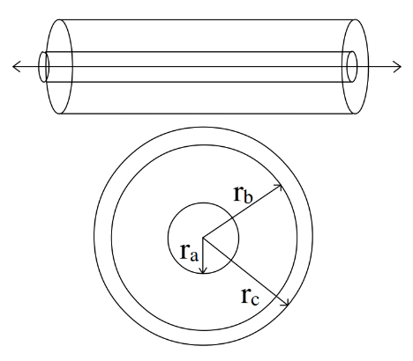

* 1. Consider a metal cylindrical shell of outer radius *rc* and inner radius *rb* which is concentric with a metal wire of radius *ra*. The linear charge density of the wire is +*λ* and the linear charge density of the cylinder is –*λ*. Which of the following statement(s) is (are) true?

1. The potential difference between *rc* and *rb* is zero.
2. The potential difference between *rb* and *ra* is zero.
3. The potential difference between a point outside the cylinder and *rc* is zero.
4. The electric field between a point outside the cylinder and *rc* is zero.
5. I and III
6. I and IV
7. II and III
8. II and IV
9. I, III and IV
10. II, III, and IV
11. I, II, III, and IV
    1. Which of the following statements regarding conductors in electric fields (static situations) is false?
12. The electric field inside any solid conductor is always zero.
13. The value of the electrostatic potential is the same at all points inside of, and on the surface of, a conductor of any shape.
14. Any excess charge placed on an isolated solid conductor will always move to the outside surface of that conductor.
15. The surface charge density (charge per unit area) on the surface of a conductor is always largest near sharp points.
16. The electric field at the surface of a conductor is always perpendicular to the surface of that conductor.
17. None (they are all true)

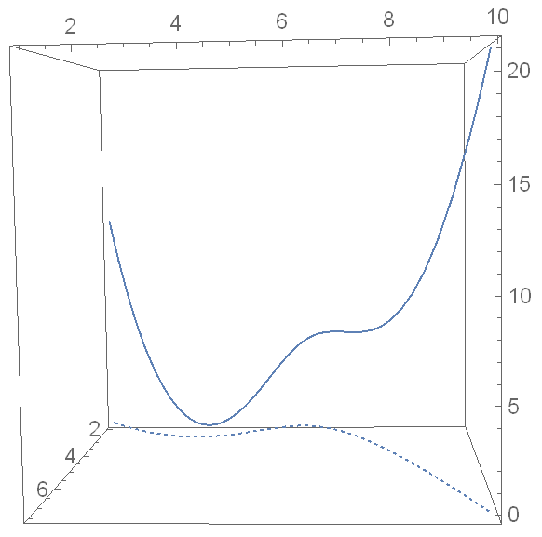

V at point A

V at point B

The potential at points from A to B is the solid curve

The path from A to B is the dashed curve, in the x-y plane

Point A

Point B

Point C

V at

point C

* 1. A charged particle takes the dashed path from A to B in the *x*-*y* plane, and the potential V that it experiences along that path is plotted as a function of *x* and *y* as the solid curve. What is $\int_{pt A}^{pt B}{∇V∙dl}$ for the particular path shown? (Choose the closest value.) Don’t worry about units, just use the numbers from the plot if you need numbers.

1. 0
2. 8.5
3. 12.5
4. 21.0
5. 22.5
6. Can’t tell; need more information
   1. For the same plot, what direction is the electric field at point C?
$\hat{x}$

$-\hat{x}$

$\hat{y}$

$-\hat{y}$

$\hat{z}$

$-\hat{z}$

8. Can’t tell; need more information

(6 pts) Problem 2. Short answers.

(a) In terms of $\hat{x}$, $\hat{y}$, and $\hat{z}$, what is $\hat{r}$ for the point (1, 2, 3)?

(b) In terms of $\hat{x}$, $\hat{y}$, and $\hat{z}$, what is $\hat{s}$ for the point (1, 2, 3)?

(c) Draw the electric field lines in the region between and around two opposite charges of unequal magnitudes, one having charge *q* and the other –2*q*.

(12 pts) **Problem 3.** A charge *q* is at the location (2, 3, 4) as shown by the dot. Consider a “test point” at (2, 4, –2) (not shown).

Part 1: What are the following? Put your vector answers in terms of $\hat{x}$, $\hat{y}$, and $\hat{z}$.

*x*

*y*

*z*

1. **r** (vector)
2. **r′** (vector)
3.  (vector)
4.  (scalar)

Part 2: Draw the test point on the graph above, and also draw in the three vectors from Part 1.

(14 pts) **Problem 4**: An infinite slab with thickness 2*d* is centered on the *x*-*y* plane. A section is shown. It has charge density $ρ=ρ_{0}\cos\left(\frac{πz}{2d}\right)$. Determine the electric field *inside* the slab, both magnitude and direction, as a function of *z*, for 0 < z < *d*.

(15 pts) **Problem 5**. A disc of charge with radius *R* lies in the *x-y* plane, centered on the *z*-axis as shown. Its charge density is: $σ=σ_{0}\left(\frac{s}{R}\right)\cos\left(3ϕ\right)$. Set up an integral that you could use to calculate the electric potential *V* at the point indicated, (*R*, 0, *h*). Please don’t do the integral, just set it up. Make sure all quantities in your integral are explicitly written in terms of constants, the given variables, or variables of integration.

*x*

*y*

*z*

(*R*, 0, *h*)

(12 pts) **Problem 6**. Don’t worry about units in this problem. The electric field in a given region of space is given in spherical coordinates by $E=\left(C_{1}r^{2}+C_{2}\right)\hat{r}$, where $C_{1}$ and $C_{2}$ are positive numbers. Find the potential difference between $r=5$ and $r=3$, and state which point is at the higher potential.

(14 pts) **Problem 7**. Find the capacitance per length of a pair of concentric conducting cylinders, infinite in length, the inner one having radius *a* and the outer one having radius *b*. (Yes, this is exactly like a HW problem.)