**Fall 2016** barcode here

**Physics 441**

**Exam 2**

**Dr. Colton, cell: 801-358-1970**

**No time limit. Student calculators are allowed. One page of handwritten notes allowed (front & back). Books not allowed. A HANDOUT WITH FRONT AND BACK INSIDE COVERS OF GRIFFITHS TEXTBOOK SHOULD BE PROVIDED. If not, please ask the Testing Center for it and/or have them call me.**

Name ____________________________________

*Instructions:* Please label & circle/box your answers. **Show your work**, where appropriate! And remember: **in any problems involving Gauss’s Law, you should explicitly show your Gaussian surface**. For all problems, unless otherwise specified you may assume that you are dealing with **electrostatics**, i.e. the charges are not moving and the fields have come to equilibrium.

*Integral/derivative table*: One or more of the following integrals or derivatives may or may not be helpful on the exam. If you find yourself needing anything more complicated than this, then you have likely made an error.

( = Mathematica for )

Some Legendre polynomials:

P0(*x*) = 1

P1(*x*) = *x*

P2(*x*) = 3/2 *x*2 – 1/2

P3(*x*) = 5/2 *x*3 – 3/2 *x*

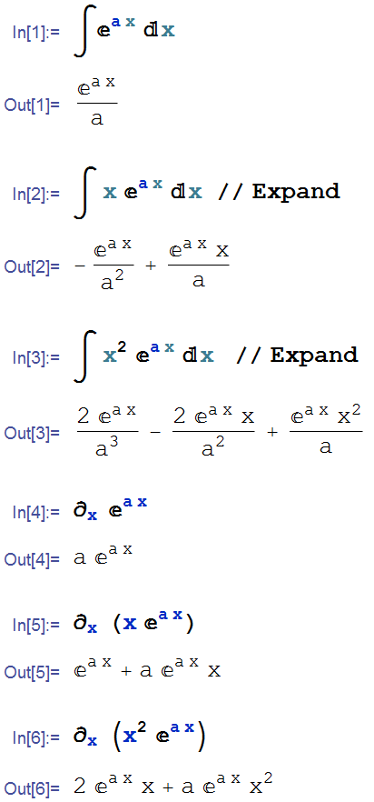

Orthogonality of the Legendre polynomials:

$$\int_{-1}^{1}{P_{l}\left(x\right)}P_{m}\left(x\right)dx =\left\{\begin{matrix}0 if l≠m \\ \\ \frac{2}{2l+1} if l=m\end{matrix}\right.$$

$$\int_{0}^{π}{P_{l}\left(\cos{θ}\right)}P_{m}\left(\cos{θ}\right)\sin{θ}dθ =\left\{\begin{matrix}0 if l≠m \\ \\ \frac{2}{2l+1} if l=m\end{matrix}\right.$$

Orthogonality of the sine functions:

$$\int_{0}^{1}{\sin\left(nπx\right)\sin\left(mπx\right)dx} =\left\{\begin{matrix}0 if n≠m \\ \\ 1/2 if n=m\end{matrix}\right.$$

$$\int_{0}^{2π}{\sin\left(nx\right)\sin\left(mx\right)dx} =\left\{\begin{matrix}0 if n≠m \\ \\ 1/2 if n=m\end{matrix}\right.$$

(20 pts) Problem 1: Multiple choice, 2 pts each. Circle the correct answer.

* 1. A charge *q* is near two infinite grounded planes that run along the positive *x* and *y* axes as depicted below.

*+q*

What collection of image charges would map the same potential?

(a) (b) (c) (d)

*+q*

*–q*

*+q*

*+q*

*–q*

*–q*

*–q*

*+q*

*–q*

*–q*

*+q*

*–q*

*+q*

*–q*

(e) (f) (g) (h)

None of them.

*+q*

*+q*

*+q*

*–q*

*+q*

*+q*

*+q*

* 1. In class we solved Laplace’s equation in 2D, obtaining *V*(*x*, *y*). You have also worked one or more 2D problems for homework. Which of the following is true about situations like that where we can write *V* is a function of *x* and *y* only?

1. The third dimension must be infinitely thin.
2. The third dimension must be infinitely long.
3. Such a potential is just a mathematical construct; it has no physical basis in reality.
   1. 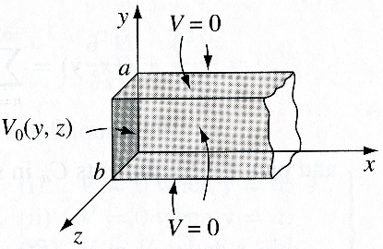An infinitely long rectangular metal pipe (sides *a* and *b*) is grounded, but one end, at *x* = 0, is maintained at a specified potential $V_{0}\left(y,z\right).$ See the figure.

The potential can be described through the general equation:

$V\left(x,y,z\right)=\left(Ae^{\sqrt{k^{2}+l^{2}}x}+Be^{-\sqrt{k^{2}+l^{2}}x}\right)\left(C\sin{ky}+D\cos{ky}\right)\left(E\sin{lz}+F\cos{lz}\right)$

Which of the following is true about the constants in the equation?

1. A = 0
2. D = 0
3. F = 0
4. $k=\frac{nπ}{a}$ (where *n* = an integer)
5. I only
6. I and II only
7. I and III only
8. I and IV only
9. II and III only
10. II and IV only
11. III and IV only
12. I, II, and III only
13. I, II, and IV only
14. I, III, and IV only
15. II, III, and IV only
16. I, II, III, and IV



A

B

* 1. Points A and B are the same large distance from an electric dipole, but in different directions as per the figure. The dipole is depicted by the arrow (dipole moment in the direction of the arrow). What is true of the magnitude of the E field at point A compared to point B?

$\left|{\overset{⃑}{E}}_{a}\right|=0$

$\left|{\overset{⃑}{E}}_{b}\right|=0$

$\left|{\overset{⃑}{E}}_{a}\right| and \left|{\overset{⃑}{E}}_{b}\right| both=0$

1. $\left|{\overset{⃑}{E}}_{a}\right|>\left|{\overset{⃑}{E}}_{b}\right|$ (and $\left|{\overset{⃑}{E}}_{b}\right|≠0$)
2. $\left|{\overset{⃑}{E}}_{a}\right|<\left|{\overset{⃑}{E}}_{b}\right|$ (and $\left|{\overset{⃑}{E}}_{a}\right|≠0$)
3. $\left|{\overset{⃑}{E}}_{a}\right|=\left|{\overset{⃑}{E}}_{b}\right|$ (and neither one is zero)
   1. Which of the following configurations would have the fastest “fall off” of the electric field with *r*, for regions far from the charges? (The spheres are not conducting.)



(a) (b) (c) (d)



(e) (f) It’s a tie between more than one of them.

* 1. What does the “polarization” of a material describe?
     1. The net amount of charge in a unit volume, changing throughout the region of space
     2. A conductor’s ability to fluctuate its net charge from positive to negative continuously
     3. Leakage of excess charge in a densely charged area or “pole” of a material
     4. The vector sum of all dipole moments per small volume element at various points within a material
     5. The displacement from equilibrium position due to free charges in a material
  2. Which of the following is true of the displacement field, D?
  3. It is determined solely by the free volume charge density, *ρfree*.
  4. It represents the electric field created by the bound charges.
  5. **D** field lines must begin and end on surface charges
  6. The **D** field is only non-zero in regions where there is polarization of charges.
  7. More than one of the above.

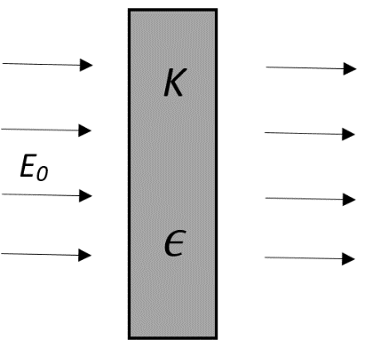

* 1. An infinite slab of insulating material with dielectric constant *K* and permittivity $ϵ=ϵ_{0}K$ is placed in a uniform electric field of magnitude *E*0. The field is perpendicular to the surface of the material, as shown in the figure. What is the magnitude of the electric field inside the material?

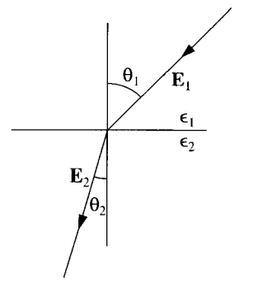

* 1. The following diagram depicts how the E-field changes across the boundary of two linear dielectric mediums. What can be said about $ϵ_{1}$ and $ϵ_{2}?$ Assume there are no free charges at the boundary and $θ_{1}=45°$. (Careful: even though the figure looks a bit like optical refraction, these are not light rays.)

$ϵ_{1}{>ϵ}_{2}$

$ϵ_{1}<ϵ_{2}$

$ϵ_{1}=ϵ_{2}$

$ϵ_{1}=0$

$ϵ_{2}=0$

(14 pts) **Problem 2**: A thin insulating spherical shell (radius *R*) has auniform surface charge density **0 coating it. The center of the sphere is fixed at a distance *d* above the center of an infinite, grounded conducting plate.



(a) Find the potential *V* for an arbitrary point (*x*, *y*, *z*) that lies *inside* the spherical shell. Use the specified origin of coordinates.

(b) Sketch the electric field lines on the figure above. Or, you can reproduce the figure and sketch here.

(16 pts) **Problem 3**: A sphere of radius *R* has potential $V=V_{0}\cos^{2}{θ}$ on its surface. Find the potential as a function of *r* and **, for points *outside* the sphere. Hint: first find $\cos^{2}{θ}$ in terms of the Legendre polynomials in *θ*. See the first page of the exam.

(16 pts) **Problem 4**: A sphere of radius *R* centered on the origin carries a surface charge density of *σ*0cos**. Find the approximate potential and the field for this charge distribution for points along the y-axis (0, 0, *y*), where |*y|* ≫ *R*.

(11 pts) **Problem 5**. A finite cylindrical shell of length *L*, inner radius *a*, and outer radius *b* carries a polarization $P=ks\hat{s}$, where *k* is a constant and *s* is the usual cylindrical coordinate. Calculate the bound charges *σb* (on all four surfaces) and *ρb*.

(12 pts) **Problem 6**. A point charge (+*q*) is at the origin. It is surrounded by a spherical dielectric shell (dielectric constant *r*) with inner radius *a* and outer radius *b*. (a) Determine ***D*** in the three regions: (i) *r*< *a*, (ii) *a* < *r* <*b*, and (iii) *r* > *b*. (b) Determine ***E*** in the same three regions.

*+q*

(13 pts) **Problem 7**. A spherical conductor of radius *a*, carries a charge *Q* as shown below. It is surrounded by a linear dielectric material of susceptibility $χ_{e}$, which extends out to radius *b*. Find the energy stored in the electric field for this configuration in terms of the variables given.

*Q*

*b*

*a*

$$χ_{e}$$