Fall 2017 barcode here
Physics 441
Exam 2
Dr. Colton, cell: 801-358-1970

No time limit. Student calculators are allowed. One page of handwritten notes allowed (front & back). Books not allowed.

Name ____________________________________

Instructions: Please label & circle/box your answers. Show your work, where appropriate! And remember: in any problems involving Gauss’s Law, you should explicitly show your Gaussian surface. For all problems, unless otherwise specified you may assume that you are dealing with electrostatics, i.e. the charges are not moving and the fields have come to equilibrium, and that all dielectrics are linear and isotropic.

Griffiths front and back covers
(similar things true for )
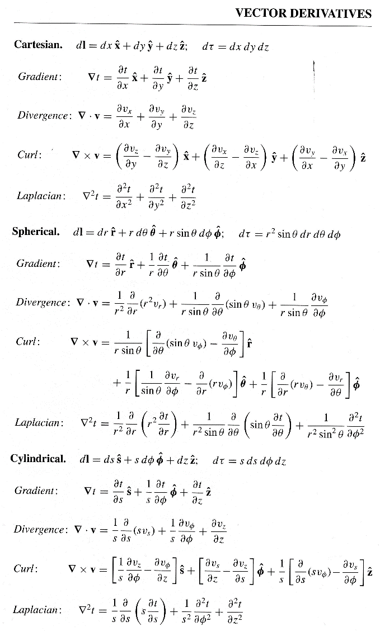  Special case derivatives:  $$∇∙\frac{\hat{r}}{r^{2}}=4πδ(r)$$  $$∇^{2}\frac{1}{r}=-4πδ(r)$$ | 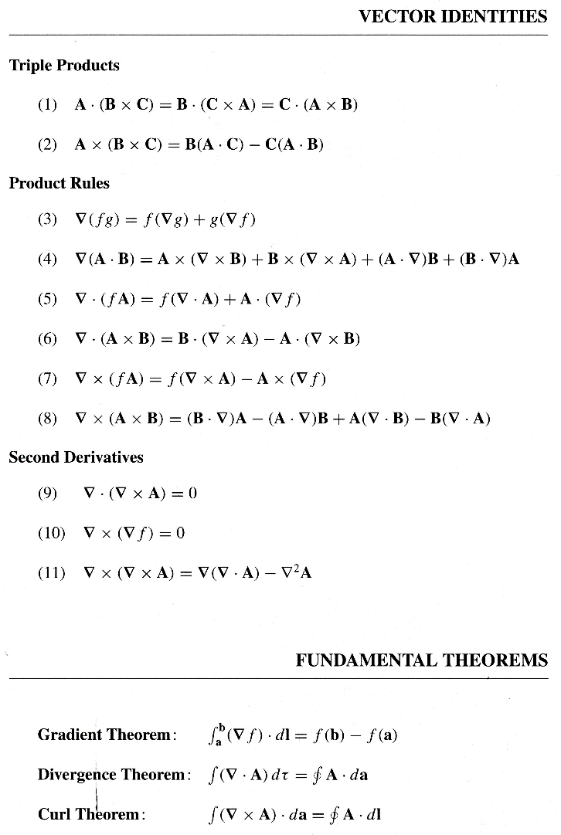
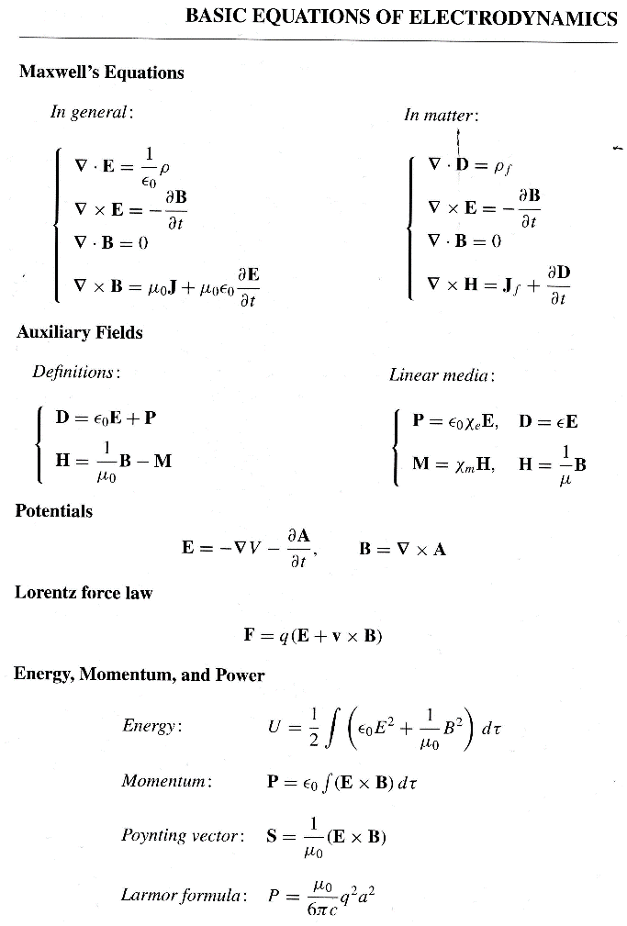 | 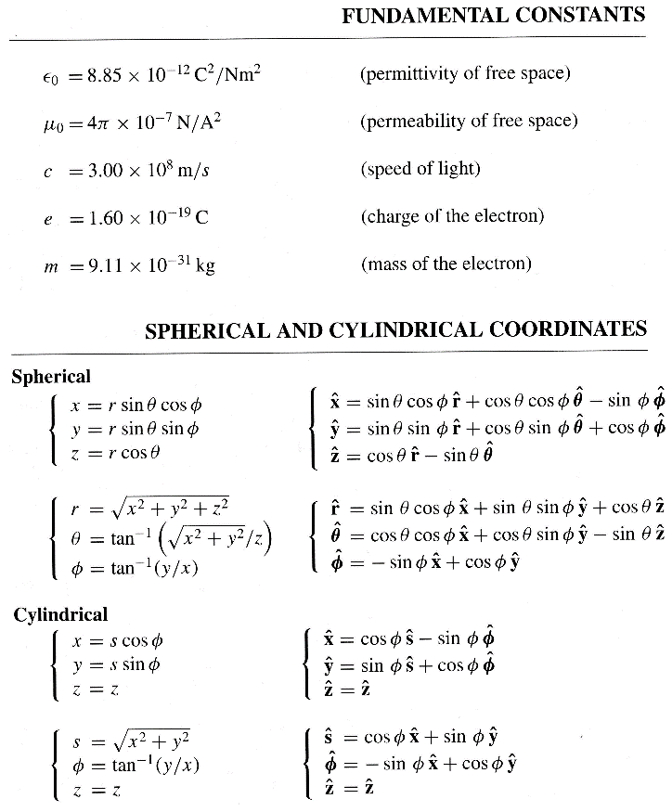

Some miscellaneous mathematical stuff:

$\int_{0}^{a}{\sin\left(\frac{nπx}{a}\right)\sin\left(\frac{mπx}{a}\right)dx}=\left\{\begin{matrix}0, if n≠m \\ \frac{\begin{aligned} \\ a\end{aligned}}{2}, if n=m\end{matrix}\right.$

$\sin^{2}{x}=\frac{1}{2}-\frac{1}{2}\cos{2x}$
$\cos^{2}{x}=\frac{1}{2}+\frac{1}{2}\cos{2x}$

$\int_{-1}^{1}{P_{l}\left(x\right)}P_{m}\left(x\right)dx =\left\{\begin{matrix}0, if l≠m \\ \\ \frac{2}{2l+1}, if l=m\end{matrix}\right.$ $\int_{0}^{π}{P_{l}\left(\cos{θ}\right)}P_{m}\left(\cos{θ}\right)\sin{θ}dθ =\left\{\begin{matrix}0, if l≠m \\ \\ \frac{2}{2l+1}, if l=m\end{matrix}\right.$

$P_{l}\left(x\right)$ are the Legendre polynomials; the first few are these:

$P_{0}\left(x\right)=1$

$$P_{1}\left(x\right)=x$$

$P_{2}\left(x\right)=\frac{3}{2}x^{2}-\frac{1}{2}$
$P_{3}\left(x\right)=\frac{5}{2}x^{3}-\frac{3}{2}x$

$P_{4}\left(x\right)=\frac{35}{8}x^{4}-\frac{15}{4}x^{2}+\frac{3}{8}$

Some definite integrals:
$\int_{0}^{π}{\sin^{2}{x}dx}=\frac{π}{2}$ $\int_{0}^{π}{\cos^{2}{x}dx}=\frac{π}{2}$ $\int_{0}^{2π}{\sin^{2}{x}dx}=π$ $\int_{0}^{2π}{\cos^{2}{x}dx}=π$
$\int_{0}^{π}{\sin^{3}{x}dx}=\frac{4}{3}$ $\int_{0}^{π}{\cos^{3}{x}dx}=0$ $\int_{0}^{2π}{\sin^{3}{x}dx}=0$ $\int_{0}^{2π}{\cos^{3}{x}dx}=0$
$\int_{0}^{π}{\sin^{4}{x}dx}=\frac{3π}{8}$ $\int_{0}^{π}{\cos^{4}{x}dx}=\frac{3π}{8}$ $\int_{0}^{2π}{\sin^{4}{x}dx}=\frac{3π}{4}$ $\int_{0}^{2π}{\cos^{4}{x}dx}=\frac{3π}{4}$

(16 pts) Problem 1: Multiple choice, 2 pts each. Circle the correct answer.

  - For an infinitesimal dA on the top surface of a cylinder, what would be the appropriate formula to use in cylindrical coordinates?
- $s ds dϕ \hat{s}$
- $s ds dϕ \hat{ϕ}$
- $s ds dϕ \hat{z}$
- $s dϕdz \hat{s}$
- $s dϕdz \hat{ϕ}$
- $s dϕdz \hat{z}$

  - A potential varies as $1/r^{3}$. Which of the following could it be?
- A monopole potential
- A dipole potential
- A quadrupole potential
- An octopole potential
- A higher order potential

  - A spherical surface of radius R is somehow maintained at the following potential: $V\left(θ\right)=V_{0}\left(\cos^{4}{θ}+1\right)$. The formula for the potential inside the surface will involve:
- An infinite sum of Legendre polynomials in $\cos{θ}$.
- A finite sum of Legendre polynomials in $\cos{θ}$.
- An infinite sum of sines/cosines and/or exponentials.
- A finite sum of sines/cosines and/or exponentials.

  - A cube of side length a is somehow maintained at the following potential: V = 0 for all sides except for one, and is a constant $V_{0}$ on that side. The formula for the potential inside the surface will involve:
- An infinite sum of Legendre polynomials in $\cos{θ}$.
- A finite sum of Legendre polynomials in $\cos{θ}$.
- An infinite sum of sines/cosines and/or exponentials.
- A finite sum of sines/cosines and/or exponentials.

  - A dielectric is placed in an external electric field whose magnitude was E₀ before the dielectric was put in the region. (Initially the region contained only a vacuum.) Which is true about the total electric field inside the dielectric, E_{tot}?
- E_{tot} < E₀, and they are in the same direction
- E_{tot} = E₀, and they are in the same direction
- E_{tot} > E₀, and they are in the same direction
- E_{tot} < E₀, and they are in the opposite direction
- E_{tot} = E₀, and they are in the opposite direction
- E_{tot} > E₀, and they are in the opposite direction

  - Same situation. D₀ is the magnitude of the D field before the dielectric was put in the region. What is true about the total D field inside the dielectric, D_{tot}? (Assume no edge effects, if it matters.)
- D_{tot} < D₀, and they are in the same direction
- D_{tot} = D₀, and they are in the same direction
- D_{tot} > D₀, and they are in the same direction
- D_{tot} < D₀, and they are in the opposite direction
- D_{tot} = D₀, and they are in the opposite direction
- D_{tot} > D₀, and they are in the opposite direction

These last two aren’t multiple choice questions but they seemed to fit best here, and each one counts 2 pts like the multiple choice questions.

X
p

  - Given a dipole moment p and point X as shown in the figure, what is the direction of $\hat{r}$ as must be used in the dipole electric field equation, namely $E=\frac{1}{4πϵ_{0}}\frac{p}{r^{3}}\left(2\cos{θ} \hat{r}+\sin{θ}\hat{θ}\right)$? Draw the $\hat{r}$ direction on the figure just above.

X
p

  - Same situation… what is the direction of $\hat{θ}$? Draw the $\hat{θ}$ direction on the figure just above.

(9 pts) Problem 2: Short answers—use words, not equations. Or at most, perhaps a single equation in a supplementary role.

(a) Briefly explain how/why the method of relaxation works.

(b) Briefly explain why you may generally stop at the first non-zero term when solving problems with the multipole expansion.

(c) Briefly explain what the polarization field, P, means.

(11 pts) Problem 3: Two charges are above a grounded conducting plane: charge +q a distance d above the plane, and another charge +q a distance d directly above that (i.e. 2d from the plane). What is the net force on the upper charge?

(16 pts) Problem 4: An insulating spherical shell has potential on its surface (at r = R) given by $V\left(R,θ\right)=V_{0}\cos^{2}{θ }$. Find $V\left(r,θ\right)$ for all points outside the shell. Hint: your first step could be to use page 2 of the exam to find $\cos^{2}{θ }$ in terms of Legendre polynomials.

(16 pts) Problem 5: An insulating spherical shell (radius R) has a surface charge density of $σ\left(R,θ\right)=σ_{0}\sin^{2}{θ }\cos{ϕ}$. The sphere has no net charge, but it does have a dipole moment.

(a) Make a sketch of the shell, indicating where the charges will be positive, negative and zero, and use that to deduce the direction of the dipole moment. Or, if your sketching ability is not up to it, describe very carefully with words where the charges will be positive, negative, and zero, and what that means for the direction of the dipole moment.

(b) Calculate the dipole moment, hopefully using your answer to part (a) to help you avoid some work. Hint: there are some definite integrals given on page 2 of the exam; one or more should be helpful.

(16 pts) Problem 6. An infinitely long cylinder (radius R) has a built-in polarization given by $P(s)=P_{0}\left(\frac{s}{R}\right)\hat{s}$. There are no free charges present.

(a) Find the bound volume and surface charge densities.

(b) Determine E(s) inside the cylinder via Gauss’s Law for E.

(problem continues on next page)
(c) Determine E(s) inside the cylinder via Gauss’s Law for D, and the equation $D=ϵ_{0}E+P$. If you do things correctly your answers to (b) and (c) will agree.

(16 pts) Problem 7. A spherical capacitor is made by putting dielectric (relative permittivity $ϵ_{r}$) between two concentric spherical conductors as shown.
conductor, radius b
conductor, radius a
dielectric, $ϵ_{r}$

(a) Find the capacitance of the system.

(b) Find the polarization function P(r) for the dielectric in terms of the given quantities.

(problem continues on next page)
(c) The bound volume charge density is zero (you don’t have to verify this). Find the bound surface charge densities at the inner and outer surfaces of the dielectric.

(d) Verify that the total bound charge is zero.

(xx pts) Problem xx. (a) A spherical cavity (hole) of radius $R$ exists in a large dielectric, as shown. There is an electric field inside the dielectric, $E=E_{0}\hat{z}$, which is causing a constant polarization, $P$, also in the $\hat{z}$ direction. Therefore there are bound charges in the dielectric, on the surface of the sphere. Show that the surface bound charge density $σ_{b}=-P\cos{θ}$. Then find the electric field at the center of the sphere due to that $σ$ via the “script r” method of integration, in terms of $P$. (The total electric field at the center of the sphere would be this answer, plus $E_{0}\hat{z}$.) Hint: draw the bound charges on the sphere in the picture; in what direction does symmetry require the field to be?

(continued on next page)
(b) The previous situation is a model for the region around an atom in a linear, isotropic, homogeneous solid. Close to the atom there is nothing else around (or equivalently, contributions from nearby charges will tend to cancel out), but beyond a certain distance, i.e. $R$, the macroscopic effects from polarization can be felt. This model gives us a way to derive a correspondence between the microscopic polarizability of the atom, $α$, and the macroscopic susceptibility of the solid, $χ_{E}$. On the one hand, the microscopic polarizability is defined by $p=αE$ where $p$ is the induced dipole moment of the atom. On the other hand, the macroscopic polarization field is caused by all the dipoles acting together and is the collection of all the dipole moments, per volume: $P=np$ where $n$ is the number of atoms per volume. As you know, the susceptibility is also defined by $P=ϵ_{0}χ_{E}E$. However, the appropriate $E$ to use in the $p=αE$ equation is the microscopic $E$, namely $E_{0}\hat{z}$ plus your answer to part (a); whereas the appropriate E to use in the $P=ϵ_{0}χ_{E}E$ equation is the macroscopic $E$, namely just $E_{0}\hat{z}$. Use those equations and concepts, along with your answer to part (a), to derive an equation for $α$ in terms of $χ_{E}$. Your answer should be $α=$ stuff that only depends on $χ_{E}$, $ϵ_{0}$, and $n$.

