Fall 2017 barcode here
Physics 441
Exam 3
Dr. Colton, cell: 801-358-1970

No time limit. Student calculators are allowed. One page of handwritten notes allowed (front & back). Books not allowed.

Name ____________________________________

Instructions: Please label & circle/box your answers. Show your work, where appropriate! And remember: in any problems involving Gauss’s Law/Ampere’s Law, you should explicitly show your Gaussian surface/Amperian loop. For all problems, unless otherwise specified you may assume that you are dealing with electrostatics, i.e. the charges are not moving and the fields have come to equilibrium, and that all dielectrics are linear and isotropic.

Griffiths front and back covers
(similar things true for 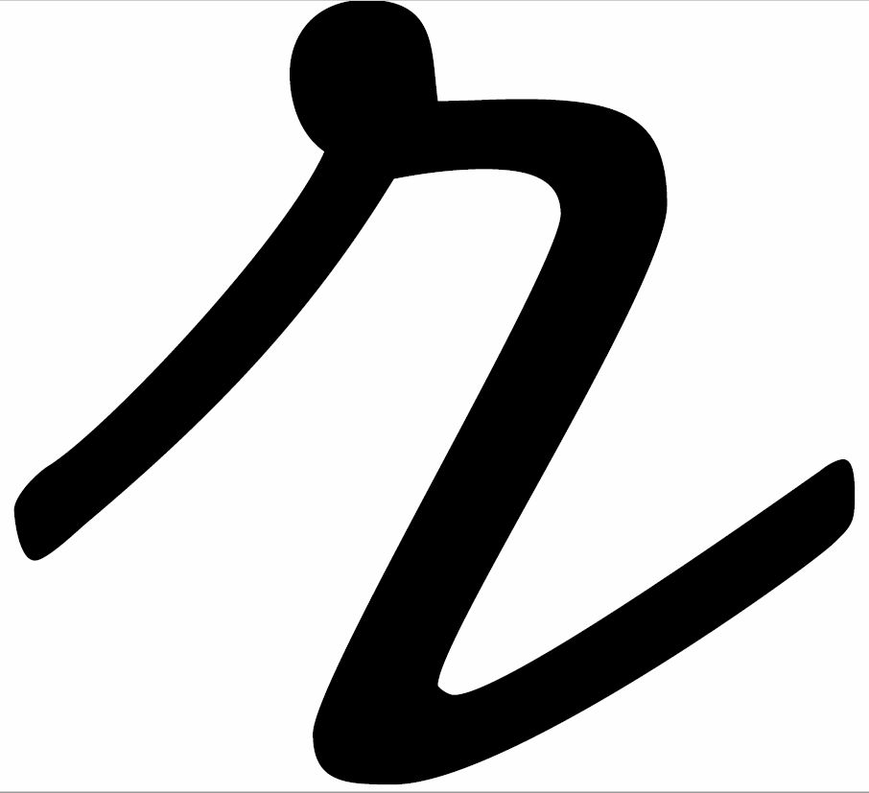)
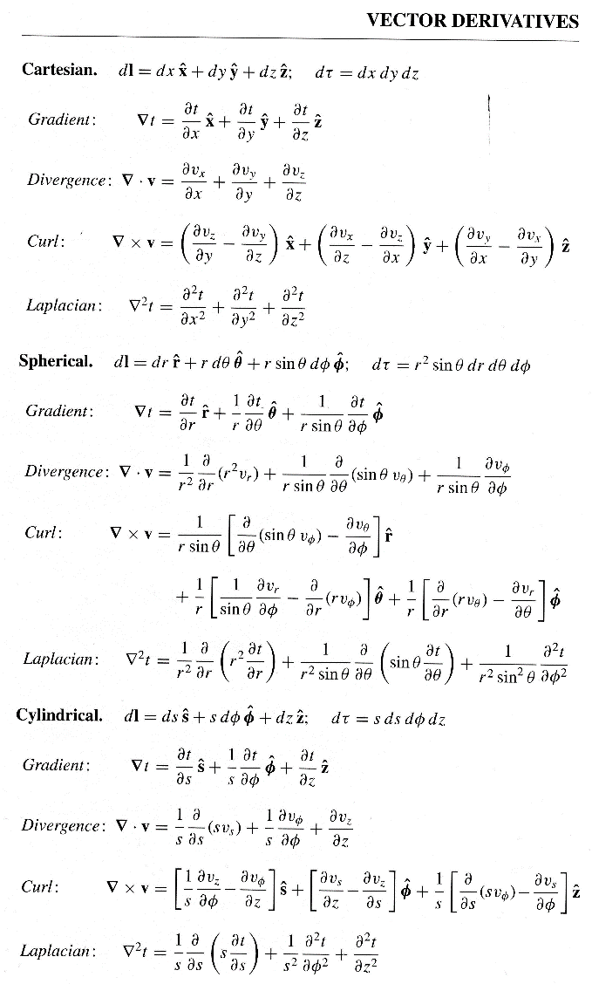  Special case derivatives:  $$∇∙\frac{\hat{r}}{r^{2}}=4πδ(r)$$  $$∇^{2}\frac{1}{r}=-4πδ(r)$$ | 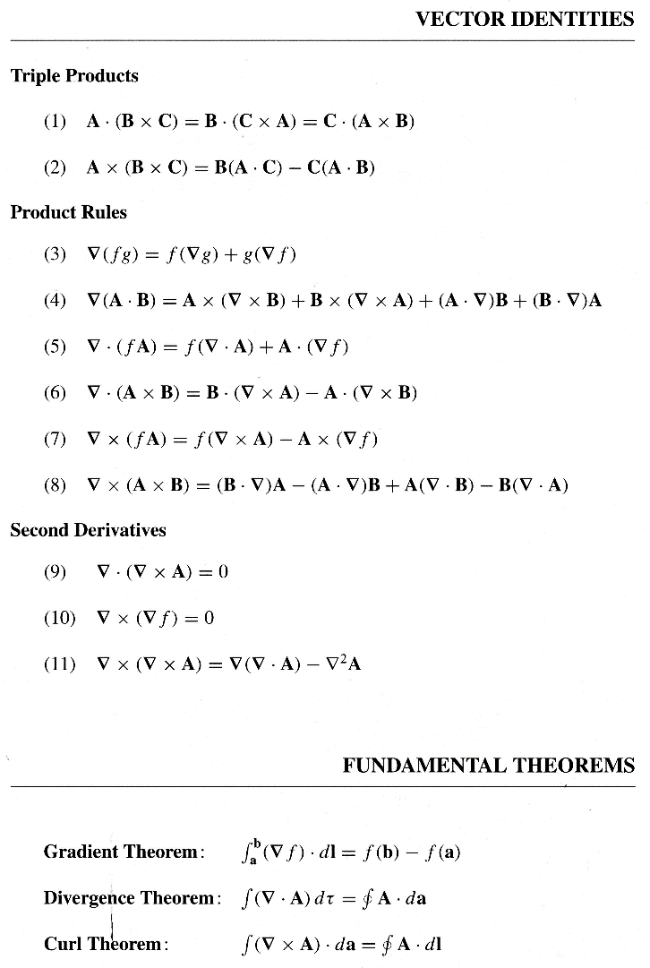
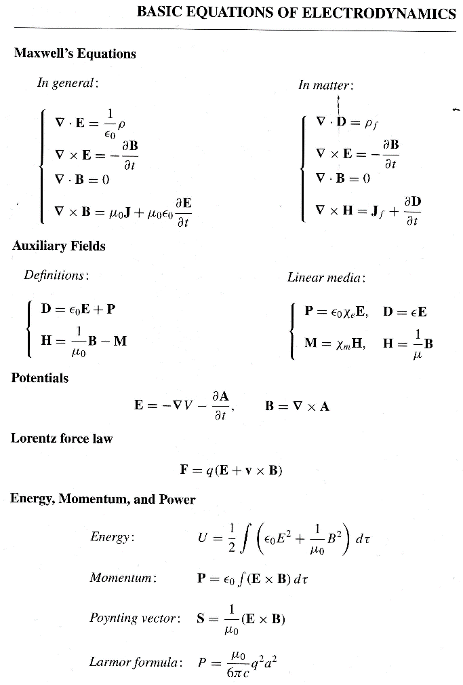 | 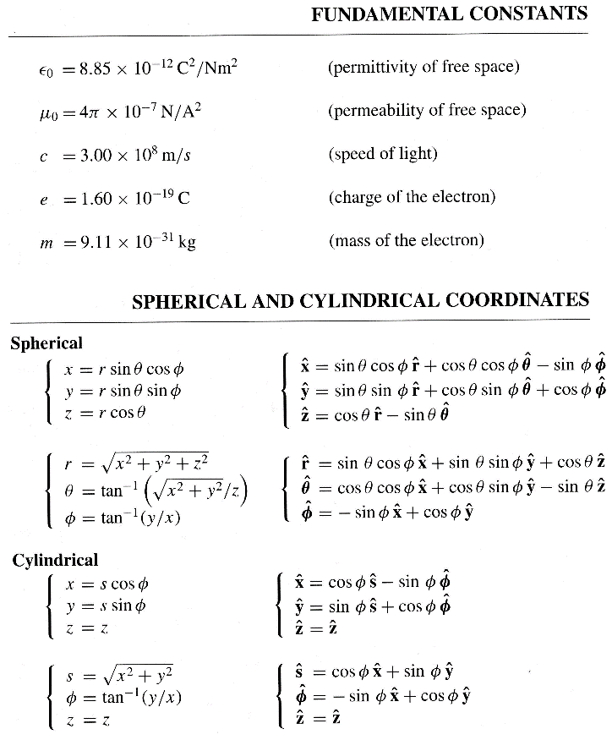

Some miscellaneous mathematical stuff:

$\int_{0}^{a}{\sin\left(\frac{nπx}{a}\right)\sin\left(\frac{mπx}{a}\right)dx}=\left\{\begin{matrix}0, if n≠m \\ \frac{\begin{aligned} \\ a\end{aligned}}{2}, if n=m\end{matrix}\right.$

$\sin^{2}{x}=\frac{1}{2}-\frac{1}{2}\cos{2x}$
$\cos^{2}{x}=\frac{1}{2}+\frac{1}{2}\cos{2x}$

$\int_{-1}^{1}{P_{l}\left(x\right)}P_{m}\left(x\right)dx =\left\{\begin{matrix}0, if l≠m \\ \\ \frac{2}{2l+1}, if l=m\end{matrix}\right.$ $\int_{0}^{π}{P_{l}\left(\cos{θ}\right)}P_{m}\left(\cos{θ}\right)\sin{θ}dθ =\left\{\begin{matrix}0, if l≠m \\ \\ \frac{2}{2l+1}, if l=m\end{matrix}\right.$

$P_{l}\left(x\right)$ are the Legendre polynomials; the first few are these:

$P_{0}\left(x\right)=1$

$$P_{1}\left(x\right)=x$$

$P_{2}\left(x\right)=\frac{3}{2}x^{2}-\frac{1}{2}$
$P_{3}\left(x\right)=\frac{5}{2}x^{3}-\frac{3}{2}x$

$P_{4}\left(x\right)=\frac{35}{8}x^{4}-\frac{15}{4}x^{2}+\frac{3}{8}$

Some definite integrals:
$\int_{0}^{π}{\sin^{2}{x}dx}=\frac{π}{2}$ $\int_{0}^{π}{\cos^{2}{x}dx}=\frac{π}{2}$ $\int_{0}^{2π}{\sin^{2}{x}dx}=π$ $\int_{0}^{2π}{\cos^{2}{x}dx}=π$
$\int_{0}^{π}{\sin^{3}{x}dx}=\frac{4}{3}$ $\int_{0}^{π}{\cos^{3}{x}dx}=0$ $\int_{0}^{2π}{\sin^{3}{x}dx}=0$ $\int_{0}^{2π}{\cos^{3}{x}dx}=0$
$\int_{0}^{π}{\sin^{4}{x}dx}=\frac{3π}{8}$ $\int_{0}^{π}{\cos^{4}{x}dx}=\frac{3π}{8}$ $\int_{0}^{2π}{\sin^{4}{x}dx}=\frac{3π}{4}$ $\int_{0}^{2π}{\cos^{4}{x}dx}=\frac{3π}{4}$

(20 pts) Problem 1: Multiple choice, 2 pts each. Circle the correct answer.

  - A surface current $K=K \hat{y}$ flows within a finite rectangle in the x-y plane as shown. The rectangle goes from –a to +a in the x-direction and –b to +b in the y-direction. How should you set up the integral to calculate the amount of current flowing?
y
x
K
- $I=\int_{-a}^{a}{Kdx}$
- $I=\int_{-b}^{b}{Kdy}$
- $I=\int_{-a}^{a}{\int_{-b}^{b}{Kdydx}}$

  - True/False: $∇∙J$ is nonzero and positive for a region of space, the charge density in that region must necessarily be decreasing.
- True
- False

  - A trajectory of a positive particle is shown. Please forgive the artwork. To help you see the 3D nature of the path the way I intend, I have indicated some places where the particle’s path is behind the y-axis and some places where the path is in front. Alternately, viewed from the right, the path is counter-clockwise. There is no electric field present (aside from that created by the particle itself). In which direction is the magnetic field?
y
x
z
Path in front of the y-axis
Path behind the y-axis
- $+\hat{x}$
- $–\hat{x}$
- $+\hat{y}$
- $-\hat{y}$
- $+\hat{z}$
- $-\hat{z}$

  - Same coordinate axes as the previous problem. According to the Lorentz force, what general direction is the force of wire 1 on wire 2? The wires are finite; the arrows indicate both the length of the segment of wire as well as the direction of positive current flow.
wire 1
wire 2
- $+\hat{x}$
- $–\hat{x}$
- $+\hat{y}$
- $-\hat{y}$
- $+\hat{z}$
- $-\hat{z}$

  - Same situation, what direction is the force of wire 2 on wire 1? Hint: as we will learn next semester Newton’s Third Law doesn’t apply in electricity and magnetism quite the way you learned it in Physics 121.
- $+\hat{x}$
- $–\hat{x}$
- $+\hat{y}$
- $-\hat{y}$
- $+\hat{z}$
- $-\hat{z}$

  - A current runs in the$+\hat{z}$ direction. In which direction is the vector potential A?
- $+\hat{s}$
- $–\hat{s}$
- $+\hat{ϕ}$
- $-\hat{ϕ}$
- $+\hat{z}$
- $-\hat{z}$

  - What are the units of the magnetization M? (T = tesla, A = ampere)
- T
- T/m
- T/m²
- T⋅m
- T⋅m²
- A
- A/m
- A/m²
- A⋅m
- A⋅m²
- None of the above
- More than one of the above

  - True/False: Ampere’s Law for H means that whenever you have I_{free} = 0, H will also be 0.
- True
- False

  - Assuming that there is no free surface current on the boundary between the two magnetic media shown, which of the figures represents possible magnetic field intensity vectors on the two sides of the boundary? The B₁ and B₂ arrows represent magnetic fields just below and just above the boundary, respectively (where the arrows begin).
B₁
μ_{r1} = 4
μ_{r2} = 2
(b)
B₂
B₁
μ_{r1} = 4
μ_{r2} = 2
(a)
B₂

B₁
μ_{r1} = 4
μ_{r2} = 2
(c)
B₂
B₁
μ_{r1} = 4
μ_{r2} = 2
(d)
B₂

B₁
μ_{r1} = 4
μ_{r2} = 2
(e)
B₂
B₁
μ_{r1} = 4
μ_{r2} = 2
(f)
B₂
  - Ampere’s Law, written as $∇×B=μ_{0}J$, is ___________ with the rule that the divergence of the curl of a vector field must necessarily be zero.
- always consistent
- never consistent
- consistent if ρ = constant in time
- not consistent if ρ = constant in time
(9 pts) Problem 2: Short answers.

(a) Write out explicitly in Cartesian coordinates what is mean by $\vec{∇}(m∙B)$. Simplify as much as possible.

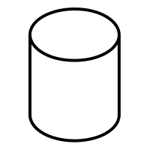
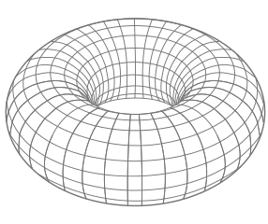
(b) Draw an appropriate Amperian loop on each figure for the indicated magnetization M, magnetic field B, and current I.
$$\vec{M}$$
ii. torus with magnetic field $\vec{B}$ in the $\hat{ϕ}$ direction.
iii. infinite plane of wires with current I coming out of the page.
$$\vec{B}$$
i. cylinder with magnetization $\vec{M}$ in the $\hat{z}$ direction.

(c) A piece of initially unmagnetized material is placed inside a solenoid. Sketch the general shape of the magnetization as a function of solenoid current as the current is increased from zero, for (1) paramagnetic, (2) diamagnetic, and (3) ferromagnetic materials.
(3)
I
M
(2)
I
M
I
M
(1)

(14 pts) Problem 3: Use the Biot-Savart law to determine the magnetic field of a current loop (radius R, current I) a distance z above its center along the axis of symmetry. The current is counter-clockwise as viewed from above.
B = ?
z

(14 pts) Problem 4: Later in life you make the (questionable?) career choice of becoming a university professor and you are assigned to teach Physics 441. A student comes to you after you teach the unit on the vector potential A, and says, “I think I have figured out the vector potential field for an infinite solenoid!” The solenoid has radius R and the magnetic field inside the solenoid is a constant $B_{0}\hat{z}$ (field outside the solenoid is zero). The student shows you this:

$$A=\left\{\begin{matrix}\frac{B_{0}s}{2}\hat{ϕ}, s<R \\ \frac{B_{0}R^{2}}{2s}\hat{ϕ}, s>R\end{matrix}\right.$$

(a) Prove whether or not this is a correct vector potential for the solenoid field.

(b) Regardless of whether this is the correct A for the situation, prove whether or not this vector potential is in the Coulomb gauge.

(14 pts) Problem 5: A thick cylindrical shell with inner radius R₁ and outer radius R₂ and extending infinitely in the z-direction has a built-in magnetization between R₁ and R₂ given by: $M=M_{0}\frac{R_{1}}{s}\hat{ϕ}$.

(a) Calculate the bound currents on the two surfaces and inside the volume of the shell.

(b) Using either Ampere’s law for B or for H (or both, if you want to check yourself), calculate the magnetic field as a function of s inside the shell, i.e. for R₁ < s < R₂.

(15 pts) Problem 6. A rectangular loop of wire spans a region of space where the magnetic field abruptly goes from being zero to being constant in space, as shown. The dimensions of the loop are shown and there is a resistor, resistance R, as part of the loop.

No magnetic field Magnetic field present

× × × × ×
× × × × ×
× × × × ×
y₀
resistor

x₀

The rectangular loop is pushed to the right at speed v without deforming it. At the same time the B-field increases in magnitude with time according to $B=B_{0}{\left(\frac{t}{τ}\right)}^{2}\hat{z}$ where $\hat{z}$ is into the page and τ is a positive constant.

(a) What direction is the current through the resistor? (up or down) Show your work and/or explain your logic; no credit for answers with no work/explanation.

(b) What is the current through the resistor as a function of time, assuming that at time $t=0$ exactly half of the rectangle is inside the field (as shown)?

(14 pts) Problem 7. The charge of a capacitor (parallel circular plates with area A, electric field in the $\hat{z}$direction) is decreasing according to $Q=Q_{0}e^{-t/τ}$, where Q₀ and τ are positive constants). Determine the induced magnetic field, both magnitude and direction.

