Fall 2018 barcode here
Physics 441
Exam 3
Dr. Colton, cell: 801-358-1970

No time limit. Student calculators are allowed. One page of handwritten notes allowed (front & back). Books not allowed.

Name ____________________________________

Instructions: Please label & circle/box your answers. Show your work, where appropriate! Remember: in any problems involving Gauss’s or Ampere’s Laws, you should explicitly show your Gaussian surface/Amperian loop. For all problems, unless otherwise specified you may assume that you are dealing with electrostatics, i.e. the charges are not moving and the fields have come to equilibrium, and that any/all vector potentials are in the Coulomb gauge.

Griffiths front and back covers
(similar things true for 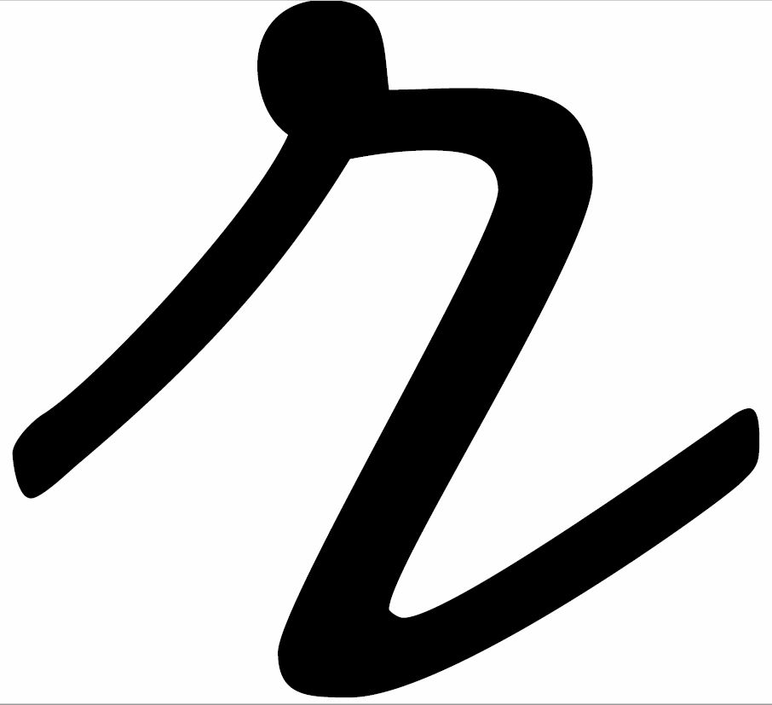)
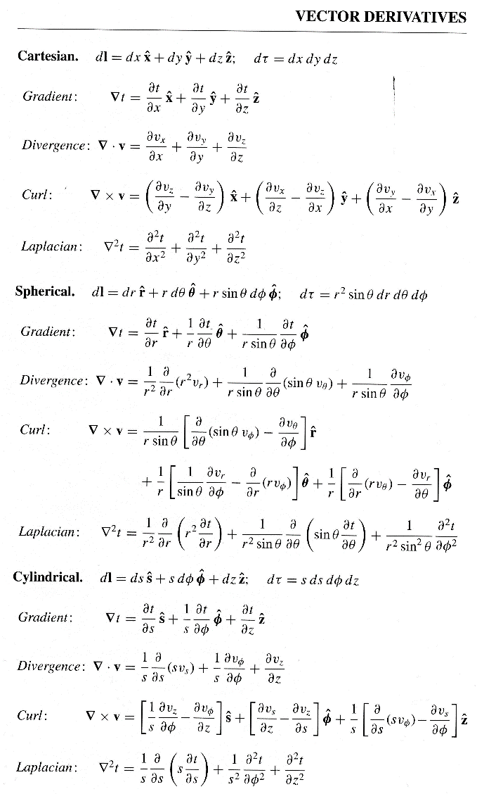  Special case derivatives:  $$∇∙\frac{\hat{r}}{r^{2}}=4πδ(r)$$  $$∇^{2}\frac{1}{r}=-4πδ(r)$$ | 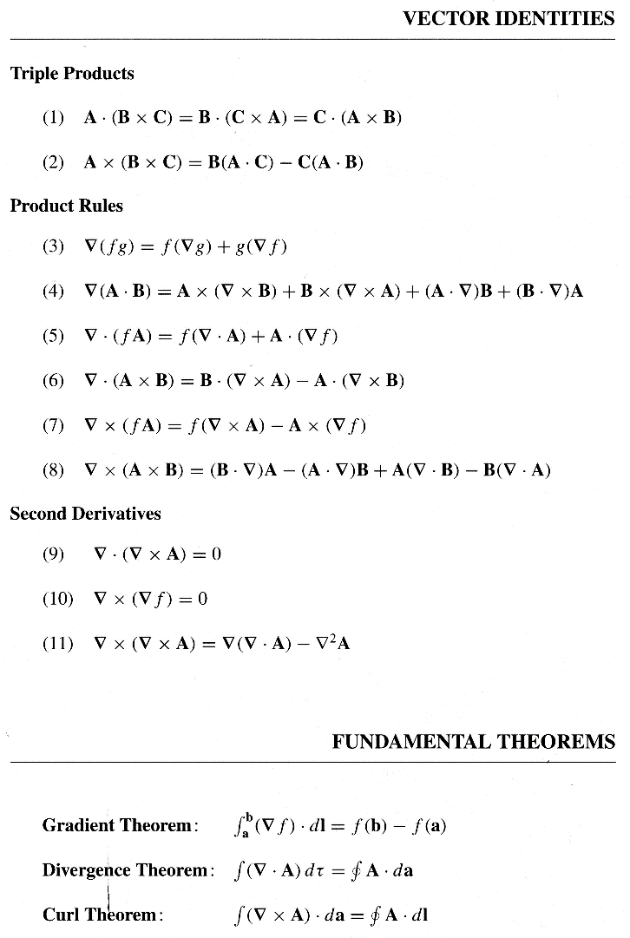
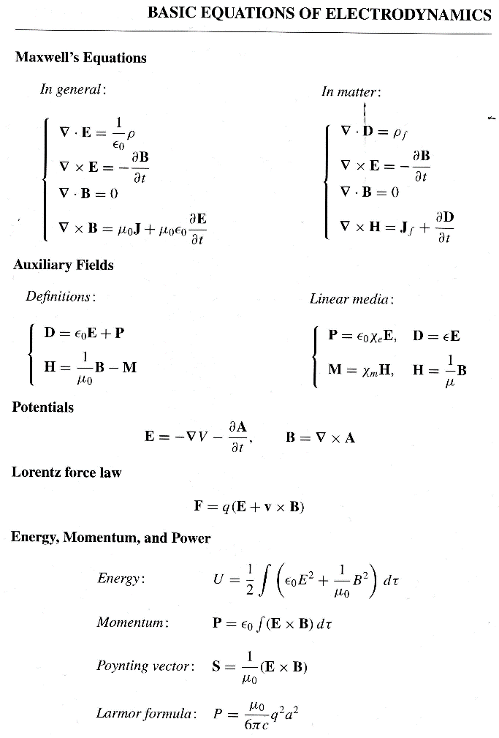 | 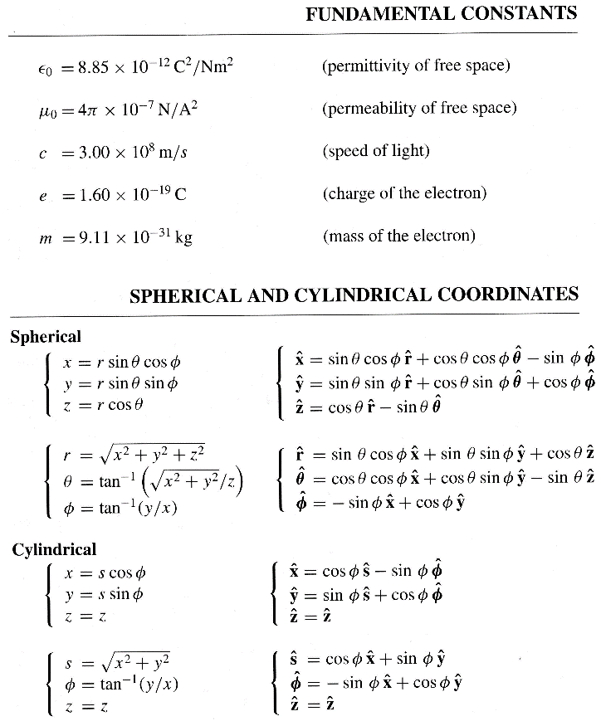

Some miscellaneous mathematical stuff:

$\sin^{2}{x}=\frac{1}{2}-\frac{1}{2}\cos{2x}$ $\sin^{3}{x}=\frac{3}{4}\sin{x}-\frac{1}{4}\sin{3x}$ $\cos^{2}{x}=\frac{1}{2}+\frac{1}{2}\cos{2x}$ $\cos^{3}{x}=\frac{3}{4}\cos{x}+\frac{1}{4}\cos{3x}$

The first few Legendre polynomials:
$P_{0}\left(x\right)=1$ $P_{1}\left(x\right)=x$ $P_{2}\left(x\right)=\frac{3}{2}x^{2}-\frac{1}{2}$ $P_{3}\left(x\right)=\frac{5}{2}x^{3}-\frac{3}{2}x$ $P_{4}\left(x\right)=\frac{35}{8}x^{4}-\frac{15}{4}x^{2}+\frac{3}{8}$

Some indefinite integrals:
$\int{\sin{Cx}}=\frac{-\cos{Cx}}{C}$ $\int{\sin^{2}{Cx}}=\frac{x}{2}-\frac{\sin{2Cx}}{4C}$ $\int{\cos{Cx}}=\frac{\sin{Cx}}{C}$ $\int{\cos^{2}{Cx}}=\frac{x}{2}+\frac{\sin{2Cx}}{4C}$

Some definite integrals:
$\int_{0}^{a}{\sin\left(\frac{nπx}{a}\right)\sin\left(\frac{mπx}{a}\right)dx}=\left\{\begin{matrix}0, if n≠m \\ \frac{\begin{aligned} \\ a\end{aligned}}{2}, if n=m\end{matrix}\right.$

$\int_{0}^{π}{\sin^{2}{x}dx}=\frac{π}{2}$ $\int_{0}^{π}{\cos^{2}{x}dx}=\frac{π}{2}$ $\int_{0}^{2π}{\sin^{2}{x}dx}=π$ $\int_{0}^{2π}{\cos^{2}{x}dx}=π$
$\int_{0}^{π}{\sin^{3}{x}dx}=\frac{4}{3}$ $\int_{0}^{π}{\cos^{3}{x}dx}=0$ $\int_{0}^{2π}{\sin^{3}{x}dx}=0$ $\int_{0}^{2π}{\cos^{3}{x}dx}=0$
$\int_{0}^{π}{\sin^{4}{x}dx}=\frac{3π}{8}$ $\int_{0}^{π}{\cos^{4}{x}dx}=\frac{3π}{8}$ $\int_{0}^{2π}{\sin^{4}{x}dx}=\frac{3π}{4}$ $\int_{0}^{2π}{\cos^{4}{x}dx}=\frac{3π}{4}$

$\int_{-1}^{1}{P_{l}\left(x\right)}P_{m}\left(x\right)dx =\left\{\begin{matrix}0, if l≠m \\ \\ \frac{2}{2l+1}, if l=m\end{matrix}\right.$ $\int_{0}^{π}{P_{l}\left(\cos{θ}\right)}P_{m}\left(\cos{θ}\right)\sin{θ}dθ =\left\{\begin{matrix}0, if l≠m \\ \\ \frac{2}{2l+1}, if l=m\end{matrix}\right.$

(18 pts) Problem 1. Multiple choice, 1.5 pts each. Circle the correct answers for the multiple choice questions.

  - A surface current $K=K(x,y) \hat{y}$ somehow flows within a finite rectangle in the x-y plane as shown. The rectangle goes from –a to +a in the x-direction and –b to +b in the y-direction. How should you set up the integral to calculate the amount of current flowing?
y
x
K
- $I=\int_{-a}^{a}{Kdx}$
- $I=\int_{-b}^{b}{Kdy}$
- $I=\int_{-a}^{a}{\int_{-b}^{b}{Kdydx}}$

  - To find the magnetic field B at the point P due to a current-carrying wire we use the Biot-Savart law. What is the direction of the infinitesimal contribution dB created by current in the section of wire, dl, that is shown?
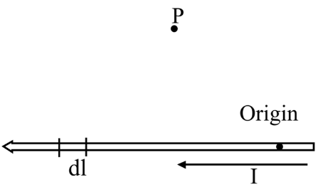
- Upwards
- Up and to the left
- Up and to the right
- Downwards
- Down and to the left
- Down and to the right
- Into the page
- Out of the page

  - A trajectory of a positive particle is shown. Please forgive the artwork. To help you see the 3D nature of the path the way I intend, I have indicated some places where the particle’s path is behind the y-axis and some places where the path is in front. Alternately, viewed from the right, the path is counter-clockwise. There is no electric field present (aside from that created by the particle itself). In which direction is the (constant) magnetic field that is influencing the trajectory?
y
x
z
Path in front of the y-axis
Path behind the y-axis
- $+\hat{x}$
- $–\hat{x}$
- $+\hat{y}$
- $-\hat{y}$
- $+\hat{z}$
- $-\hat{z}$

  - A magnetic field is created by running current through a solenoid. A second magnetic field is created by running the same magnitude current through another solenoid which is identical except it has a core made of diamagnetic material. In which case is there more energy stored in the field?
- First field
- Second field

  - A current $I$ in a circular loop of radius $b$ produces a magnetic field. At a fixed point far from the loop, the strength of the magnetic field is proportional to which of the following combinations of $I$ and $b$?

    - $Ib$
    - $Ib^{2}$
    - $I^{2}b$
    - $I/b$
    - $I/b^{2}$
    - $I^{2}/b^{2}$
    - None of the above

  - A localized current distribution has no magnetic monopole moment, no magnetic dipole moment, but a nonzero magnetic quadrupole moment. At a large distance r from the distribution, the magnetic field will fall off like:
- No fall off; it’s constant
- 1/r
- 1/r²
- 1/r³
- 1/r⁴
- 1/r⁵
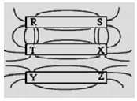
  - The diagram depicts iron filings sprinkled around three permanent magnets. Pole R is the same type of pole (i.e. north vs. south) as:
- T and Y
- T and Z
- X and Y
- X and Z
- T, X, and Y
- T, Y, and Z
- X, Y, and Z

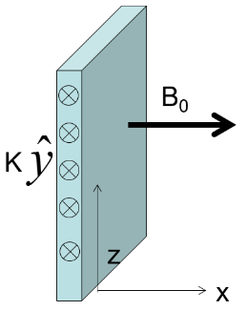
  - A sheet of current with surface current density K in the y-direction as shown serves as a boundary between two regions of space (the y-axis points into the page). If $B=B_{0}\hat{x}$ just to the RIGHT of the sheet, in what direction will B be just to the LEFT of the sheet? (The magnetic fields are not solely due to the sheet itself; they are produced in part by additional currents not shown.)
- +x
- –x
- +z
- -z
- +y
- –y
- None of the above
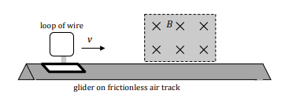

  - A single, continuous loop of conducting wire is mounted on a glider which travels on a frictionless air track with an initial velocity v. When the front edge of the loop enters the magnetic field region which points into the page as shown...
- there is a clockwise current in the loop, and the glider slows down.
- there is a counterclockwise current in the loop, and the glider slows down.
- there is a clockwise current in the loop, and the glider speeds up.
- there is a counterclockwise current in the loop, and the glider speeds up.
- there is no current in the loop, and the glider travels at constant v.

  - Ampere’s Law, written as $∇×B=μ_{0}J$, is ___________ with the rule that the divergence of the curl of a vector field must necessarily be zero.
- always consistent
- never consistent
- consistent if ρ = constant in time
- not consistent if ρ = constant in time
× × ×
× × × × ×
× × × × ×
× × × × ×
× × ×

a
b
2b
B
  - Two concentric wire loops of radius b and 2b lie in the plane of the page as shown. A uniform magnetic field B going into the page is confined to a concentric region of radius a, where a < b but is increasing. At a particular moment in time the induced EMF in the wire loop of radius b is ε. What will be the induced EMF in the wire loop of radius 2b at that same moment?
- ε/4
- ε/2
- ε
- 2ε
- 4ε
- Zero
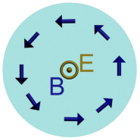
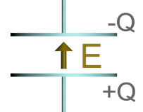
  - The figures show a side and top view of a capacitor with charge Q and electric and magnetic fields E and B at time t. At this time the charge Q must be:
- Increasing in time
- Decreasing in time.
- Constant in time.

(15 pts) Problem 2. Short answers. No explanations needed. Negative signs required when appropriate. Half credit if wrong sign but otherwise right answer, otherwise questions will be graded pass/fail.

(a) A very long diamagnetic rod carries a uniformly distributed current I along the $+\hat{z}$
I
direction. The current sets up a B field inside the rod (as well as outside), which then induces a magnetization. Indicate the direction of all of the following (no magnitudes needed). If a given quantity is zero then state that instead of a direction.

- The (total) B field inside the rod

- The H field inside the rod

- The M field inside the rod

- The A field inside the rod

- The bound surface current on the “wrapper”

- The bound volume current

(b) Units!

- What are the units of the B-field in terms of N = newton, A = ampere, and m = meter?

- What are the units of the H-field in terms of N = newton, A = ampere, and m = meter?

(13 pts) Problem 3. Two parallel infinite line charges (charge density λ) are separated by a distance d. Both move in the same direction with velocity v, thus creating parallel currents. How great would the speed v have to be in order for the magnetic attraction to exactly balance the electrical repulsion? Note: I want a numeric answer in m/s as well as symbolic answer. Hint: the current I created by a moving line charge λ is given by I = λv.

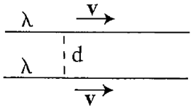

(15 pts) Problem 4: A thick cylindrical shell with inner radius R₁ and outer radius R₂ and extending infinitely in the z-direction has a built-in magnetization between R₁ and R₂ given by: $M=M_{0}\frac{R_{1}}{s}\hat{ϕ}$.

(a) Calculate the bound currents on the two surfaces and inside the volume of the shell.

(b) Using either Ampere’s law for B or for H (or both, if you want to check yourself), calculate the magnetic field as a function of s inside the shell, i.e. for R₁ < s < R₂.

(16 pts) Problem 5. A rectangular loop of wire spans a region of space where the magnetic field abruptly goes from being zero to being constant in space, as shown. The dimensions of the loop are shown and there is a resistor, resistance R, as part of the loop.
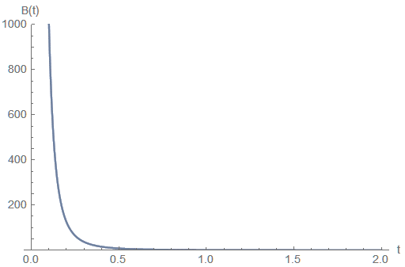
resistor
× × × × ×
× × × × ×
× × × × ×
No magnetic field Magnetic field present
y₀
x₀

The rectangular loop is pushed to the right at speed v without deforming it. At the same time the B-field changes with time according to $B=B_{0}{\left(\frac{t}{τ}\right)}^{-3}\hat{z}$ where $\hat{z}$ is into the page and τ is a positive constant. This is depicted in the right-hand graph for some choice of B₀ and τ. (Ignore the fact that B is infinite at time t = 0, which isn’t possible.)

(a) What direction is the current in the loop? (CW vs CCW) Show your work and/or explain your logic. If it can’t be determined, explain why. No credit for answers with no work/explanation.

(b) What is the current through the resistor as a function of time, assuming that at time $t=0$ exactly half of the rectangle is inside the field (as shown)? Hint: that means that if you call x the horizontal distance the loop is immersed in the field, then $x=\frac{x_{0}}{2}+vt$.

(13 pts) Problem 6. A cylindrical bar magnet has a constant magnetization M which points in the z-direction along the cylindrical axis. The magnet is long but not infinite, with its length equal to 20 times its radius R. It is centered at z = 0, and therefore extends from $z=-10R$ to $z=+10R$.

(a) Make a plot of B vs. z for $-15R<z<15R$. You don’t have to work out any equations; a general (but accurate) plot based on your experience/our class discussions is fine. Note that I’m not talking about field lines, I’m talking about the actual value of B, with positive and negative B values indicating a field in the $+\hat{z}$ and $-\hat{z}$ directions as appropriate.

(b) The peak value of the B field on your graph should be the same as if it were an infinite cylinder. Figure out that value and label it on your graph above.

(c) On a new graph, make a plot of H vs. z for the same situation, again with positive and negative H values indicating a field in the $+\hat{z}$ and $-\hat{z}$ directions as appropriate. Hint: $H=\frac{B}{μ_{0}}-M$. This graph will not be just a flat line at $H=0$. One of the points of this problem is to demonstrate to you that just because I_{free} = 0 for a particular situation does not necessarily mean that $H=0$ everywhere (although it does for certain symmetric situations where we can use Ampere’s law).

(10 pts) Problem 7. Same situation as the last problem. In terms of M, R, and z, what is the B field for points along the z-axis where $z≫R$?

