Physics 441 Final Exam - due Thurs 12/20/18, 5 pm, to Dr Colton’s office (N335 ESC)

Rules/Guidance:

- The exam is completely open notes/books. You may use the textbook, other textbooks, your own class notes, Wikipedia, the results of Google searches, other websites, etc.
- You may not communicate with other people about the exam (classmates, classmates’ notes, other current or past Physics Department students, relatives, internet forums or chat rooms, Facebook, etc.).
- If the wording of any of the exam problems seems unclear, please talk to me and I will clarify what is meant.
- Feel free to ask me any questions about homework, previous exam questions, or in-class worked problems. But limit it to actual problems we’ve already done, rather than hypothetical problems that might be similar to the exam problems.
- Please work neatly and start each problem on a new page.
- Please turn in this printed out exam along with your work.
- The exam is out of 150 total points.
- My best guess is that the average time the exam will take for a well-rested, well-prepared student should be about 5.5 hours. Of course, if you are not yet well-rested and well-prepared, or if you tend to work slower than the class average, then factor in additional time as appropriate.

Name ____________________________________

Additional Instructions: Please label & circle/box your answers. For the worked problems, show your work! If you use non-obvious equations from Griffiths or elsewhere, cite where they come from. And of course remember: in any problems involving Gauss’s or Ampere’s Law, you should explicitly show your Gaussian surface/Amperian loop.

(15 pts) Problem 1: Multiple choice, 1.5 pts each. Circle the correct answers below.

  - Two charges, of magnitude -Q and +4Q, are located as indicated in the diagram. At which position will the electric field due to these charges be zero?
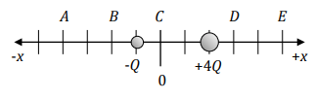
- A
- B
- C
- D
- E
- None of them
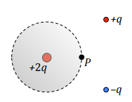
  - Charges of +2q, +q, and –q are distributed in an area as shown. Consider a Gaussian surface located around the +2q charge, with a point P located on the dashed surface. Which of the statements is true?
- The electric field at P depends only on the +2q charge.
- The electric field is the same everywhere on the Gaussian surface.
- The electric field is the same everywhere inside the Gaussian surface.
- The net flux through the Gaussian surface depends only on the +2q charge.
- The net electric field at point P can be determined using the Gaussian surface shown.
- None of the above.

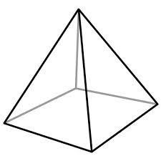
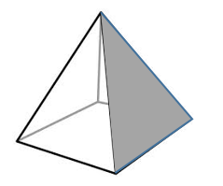
  - A charge Q is placed at the center of the base of a square pyramid as shown. What is the flux through the shaded side of the prism?
Q
    - $0$
    - $\frac{Q}{ε_{0}}$
    - $\frac{Q}{{4ε}_{0}}$
    - $\frac{Q}{{5ε}_{0}}$
    - $\frac{Q}{{8ε}_{0}}$
    - $\frac{Q}{32}$
    - None of the above.

  - A sphere centered on the origin has a constant charge density +ρ₀ in its upper hemisphere and –ρ₀ in its lower hemisphere (ρ₀ is a positive number). What will be the potential along the z-axis?
- Positive
- Negative
- Zero
- Positive for $z>0$ and negative for $z<0$
- Negative for $z>0$ and positive for $z<0$

  - True/False: Ferroelectric materials that have a polarization field that is constant in space (i.e. same direction, same magnitude everywhere in the material) will only have bound surface charges, not bound volume charges.
- True
- False

  - Four identical wires carry 4 amps of current each, coming out of the page as shown. The wire on the right is labeled P. What is the direction of the net magnetic force on wire P caused by the other wires?
- To the left
4A
4A
4A, “P”
4A
- To the right
- Towards the top of the page
- Towards the bottom of the page
- Into the page
- Out of the page
- The net force is nonzero, but in some other direction
- The net force is zero

  - True/False: In the Coulomb gauge the formula $A(r)=\frac{μ_{0}}{4π}\int{\frac{J(r^{'}) dτ^{'}}{} }$ can always be used to find the vector potential A for a given current distribution, J.
- True
- False

  - What would be the best way to calculate the magnetic field at an arbitrary point in space $(x,y,z)$, produced by a cube of current that has side length a and constant volume current density $J=J_{0}\hat{z}$?
- Coulomb’s law
- Gauss’s law
- Gauss’s law for D
- Multipole expansion for V
- Images charges
- Bound charges
- Biot-Savart law
- Ampere’s law
- Ampere’s law for H
- Multipole expansion for A
- Image currents
- Bound currents
- Faraday’s law
- Maxwell’s fix to Ampere’s law

  - Assuming there is no free surface current on the boundary between the two linear isotropic magnetic media shown, which of the figures represents possible magnetic field intensity vectors on the two sides of the boundary? The B₁ and B₂ arrows represent magnetic fields just below and just above the boundary, respectively (where the arrows begin).
B₁
μ_{r1} = 2
μ_{r2} = 4
(b)
B₂
B₁
μ_{r1} = 2
μ_{r2} = 4
(a)
B₂

B₁
μ_{r1} = 2
μ_{r2} = 4
(c)
B₂
B₁
μ_{r1} = 2
μ_{r2} = 4
(d)
B₂

B₁
μ_{r1} = 2
μ_{r2} = 4
(e)
B₂
B₁
μ_{r1} = 2

μ_{r2} = 4
(f)
B₂

(g) None of the above

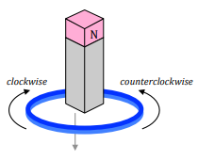
  - A permanent magnet is dropped, south pole-down, through a conducting loop as shown. What will be the direction of the current induced in the loop as the magnet falls towards, then through, then away past the loop?
- Clockwise first, then counterclockwise when falling away
- Clockwise first, and continuing to be clockwise when falling away
- Counterclockwise first, then clockwise when falling away
- Counterclockwise first, and continuing to be counterclockwise when falling away
- There will be no current induced.

Worked problems – please work on your own paper, no more than one problem per page.

(10 pts) Problem 2. At some point in your future you find yourself teaching a class on electricity and magnetism. While writing a problem for an exam, you create a scalar potential function that is $V=\frac{V_{0}}{L^{3}}\left(x^{2}y+xyz+xz^{2}\right)$ inside a cubic region of space with side length L, with $0<x<L, 0<y<L, 0<z<L$. Outside of this region of space, $V=0$. (a) Is this a physically possible V? Why/why not? (b) Assuming it is possible, what electric field would it give rise to?

(13 pts) Problem 3. A sphere of radius R has a charge density from 0 to R given by, $ρ=ρ_{0}{\left(\frac{r}{R}\right)}^{2}$. (a) In terms of the given variables how much charge total is present in the sphere? (b) How much work was required to bring together all of that charge? Tip: you may want to make sure that your final answer has units of work.

(10 pts) Problem 4. Here’s a figure you may recall from Exam 1. Suppose the x- and y-axes are given in meters and the z-axis (that is, V) is given in volts. An electron starting at rest moves in response to an electric force from point A to point B along the path shown. How fast will it be going at point B?
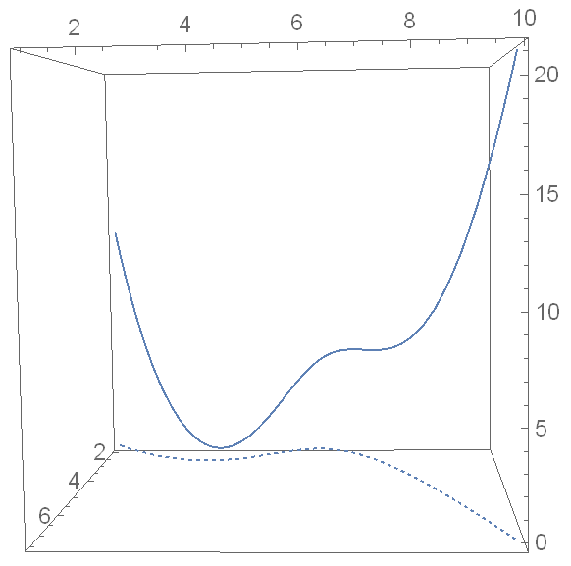
V at point A
V at point B
The potential at points from A to B is the solid curve
The path from A to B is the dashed curve, in the x-y plane
Point A
Point B
Point C
V at
point C

(18 pts) Problem 5. For a homework assignment earlier this semester you used the relaxation method to solve Laplace’s equation in 2D, $∇^{2}V(x,y)=0$, in a region around a capacitor whose plates were fixed at a certain positive and negative potential. Mathematically, the reason the averaging method works, in addition to the justification given in class, arises from approximating second derivatives as finite differences like this: (h is the spatial difference between grid points, which we can define to be 1 in some system of units)

$$\frac{∂^{2}V}{∂x^{2}}≈\frac{V\left(x+h,y\right)-2V\left(x,y\right)+V\left(x-h,y\right)}{h^{2}}$$

$$\frac{∂^{2}V}{∂y^{2}}≈\frac{V\left(x,y+h\right)-2V\left(x,y\right)+V\left(x,y-h\right)}{h^{2}}$$

You undoubtedly saw those equations in Physics 430. In the interest of simplicity I’ll write the “approximately equals” symbols as just “equals”. Laplace’s equation in 2D thus becomes the following:

$$\frac{∂^{2}V}{∂x^{2}}+\frac{∂^{2}V}{∂y^{2}}=0$$

$$\frac{V\left(x+h,y\right)-2V\left(x,y\right)+V\left(x-h,y\right)+V\left(x,y+h\right)-2V\left(x,y\right)+V\left(x,y-h\right)}{h^{2}}=0$$

$$V\left(x+h,y\right)+V\left(x-h,y\right)+V\left(x,y+h\right)+V\left(x,y-h\right)-4V\left(x,y\right)=0$$

$$V\left(x+h,y\right)+V\left(x-h,y\right)+V\left(x,y+h\right)+V\left(x,y-h\right)=4V\left(x,y\right)$$

$$V(x,y)=\frac{V\left(x+h,y\right)+V\left(x-h,y\right)+V\left(x,y+h\right)+V\left(x,y-h\right)}{4}$$

$$V\left(x,y\right)=average of surrounding points$$

That last equation gives you a way to iterate, and if you do so until $V\left(x,y\right)$ is indeed the average of the four surrounding points, then Laplace’s equation is satisfied.

(a) The relaxation method can also be used to solve the more complicated Poisson’s equation, $∇^{2}V=-ρ/ϵ_{0}$, where ρ can be a function of x and y. Setting $ϵ_{0}=1$ and $h=1$ for simplicity, your first task is to go through a similar analysis to show that the equivalent equation for Poisson’s equation is this:

$$V\left(x,y\right)=average of surrounding points+ρ(x,y)/4$$

So if you iterate until $V\left(x,y\right)$ is the average of the four surrounding points plus ρ at that point divided by 4, then Poisson’s equation is satisfied.

(b) Use this modified technique to solve the following problem by relaxation with a programming language of your choice. In the middle of a 100×100 array which is bounded by V = 0 cells around the outside, create a 10×10 square which has $ρ=+10$ for the upper half and $ρ=-10$ for the lower half. Iterate until Poisson’s equation is solved to within some suitably small tolerance level, as measured by the difference between the left hand side of the iteration equation and the right hand side. Turn in a printout of your code along with a plot of your final, relaxed, potential function.

(12 pts) Problem 6. Set up the Biot-Savart law integral that you would need to use to determine the magnetic field of a current loop (radius R, current I) at the point specified, namely (0, R, z). The current is counter-clockwise as viewed from above. Don’t do the cross product or the integral, just set it up using the given information. Do make sure you only have constant unit vectors inside the integral, however.
B = ?
z
x
y

(10 pts) Problem 7. A static magnetic field in a certain region of space is given by $B=5y^{2}\hat{x}+3z^{-2 }\hat{y}$, with all variables being in standard SI units. (a) What are the units of the numbers 5 and 3? (b) Is this a physically possible B field? Why/why not? (c) Assuming it is possible, what volume current density J would give rise to such a field?

(12 pts) Problem 8. A magnetic dipole at the origin is pointing in the positive x direction with dipole moment $m=m_{0}\hat{x}$. What are the magnetic vector potential A and magnetic field B at an arbitrary point far away from the origin along the line $y=x$, located at $(a,a,0)$? (a is positive.) Use the Coulomb gauge. Note that the point is a distance of $a\sqrt{2}$ from the origin.

(12 pts) Problem 9. A large permanent magnet has magnetization $M=M_{0}\hat{z}$. In a particular section of the inside—not necessarily right at the center but not very close to the sides—the magnetic field is a constant $B=B_{0}\hat{z}$, so that $H=\left(\frac{B_{0}}{μ_{0}}-M_{0}\right)\hat{z}$ there. A small spherical cavity, radius R, is hollowed out of the material in that section. Find B and H at the center of the cavity in terms of the given quantities. Hint: Feel free to Google/find in your textbook a formula for the magnetic field at the center of a uniformly magnetized sphere.

(10 pts) Problem 10. A certain capacitor has parallel circular plates with area A and electric field in the $\hat{z}$direction. Its charge is decreasing according to $Q=Q_{0}e^{-t/τ}$, where Q₀ and τ are positive constants. Determine the induced magnetic field, both magnitude and direction.

(14 pts) Problem 11. I mentioned in class that the voltage divider equation which we often use to analyze filters was obtained under the assumption that no current “leaks out”. This is really only the case when the output of the filter is hooked up to a circuit with a large input impedance. The point of this problem is to explore what happens when the input impedance of the next circuit varies, using a band pass filter as an example.

Start with the band pass filter picture,
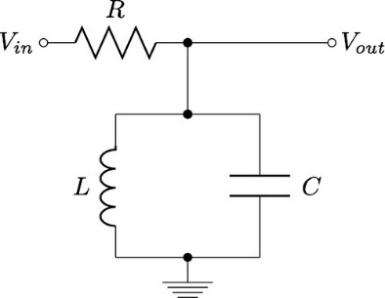

and add another resistor, let’s call it R_{load}, going from V_{out} to ground. That represents the input impedance of the load circuit, i.e. whatever circuit you are hooking the filter up to. Notice that R_{load} is in parallel with L and C.

Use these numbers: $V_{in}=1 V\cos{ωt}$, $R=100 kΩ$, $L=10 mH$, and $C=10 nF$ (same RLC values as in the band pass filter example in the Advanced Circuit Topics Part 2 handout).

The voltage of R_{load} is the voltage delivered to the load circuit. Use Mathematica or similar program to plot the magnitude and phase (on separate graphs) of this voltage as a function of ω, for R_{load} equal to:

(a) $10 kΩ$
(b) $100 kΩ$
(c) $1000 kΩ$

Force your magnitude plots to all go from 0 to 1 V on the y-axis and your phase plots to all go from –π/2 to π/2. Choose an appropriate range for your x-axis. The plots for part (c) should look fairly similar to the transfer function plots in the handout, which in some sense assumed an infinite R_{load}.

(14 pts) Problem 12. Gaussian units! If you missed the class period when we discussed Gaussian units and I gave my three rules for “translating” SI equations to Gaussian units, you are welcome to talk to me in person to get caught up. I mentioned in class that my three translation rules work about 90% of the time so here’s some more to the story to help with the other 10%. I know you can Google the answers to the questions below, so what I will be looking for especially in this problem is for you to show your understanding from your work. Answers with little or no work or explanations will receive little or no points.
- In Gaussian units, p, the dipole moment, is still charge×distance (albeit in esu⋅cm instead of C⋅m), and the polarization field $P(x,y,z)$ still describes the dipole moment per volume at the location $(x,y,z)$. What does this mean about the units of P? Specifically, show that the units of P are now the same as the units of E, namely gauss.
- Because P still represents the same physical quantity as before, we still have the equation $∇∙P={-ρ}_{b}$, where $ρ_{b}$ is the bound volume charge density (now with units of esu/cm³). Previously we used that equation along with Gauss’s law $∇∙E=ρ/ϵ_{0}$and the desire to create a new field that had the property of $∇∙(something)=ρ_{free}$ to deduce what the “something” (which we called D) had to be. But in Gaussian units, as we discussed in class, Gauss’s law is $∇∙E=4πρ$… so we want the new field to have the property that $∇∙(something)=4πρ_{free}$. Deduce what the new “something” must be, i.e. the D field as defined in Gaussian units. Your deduced definition for D should trivially show that D also has the same units as E. (Yay! E, P, and D all have units of gauss! Yet another reason why to like Gaussian units.)
- Show that if you had blindly used my original three rules, the D field you would have obtained would not have satisfied the equation $∇∙D=4πρ_{free}$. What would the divergence be equal to, instead?
- Since D and E now have the same units, there’s no need to differentiate between permittivity ϵ and relative permittivity ϵ_{r}. They are the same thing in Gaussian units—it’s just called permittivity and is given the symbol ϵ defined by $D=ϵE$. This ϵ is dimensionless, and for a given material has the same numerical value as the relative permittivity in SI units. In SI units we defined χ_{e} by the equation $P=ϵ_{0}χ_{e}E$. In Gaussian units since P and E have the same units there’s no need for the ϵ₀ so χ is defined by $P=χ_{e}E$. In SI units the relationship between ϵ_{r} and χ_{e} was $ϵ_{r}=1+χ_{e}$. Derive the relationship between ϵ and χ_{e} in Gaussian units.
- Show that these definitions/derivations require that χ_{e} for a given material in Gaussian units is not the same numerical value as χ_{e} in SI units. How are the two related?

(Some comments follow on the next page.)
Comment 1: The new definition of D is a fourth translation rule and the relationship between χ_{e}(SI) and χ_{e}(Gaussian) is a fifth rule. You can go through a nearly identical process for magnetic materials to get a new definition of H for a sixth rule and a relationship between χ_{m}(SI) and χ_{m}(Gaussian) is a seventh rule. After that there is only one more rule I am aware of, which is that the vector potential A must be replaced with A/c in all equations (since B is replaced by B/c and A is still defined by $B=∇×A$). Now you know about as much as I do with regards to Gaussian units!

Comment 2: OK, there’s actually one more thing I know that’s worth sharing here. In Gaussian units $H=B/μ$and μ is dimensionless, so it would appear that H and B have the same units (gauss). However, while B is always given in gauss, H is invariably given in a unit called “oersted”, symbol Oe. I believe this is only to help remind people that B and H are measuring different things. No one ever comes out and says that a gauss and an oersted are dimensionally the same, but that must surely be the case. Anyway, keep that in mind if/when you ever see any references to oersted—they are talking about the H field. Experimentally, you can think of it like this: if you set your Helmholtz coil/other electromagnet to a B field setting of 1 gauss (= 10^{–4} T), as measured when no material is inside the magnet, then when you put some material inside the magnet there will be an H field of 1oersted inside your material.

(0 pts) Problem 13. Approximately how long did the exam take you? Please write down your estimated time on the bottom of your last page.

If not, look at the “Second-order central” equation on this page: https://en.wikipedia.org/wiki/Finite_difference
Irrelevant side note that just occurred to me that I should have mentioned in class: an “esu”, or “electrostatic unit” is also called a “statcoulomb”. You’ll see those terms used interchangeably, but I think esu is more common now.

