Fall 2016 barcode here
Physics 441
Exam 3
Dr. Colton, cell: 801-358-1970

No time limit. Student calculators are allowed. One page of handwritten notes allowed (front & back). Books not allowed. A HANDOUT WITH FRONT AND BACK INSIDE COVERS OF GRIFFITHS TEXTBOOK SHOULD BE PROVIDED. If not, please ask the Testing Center for it and/or have them call me.

Name ____________________________________

Instructions: Please label & circle/box your answers. Show your work, where appropriate! And remember: in any problems involving Gauss’s Law, you should explicitly show your Gaussian surface. For all problems, unless otherwise specified you may assume that you are dealing with electrostatics, i.e. the charges are not moving and the fields have come to equilibrium.

(No special math formulas needed for this exam.)

(20 pts) Problem 1: Multiple choice, 2 pts each. Circle the correct answer.

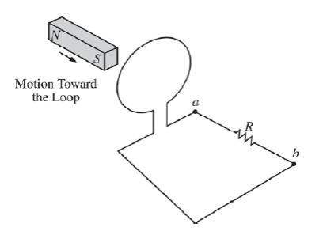
  - The bar magnet shown in the figure is moved completely through the loop. Which of the following is a true statement about the direction of the current flow between the two point a and b in the circuit? (Hint: field lines from permanent magnets go from north pole to south pole.)
- No current flows between a and b as the magnet passes through the loop.
- Current flows from a to b as the magnet passes through the loop.
- Current flows from b to a as the magnet passes through the loop.
- Current flows from a to b as the magnet enters the loop and from b to a as the magnet leaves the loop.
- Current flows from b to a as the magnet enters the loop and from a to b as the magnet leaves the loop.

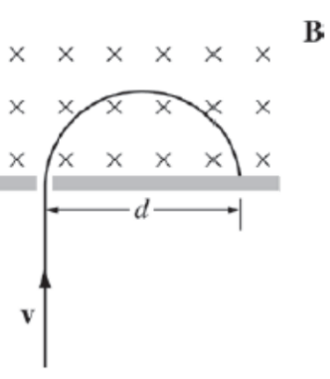
  - A particle with mass m and charge q, moving with a velocity v, enters a region of uniform magnetic field B, as shown in the figure. The particle strikes the wall at a distance d from the entrance slit. If the particle’s velocity stays the same but its charge-to-mass ratio is doubled, at what distance from the entrance slit will the particle now strike the wall?

- $2d$
- $\sqrt{2}d$
- $d$
- $\frac{1}{\sqrt{2}}d$
- $\frac{1}{2}d$

  - A current $I$ in a circular loop of radius $b$ produces a magnetic field. At a fixed point far from the loop, the strength of the magnetic field is proportional to which of the following combinations of $I$ and $b$?
    - $Ib$
    - $Ib^{2}$
    - $I^{2}b$
    - $\frac{I}{b}$
    - $\frac{I}{b^{2}}$

  - Which of the following diagrams represents the magnetic field due to a circular current? (X’s mean going into the page, dots mean coming out of the page. The symbols indicate only the direction of field; not necessarily its magnitude.)

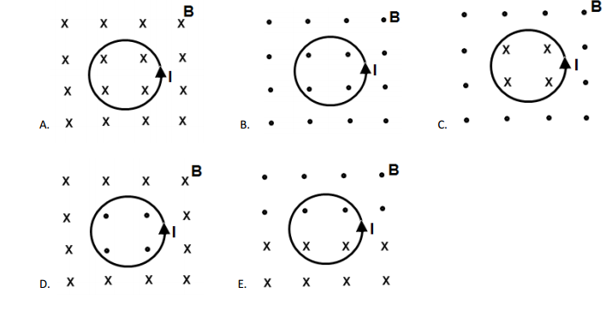

  - Which of these statements is not true of a static magnetic field?
- It can be generated by a DC current.
- It can produce an electric field.
- It doesn’t have sinks or sources.
- Magnetic flux lines are always closed.
- None of the above (all are characteristic of static magnetic fields).

  - A large circular conducting loop is positioned directly over a smaller loop, as shown. What is true about the mutual inductance between the two loops?
- The effect of the larger loop on the smaller loop is greater than the effect of the smaller one on the larger one.
- The effect of the smaller loop on the larger loop is greater than the effect of the larger one on the smaller one.
- The effect of the larger loop on the smaller loop is equal to the effect of the smaller one on the larger one.
- Which effect is larger depends on other factors, such as loop positions and orientations.

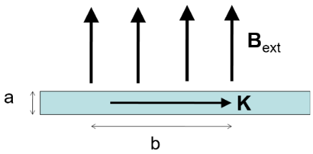
  - A "ribbon" (width a, length b, and infinitely thin in the third dimension) with a uniform surface current density K to the right is in a uniform magnetic field B_{ext}, oriented as shown. What is the magnitude of the force on the ribbon?
- KB_{ext}
- aKB_{ext}
- abKB_{ext}
- bKB_{ext}/a
- KB_{ext}/(ab)

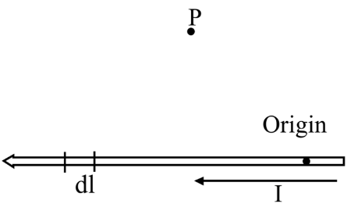
  - To find the magnetic field B at the point P due to a current-carrying wire we use the Biot-Savart law. What is the direction of the infinitesimal contribution dB created by current in the section of wire, dl, that is shown?
- Upwards
- Up and to the left
- Up and to the right
- Downwards
- Down and to the left
- Down and to the right
- Into the page
- Out of the page

  - With regards to the vector potential A (in general, i.e. not just in the Coulomb gauge), which of the following is continuous as you move past a boundary?
- A
- Not all of A, just the perpendicular component
- Not all of A, just the parallel component
- Nothing is guaranteed to be continuous regarding A for this situation

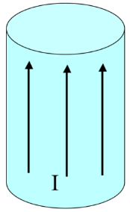
  - A very long aluminum (paramagnetic!) rod carries a uniformly distributed current I along the +z direction. What is the direction of the bound surface current? Hint: the current will set up a B field inside the rod (as well as outside); that B field will induce a magnetization.
- It points parallel to I
- It points antiparallel to I
- It points clockwise (viewed from above)
- It points counter-clockwise (viewed from above)
- It is zero

(16 pts) Problem 2. A long, straight, hollow cylindrical wire has an inner radius R and an outer radius 2R. In between the inner and outer radii there is a uniform volume current density in the z-direction as shown. There is no surface current density. The total current is I. Determine the magnitude of the magnetic field produced by this current, as a function of the distance from the center of the wire, s, and make a reasonably accurate sketch of the result.
hollow, no current here
constant volume current density here

(12 pts) Problem 3. A cube of side a is centered on the origin. It is made out of a ferromagnetic material with a permanent magnetization, $M=M_{0}\hat{z}$. (a) What bound currents are implied by this magnetization? Make a sketch and calculate the magnitude(s). (b) Approximately what is the magnetic field produced by this cube at a point, (x, y, z), a large distance away from the cube? You can give your answer in terms of the usual spherical coordinates r, θ, and ϕ and the spherical unit vectors, if you like.

• (x, y, z)

M

(12 pts) Problem 4. A conducting circular loop (radius R) is centered at the origin, and originally positioned such that it lies in the x-z plane; see the figure. There is a constant magnetic field present in the area, $B=B_{0}\hat{x}$ (not shown). The loop is then rotated about the z-axis counter-clockwise as viewed from above, at an angular frequency ω.

(a) Find the induced EMF in the loop as a function of time.
z
y
x

(b) After one full rotation, the loop returns to its original position (and continues to rotate). What direction is the current in the loop—clockwise or counter clockwise as viewed from the positive y axis on the right?

(16 pts) Problem 5. Derive the equation for inductance of an almost infinite solenoid filled with a material of relative permeability μ_{r}: $L=μ_{r}μ_{0}n^{2}lA$, where n is the number of turns per length, l is the length, and A is the cross sectional area. Be clear (and accurate!) about each step.

(10 pts) Problem 6. (a) Write down the two KVL mesh-current equations for this circuit, in terms of the left hand loop’s virtual current I₁ and the right hand loop’s virtual current I₂. Make each loop go counter-clockwise, as we did in class.
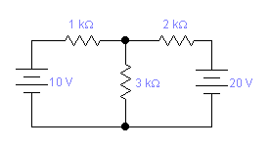

(b) Supposing you solve for I₁ and I₂ (you don’t have to do this), how would you determine the voltage of the 3 kΩ resistor? Assume the top of the resistor is at a higher voltage than the bottom.

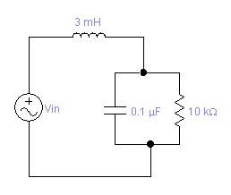
(14 pts) Problem 7. For V_{in} = 5 cos(1300t), assuming steady-state conditions, find (a) the amplitude and phase of the current through the inductor, and (b) the amplitude and phase of the voltage of the inductor. Give your answers in terms of real quantities, not complex. (Hint for part b: apply the complex version of Ohm’s law to the inductor, and recall that i = e^{iπ/2}.) If you don’t want to go through the complex number algebra by hand to put the complex impedance into polar form, that’s fine—just be clear about which steps you’d turn to Mathematica for to get which quantities, and what commands you would use. Put the rest of your work in terms of those quantities.

