Interferometry to test wavefronts
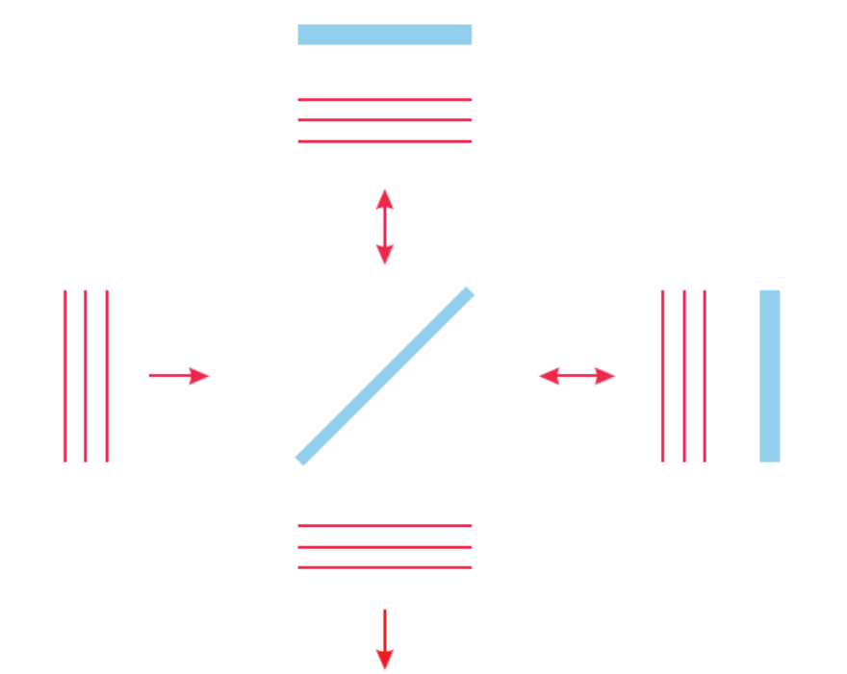
Screen

z

What is the fringe spacing?
What do these patterns represent?
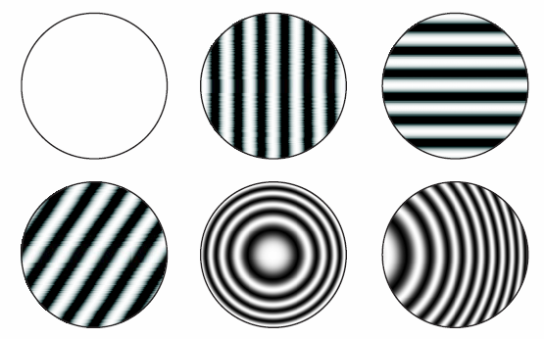

A plane wave added to a spherical wave (same ω, λ)
z≈R

Turbine blade
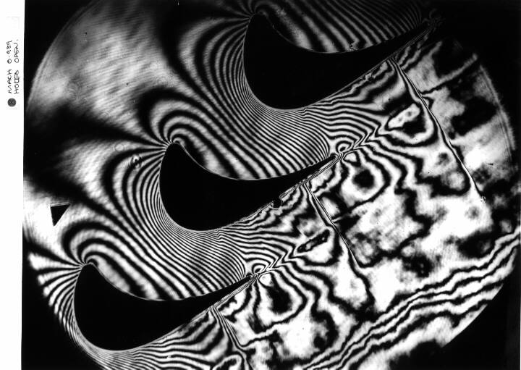

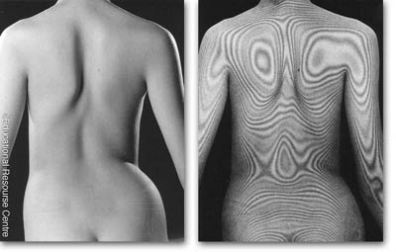
Medical Interferometry
A ballistic set-up for study of supersonic body motion through two-phase media with the powder guns of 24-35 mm in caliber. Optical system lens diameter is 400 mm) and two ruby lasers as light sources for two-frame high-speed recording of interferograms.
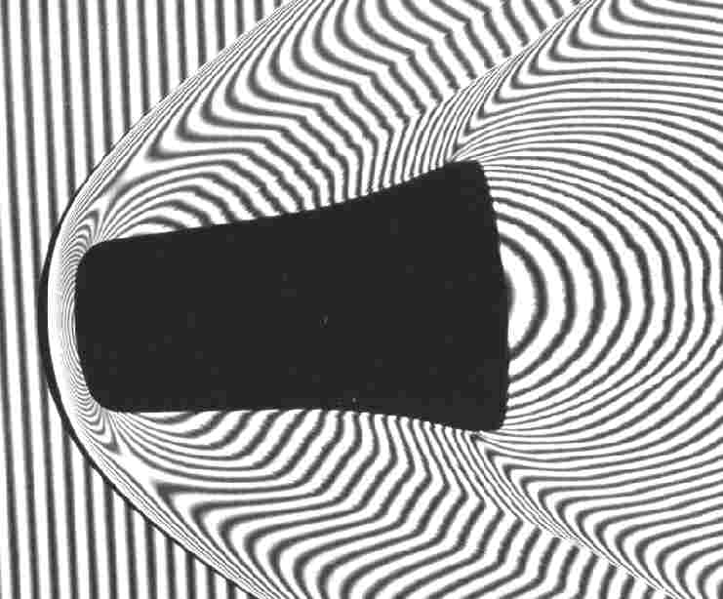
Holography
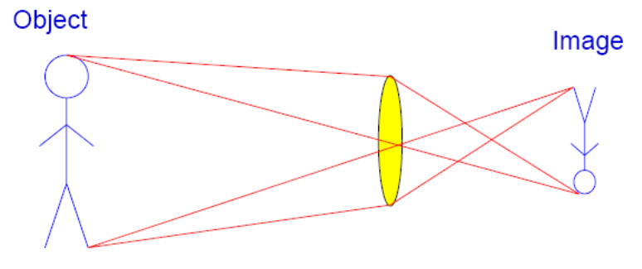
Traditional imaging
Intensity distribution in 2-D plane is recorded on photographic emulsion, digital pixels, etc
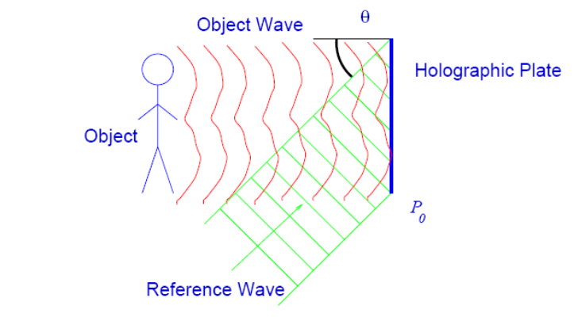
Holography
Record the interference pattern (fringes) between coherent object beam and reference beam. Then we get phase information coded as intensity!

Film requirements
Normal film:
Feature size: depends how large you want to make printed photo
(My calc.: 35 mm film enlarged to 8×10 needs ~7 μm features)
Exposure ~ I_{hitting it}; later T ~ I_{that hit film} (linear response)

Holographic film:
Feature size: needs to be smaller than wavelength of light
→ Stability!!
Designed with T ~ I²_{that hit film}, (nonlinear response)
so that later E_{transmitted} = t⋅E_{incident} ∝ I_{that hit film}⋅E_{incident}
From Hecht
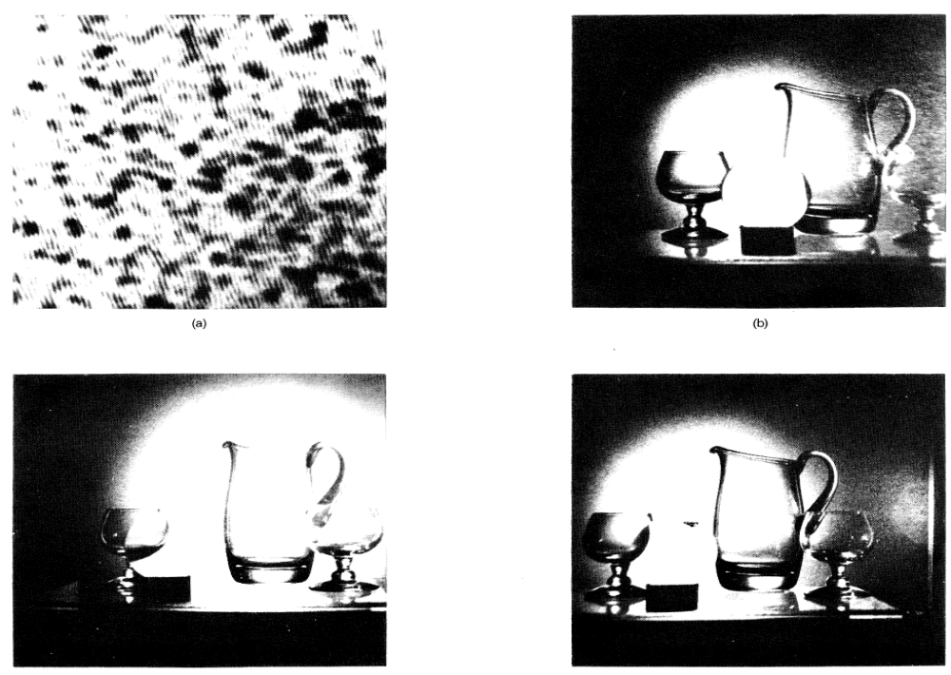

Why 3-D:
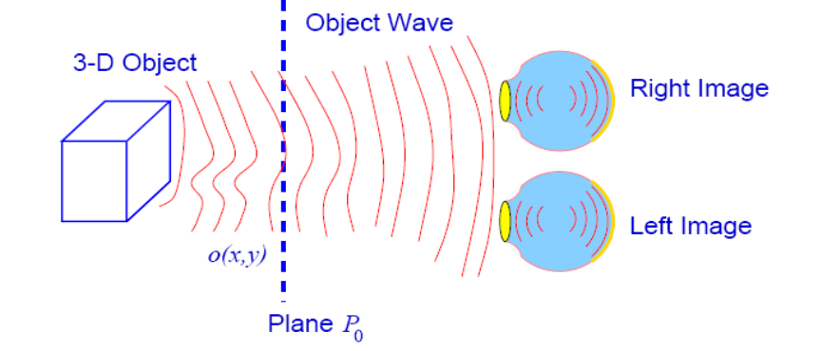
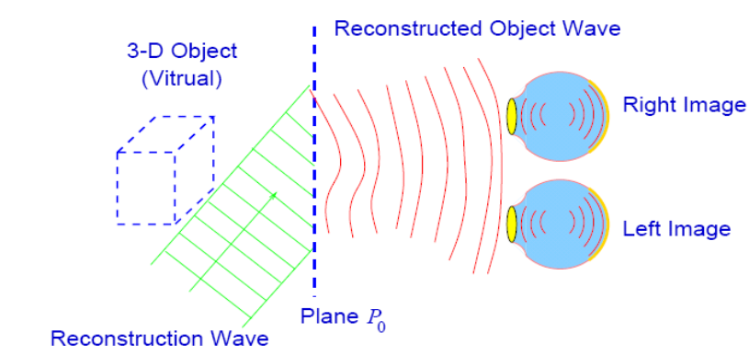
Hecht, pg 632
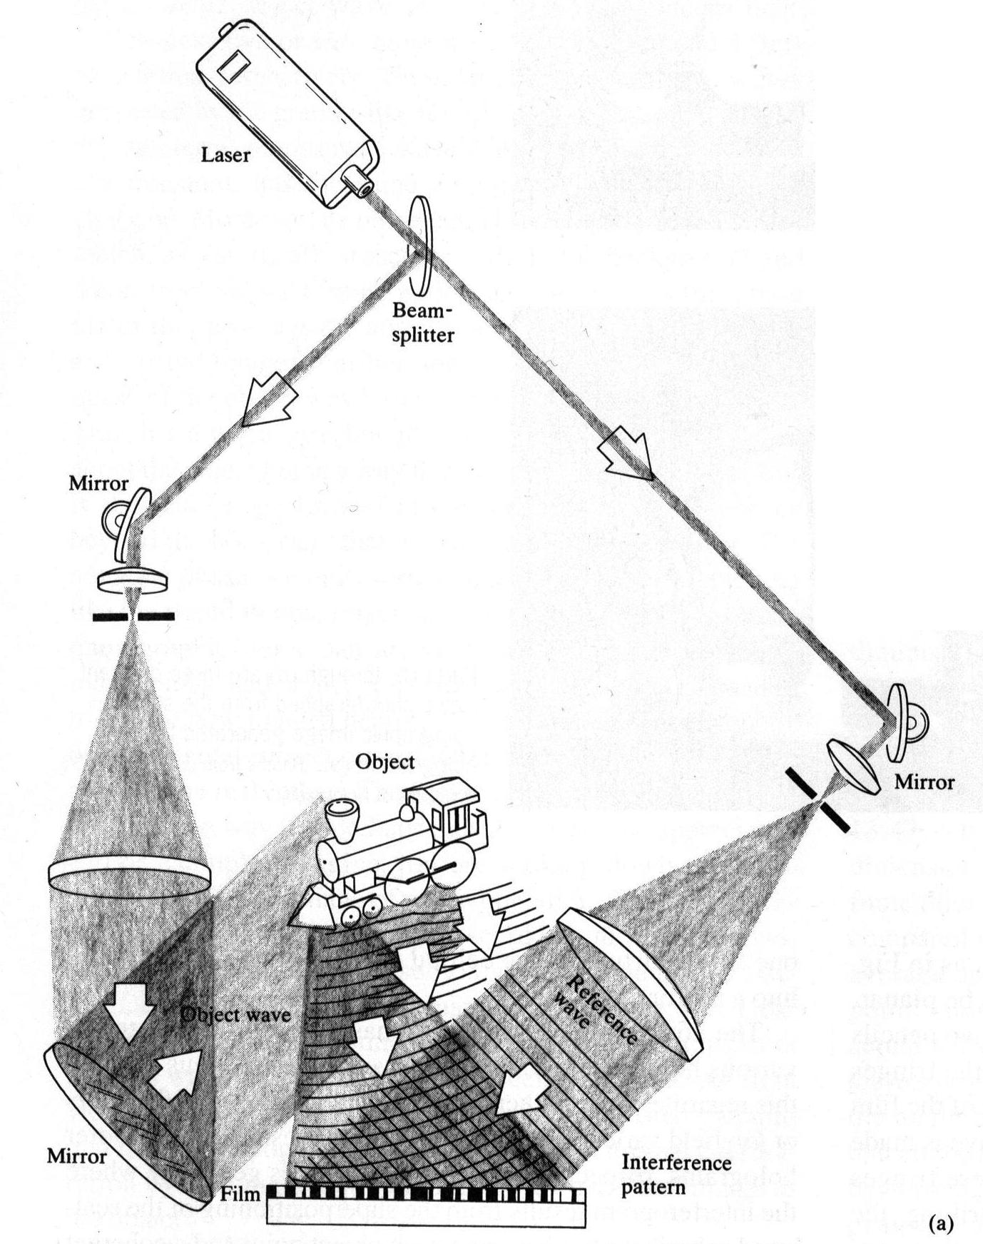

To create hologram

To view hologram
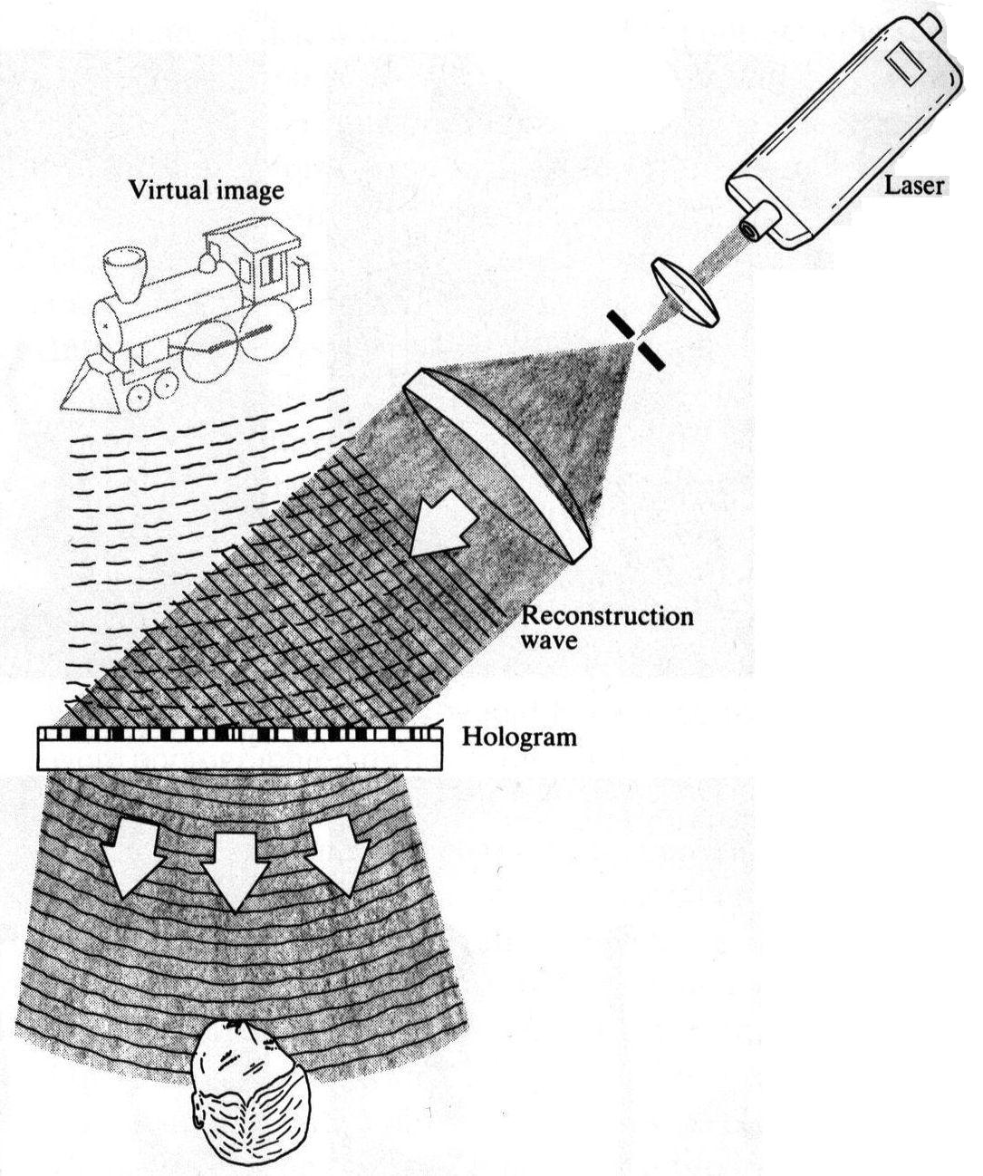

Reflection holography

Object and reference beam come from opposite sides of holographic plate. Reconstructing beam from same side as viewer reflection.
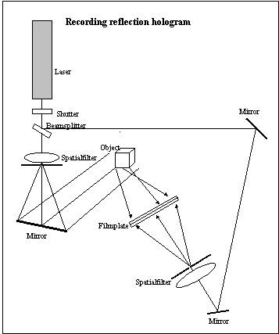

Volume holograms
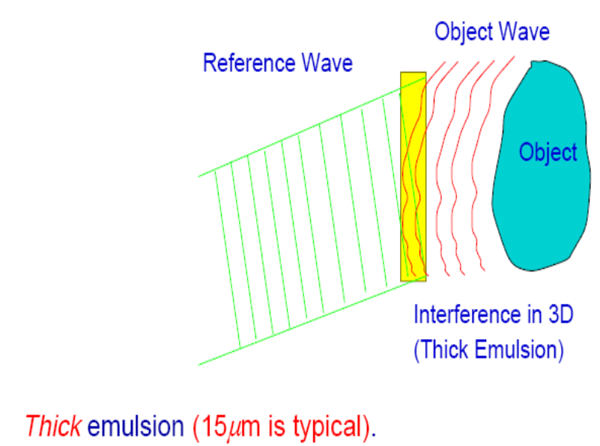

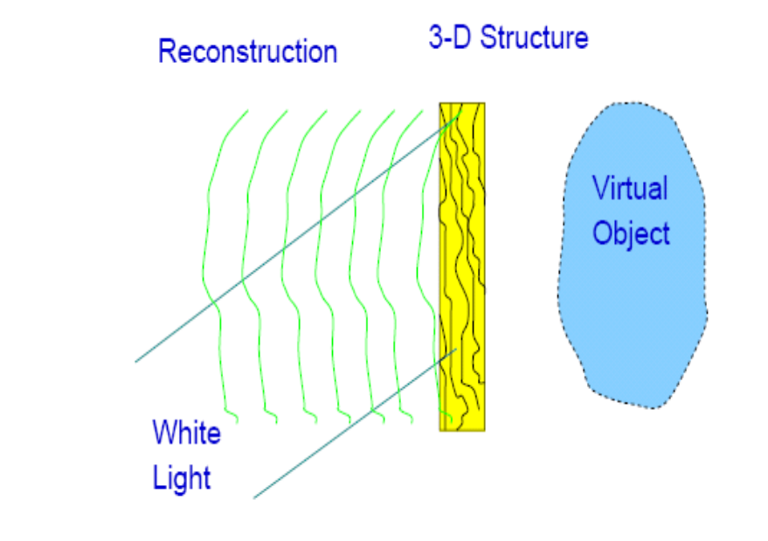

White-light reconstruction: Only light at proper Bragg angle (2dsinθ = λ) is reflected off to form a 3D virtual image.
Multiple image storage: By successively altering the incident angle (or the wavelength), a volume hologram can store hundreds of co-existing holograms at the same time.

